
UAE National Deposit Return System
Segen Business Feasibility & Investment Case
INTERNAL - SEGEN PARTNERS ONLY
July 2026
Prepared by: Segen - Strategic Advisory, GCC & International
Proposed technical partner: Earth Care Consulting (DRS design & implementation specialists)
Status: Standalone commercial companion to the National DRS Feasibility & Implementation Study
Scope: PET, metal (aluminium/steel) and glass beverage containers; national launch. Deposit and producer-fee values cited herein are analytical recommendations for policymakers and are non-binding.
Contents

Executive Summary 3
1. Segen as Project Sponsor 5
1.1 Who Segen is 5
1.2 Why a DRS is a natural - not an adjacent - mandate 5
1.3 The track-record question, answered honestly 5
2. Business Model 7
2.1 The SPV structure 7
2.2 Segen's three income lines - and the one it refuses 7
2.3 Why zero deposit income is a trust asset, not a sacrifice 7
3. Investment & Returns 9
3.1 System-level economics (context) 9
3.2 Segen-level returns 9
3.3 Scenario robustness 9
4. Revenue Stream Analysis & Durability 11
4.1 Stream-by-stream assessment 11
4.2 Downside protection architecture 11
5. Market Opportunity & First-Mover Position in the GCC 13
5.1 The UAE window - why now 13
5.2 GCC white space 13
6. Earth Care Consulting Partnership Structure 15
6.1 Complementary roles 15
6.2 Proposed governance, workshare and commercial terms 15
7. Risk Analysis - Segen-Specific 17
8. Funding Plan & Sources 19
8.1 Sources and uses 19
8.2 Why this is financeable 19
9. Five-Year Action Plan for Segen (2026-2031) 21
10. Conclusion & Recommendation 23
Annex A - Key Figures Register (consistency control) 25

Right-click the table of contents and choose “Update Field” to refresh page numbers.

Executive Summary
Segen proposes to sponsor, capitalise and operate the United Arab Emirates' first national beverage-container Deposit Return System (DRS) - the first mandatory, nationwide scheme of its kind in the Gulf - through a dedicated Special Purpose Vehicle (SPV), under the sponsorship and supervision of the relevant government authorities.
The commercial proposition in five numbers:

Metric | Value | Basis
Total Segen commitment | AED 150 million | 51% of the SPV's 40% equity share (AED 135m) + AED 15m pre-operating investment
Peak cash outlay | AED 74 million | Front-loaded; recovered by 2030
Segen-level IRR | ~50% | Asset-light management-contract model
Segen NPV @ 10% | AED +229 million | 2026-2037 horizon
Payback | 2030 | Second full year of operations

The system itself requires AED 664 million of phased capital investment - a 3,500-machine reverse vending (RVM) fleet, three counting and sorting centres (Dubai, Abu Dhabi, Sharjah/Northern Emirates), a central IT platform and logistics - and reaches steady state processing roughly 3.8 billion returned containers a year by 2034 (3.74bn POM at 2028 launch, +2%/yr, at the 90% return target). On unlevered project economics it generates a 27.7% IRR, an NPV of AED +349 million at an 8% discount rate, and pays back by 2031.
Segen's returns rest on a deliberately trust-first commercial architecture: a fixed operations management fee of AED 25 million per year, a 20% success fee on recovered-material sales, and dividends on its 51% equity stake in the non-profit-governed SPV. Critically, Segen earns nothing from consumer deposits. Deposit funds - a gross annual flow of approximately AED 935 million in the first operating year - are pass-through liabilities held in transparent escrow; unredeemed balances accrue to a ring-fenced system reserve, never to Segen. This is stated verbatim in Segen's Project Description and is the single most valuable asset this venture carries into government negotiations.
The timing window is exceptional. The federal single-use plastics ban took full effect on 1 January 2026; the MOCCAE-Tadweer Extended Producer Responsibility (EPR) pilot of July 2025 has created the producer-registration machinery into which a deposit system nests naturally; and no competitor - in the UAE, Saudi Arabia or Qatar - has locked in the national operator position. Segen's lack of an operating track record in waste and recycling is addressed head-on in this study, and is mitigated by the proposed partnership with Earth Care Consulting, the European DRS-specialist firm whose founder ran the Estonian deposit organisation for a decade and whose implementation references span Lithuania, Latvia, Slovakia, Austria, Portugal and the UK Government's DEFRA programme.
Recommendation: proceed. The investment case is strong on base-case economics, robust on the structural protections embedded in the fee design, and strategically disproportionate - it positions Segen as the reference operator for what will become a GCC-wide build-out.

1. Segen as Project Sponsor

1.1 Who Segen is
Segen is a Dubai-based strategic advisory firm, established in 2023 and led by Managing Partner Saif Bin Khadia and Managing Director Amr Konsowa, operating across the UAE and the wider GCC. Its practice model has three pillars - Principal Representation, Alliance Architecture and Strategic Introductions - built around a single signature: "The architecture between. Between manufacturers and developers. Between IP holders and capital. Between governments and operators." (Segen Company Profile, 2026).
The firm works partner-led and selectively, by introduction only, across seven sectors including Food & Beverage, with a network of principals and portfolio relationships spanning construction, marine, industrial and media interests in the Gulf and Europe (Segen Company Profile, 2026).

1.2 Why a DRS is a natural - not an adjacent - mandate
Segen's profile does not list waste, recycling or circular-economy engagements. This study does not pretend otherwise. What the DRS venture draws on is precisely what Segen does demonstrably offer, applied to a new sector:
- Alliance architecture. A national DRS is not a procurement; it is a multi-stakeholder deal among two federal ministries, seven emirate waste authorities, dozens of producers and importers, national retail chains, RVM and IT vendors, logistics operators and recyclers. Structuring exactly this class of cross-jurisdiction, state-linked counterparty arrangement is Segen's core practice.
- Principal representation. Earth Care Consulting supplies the international technical capability; Segen acts as its on-the-ground commercial and governmental counterpart in the Gulf - the firm's stated mission, "to connect international capability with Gulf ambition," taken literally (Segen Company Profile, 2026).
- Government interface. The project is framed from the outset as a national public-private initiative in which the state provides sponsorship, regulatory approval, supervision and the legal framework, while Segen builds and runs the operational and technology infrastructure (Project Description, 2026).
"Segen will not generate profit from unclaimed or unredeemed deposits. The company's commercial benefit will come from managing the collection, sorting, processing, and recycling operations, as well as from the value of the recyclable materials recovered through the system."
- Project Description (verbatim commitment), 2026

1.3 The track-record question, answered honestly
A ministerial reviewer will ask: what has this sponsor operated? The honest answer is that Segen is a 2023-founded advisory firm, not an industrial operator, and this is its first environmental-infrastructure mandate. Three mitigations are structural, not rhetorical:
1. Earth Care Consulting (proposed technical partner - §6) provides the operating blueprint. Its founder, Rauno Raal, spent 10 years as CEO of the Estonian Deposit Organization; the firm has supported DRS design or implementation in more than 15 countries, including full launch support in Lithuania (2013-2016), DSO implementation partnership in Slovakia (2021-2022), implementation and after-go-live support in Austria (2023-2025), and a current expert mandate to the UK Government on DMO licensing (Earth Care Consulting, 2025).
2. The SPV hires capability, not hope. The operating plan budgets for an experienced management team, proven vendors (TOMRA, Envipco and Sensoneo all operate in the region; TOMRA established UAE and Saudi legal entities in April 2025 (TOMRA, 2025)) and audited, non-profit-governed processes.
3. Segen capital is genuinely at risk. AED 150 million of commitment, AED 74 million of peak cash exposure, and a success-fee component that only pays when material is actually recovered and sold. Sponsors who expect to extract value without delivery do not structure themselves this way.

2. Business Model

2.1 The SPV structure
The system is delivered through a dedicated UAE SPV acting as the national Deposit System Operator (DSO), capitalised 60% debt / 40% equity, consistent with the RetuRO precedent in Romania, where the operator's build-out was financed through an €85-90 million green loan guaranteed by shareholder producers (Retail-FMCG, 2024; HotNews, 2025).
- Segen holds 51% of the equity tranche (51% × 40% = 20.4% of total capitalisation), committing AED 135 million, plus AED 15 million of pre-operating development expenditure - total commitment AED 150 million.
- The SPV is governed on the producer-controlled, non-profit, single-centralised-operator principle - the governance formula shared by every high-performing European scheme (Earth Care Consulting, 2025).
- Dividend distribution is capped at 60% of distributable profit, retaining the balance for system reinvestment and contingency.

2.2 Segen's three income lines - and the one it refuses

Stream | Structure (base case) | Character
Operations Management Fee (OMF) | AED 25m/yr, fixed; ~9% of steady-state system OPEX | Bond-like; independent of commodity prices and return rates
Material success fee | 20% of recovered-material sales (system material revenue AED 331m/yr at steady state) | Variable; upside-linked to rPET/UBC prices and recovered tonnage
Equity dividends | 51% of the SPV's 60% payout ratio | Residual; grows with system profitability
Unredeemed deposits | Zero. By design. | Pass-through liabilities in escrow; unredeemed balances accrue to a transparent system reserve (Slovakia "transparent account" model (Barikáda, 2021))

Segen also bears 50% of system delivery costs within the model - the management contract is not a free option on system economics.

2.3 Why zero deposit income is a trust asset, not a sacrifice
The European evidence shows why this matters politically. In Ireland's first year, unredeemed deposits of €66.7 million dwarfed producer-fee income (€30.5 million) and drove a €51.3 million pre-tax surplus - and triggered parliamentary scrutiny, a €23.7 million VAT settlement, and sustained media criticism of "unclaimed millions" (CSNA, 2025). Germany's producer-retained design has been attacked on similar grounds for two decades.
Segen's pledge removes this entire line of attack before it opens:
- Deposit funds "move between producers, importers, retailers, consumers, and the system administrator and are not treated as operating revenue for the project operator" (Project Description, 2026).
- Unredeemed balances - estimated at AED 421 million in year 1, falling to ~AED 110 million/yr at the 90% return target - accrue to a ring-fenced, audited system reserve usable only for system development, following Slovakia's transparent-account statute (Barikáda, 2021). Cumulative escrow reaches ~AED 1.8 billion by 2037 - visible, audited, and never on Segen's P&L.
- The self-financing role that unredeemed deposits play in some European systems is here replaced by producer fees calibrated for steady-state cost recovery - which is why the recommended UAE fees (AED 0.20 PET / 0.08 aluminium / 0.24 glass per container, non-binding) sit at the top of the European planning range of €0.01-0.05 per container (Eunomia, 2025).
For a government counterparty, the escrow pledge converts the most common source of DRS scandal into the strongest evidence of good faith. Segen monetises competence, not consumers' unclaimed money.
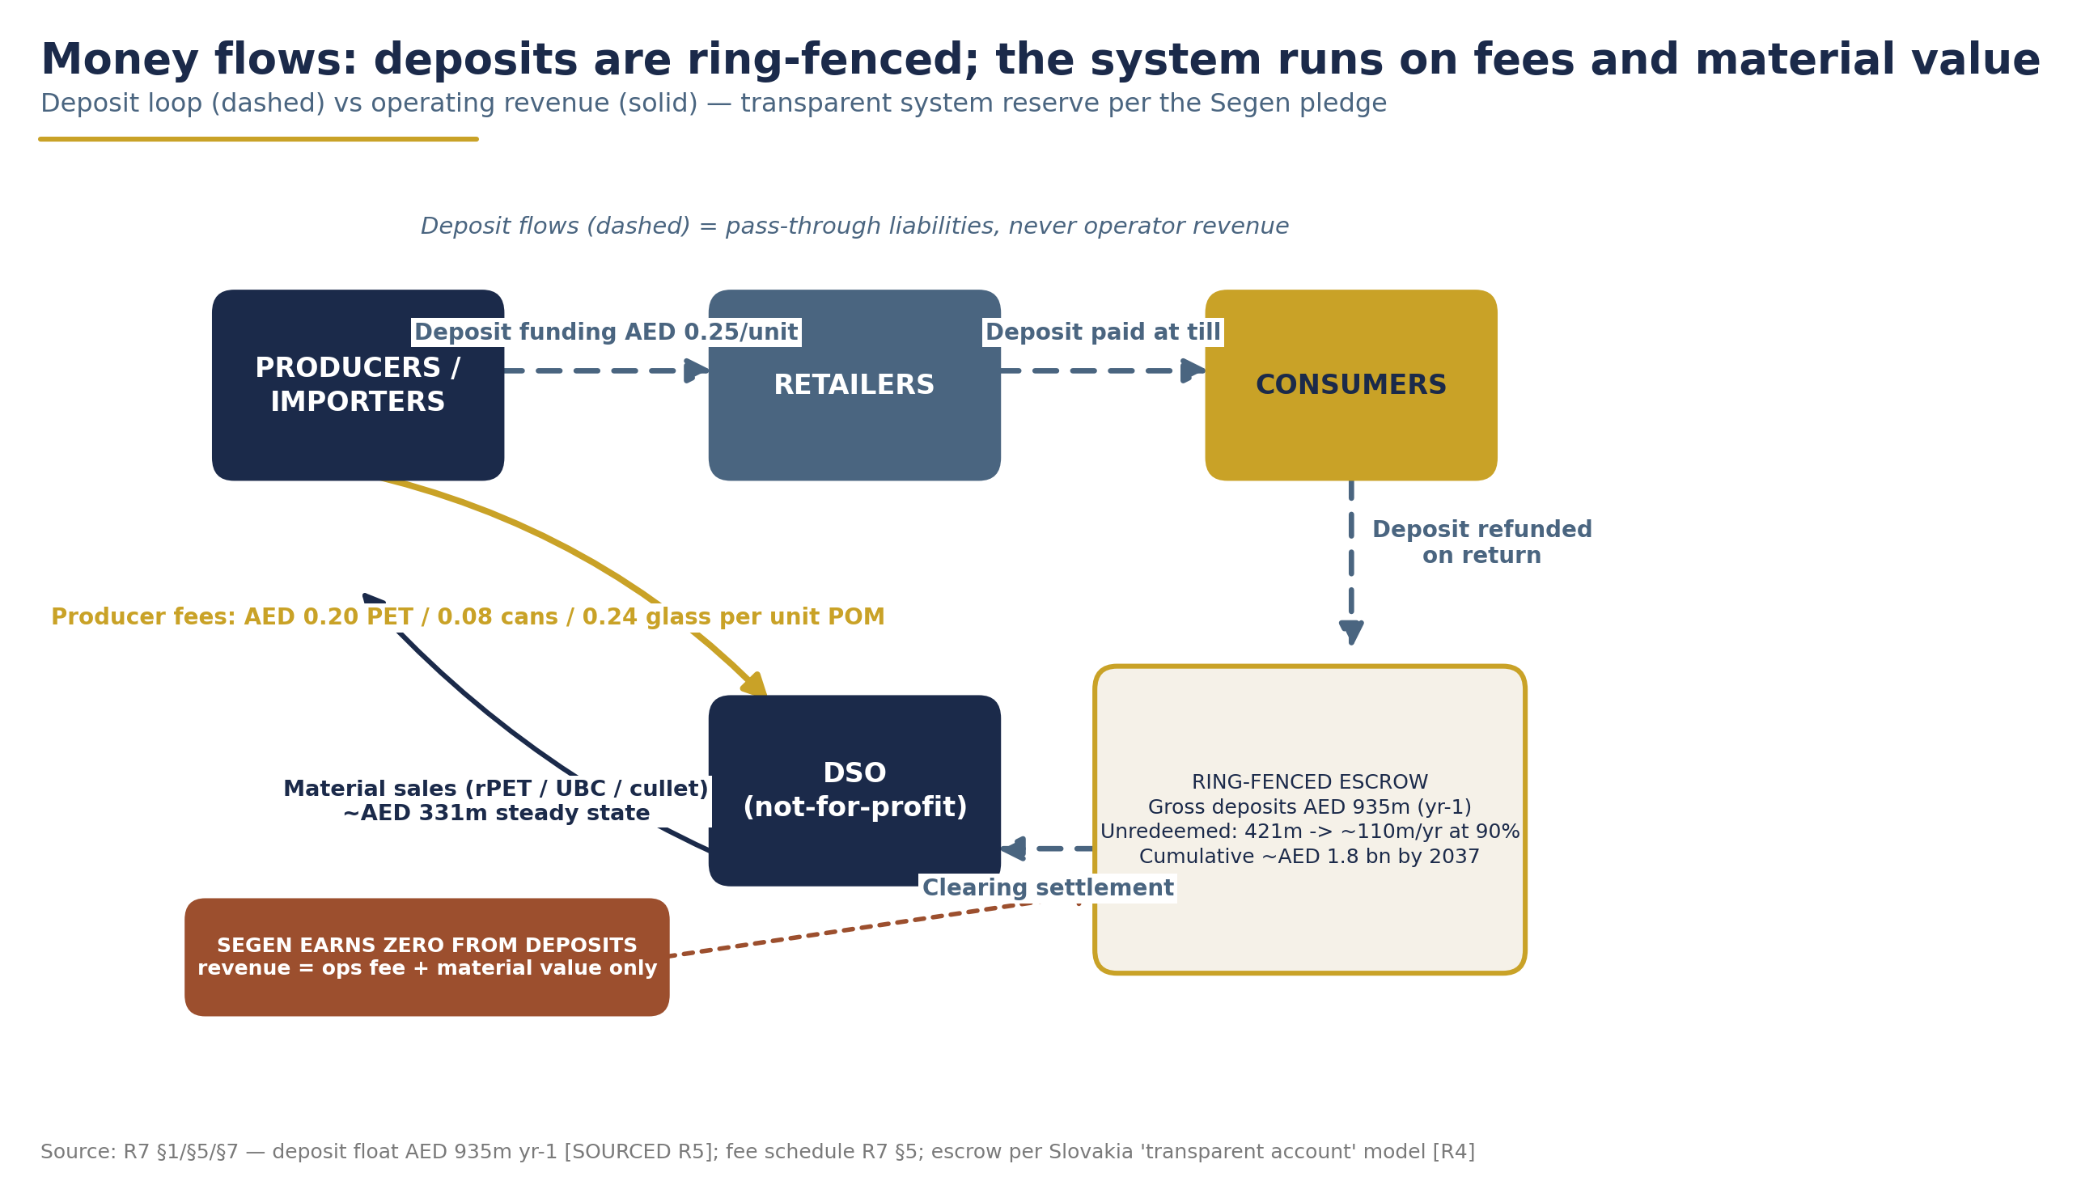
Deposit and fee money flows with ring-fenced escrow - deposit funds are never operator revenue (source: R7 financial model, 2026).

3. Investment & Returns

3.1 System-level economics (context)

Metric | Base case | Source
Total CAPEX | AED 664m (2026: 41 · 2027: 247 · 2028: 279 · 2029: 97) | R7 financial model
- RVM fleet | 3,500 machines, AED 385m (AED 110k installed) | MDPI UAE study (2023); Ireland retailer actuals (Oireachtas, 2026)
- Counting/sorting centres | 3 centres, AED 108m | Romania ~€8-9m per centre benchmark (RetuRO, 2024)
- IT platform | AED 30m | Estimate; Slovakia-type build 6-12 months (Sensoneo, 2022)
- Vehicles & logistics | AED 40m | Backhaul-first design (Lithuania model)
- Setup & contingency | AED 101m | 10% contingency on hard capex
Steady-state OPEX (2034) | AED ~1.08bn/yr (AED 0.29/returned container) | vs Ireland audited €0.053 direct / €0.071 all-in (Re-turn, 2024)
Steady-state revenue (2034) | AED ~1.10bn/yr (70% producer fees / 30% material sales) | R7
System IRR (unlevered) | 27.7% | Front-loaded by ramp-up surpluses; steady-state EBITDA margin ~9-10%
System NPV / payback | +AED 349m @ 8% / 2031 | Lakhan meta-analysis: DRS payback 2-10 yrs internationally (Eunomia, 2025)
Peak funding | AED 294m | R7

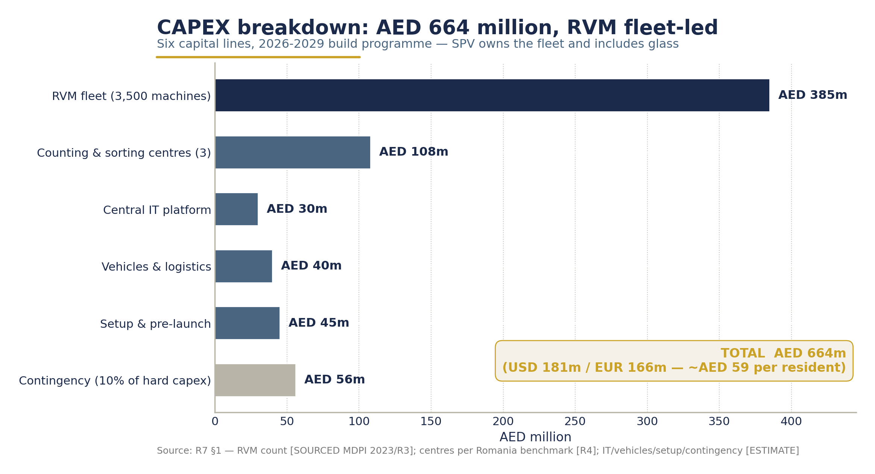
System CAPEX breakdown - AED 664m phased 2026-2029 (source: R7 financial model, 2026).
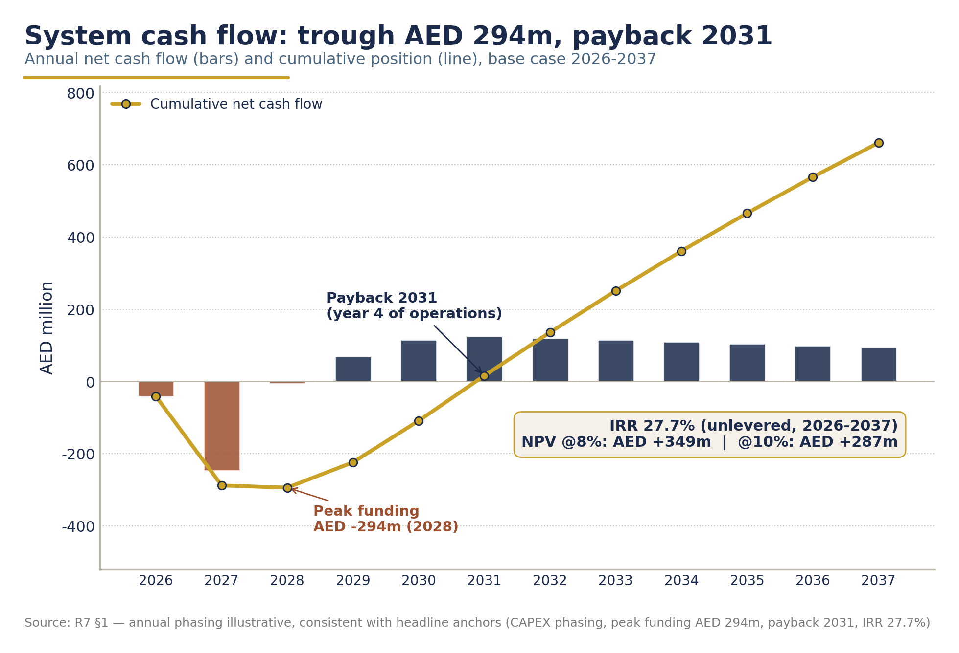
System cumulative cash-flow curve 2026-2037 - peak funding AED 294m, payback 2031 (source: R7 financial model, 2026; annual phasing illustrative).

3.2 Segen-level returns

Metric | Value
Total commitment | AED 150m (AED 135m equity + AED 15m pre-op)
Peak cash outlay | AED 74m
Segen IRR | ~50%
Segen NPV @ 10% | AED +229m
Payback | 2030 - second full year of operations

The ~50% IRR is a property of the asset-light management-contract model, not of aggressive assumptions: the fixed OMF begins at launch regardless of commodity prices, the success fee shares only in realised material revenue, and dividends follow a non-profit-governed SPV whose system IRR is 27.7% on conservative fee and volume decks. In all external communication, the headline figure for the system is 27.7%; the Segen-level IRR belongs in commercial-structure discussions only.
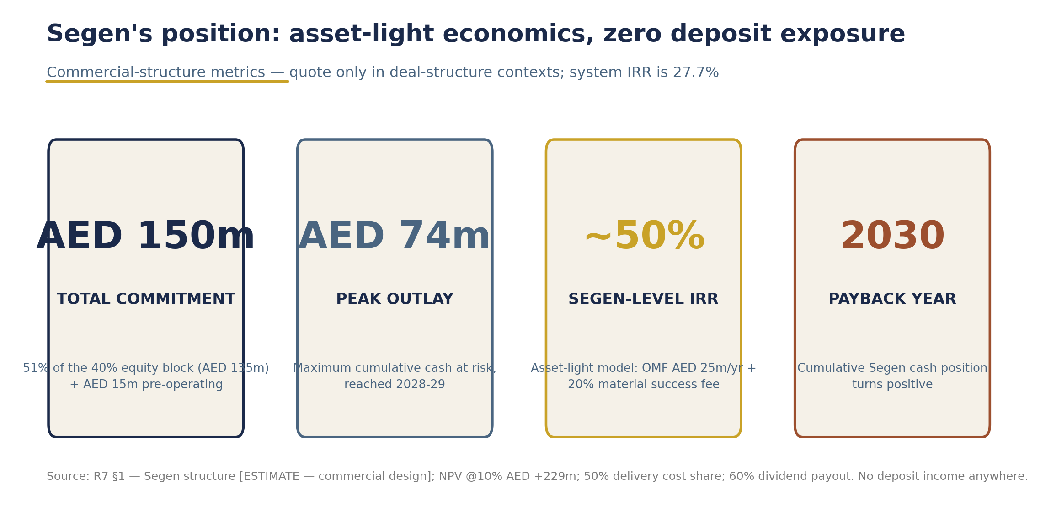
Segen-level returns - AED 150m commitment, AED 74m peak outlay, ~50% IRR, payback 2030 (source: R7 financial model, 2026; commercial design estimate).

3.3 Scenario robustness

 | Conservative | Base | Optimistic
Plateau return rate | 80% | 90% | 91%
Total CAPEX (AED m) | 745 | 664 | 603
Fee review from yr 4 | +20% (cost-recovery reset) | - | −15% (surplus returned to producers)
System project IRR | 2.5% | 27.7% | 67%
System NPV @ 8% (AED m) | −121 | +349 | +976
System payback | 2036 | 2031 | 2029

The conservative case is not a model failure - it is the designed fee-review mechanic at work: when costs outrun fees, the annual cost-recovery formula resets producer fees (+20% from year 4), restoring equilibrium, exactly as Latvia's Deloitte-recalculated fee model does in practice (DIO, 2024). Segen's fixed OMF is insulated from this cycle in both directions.
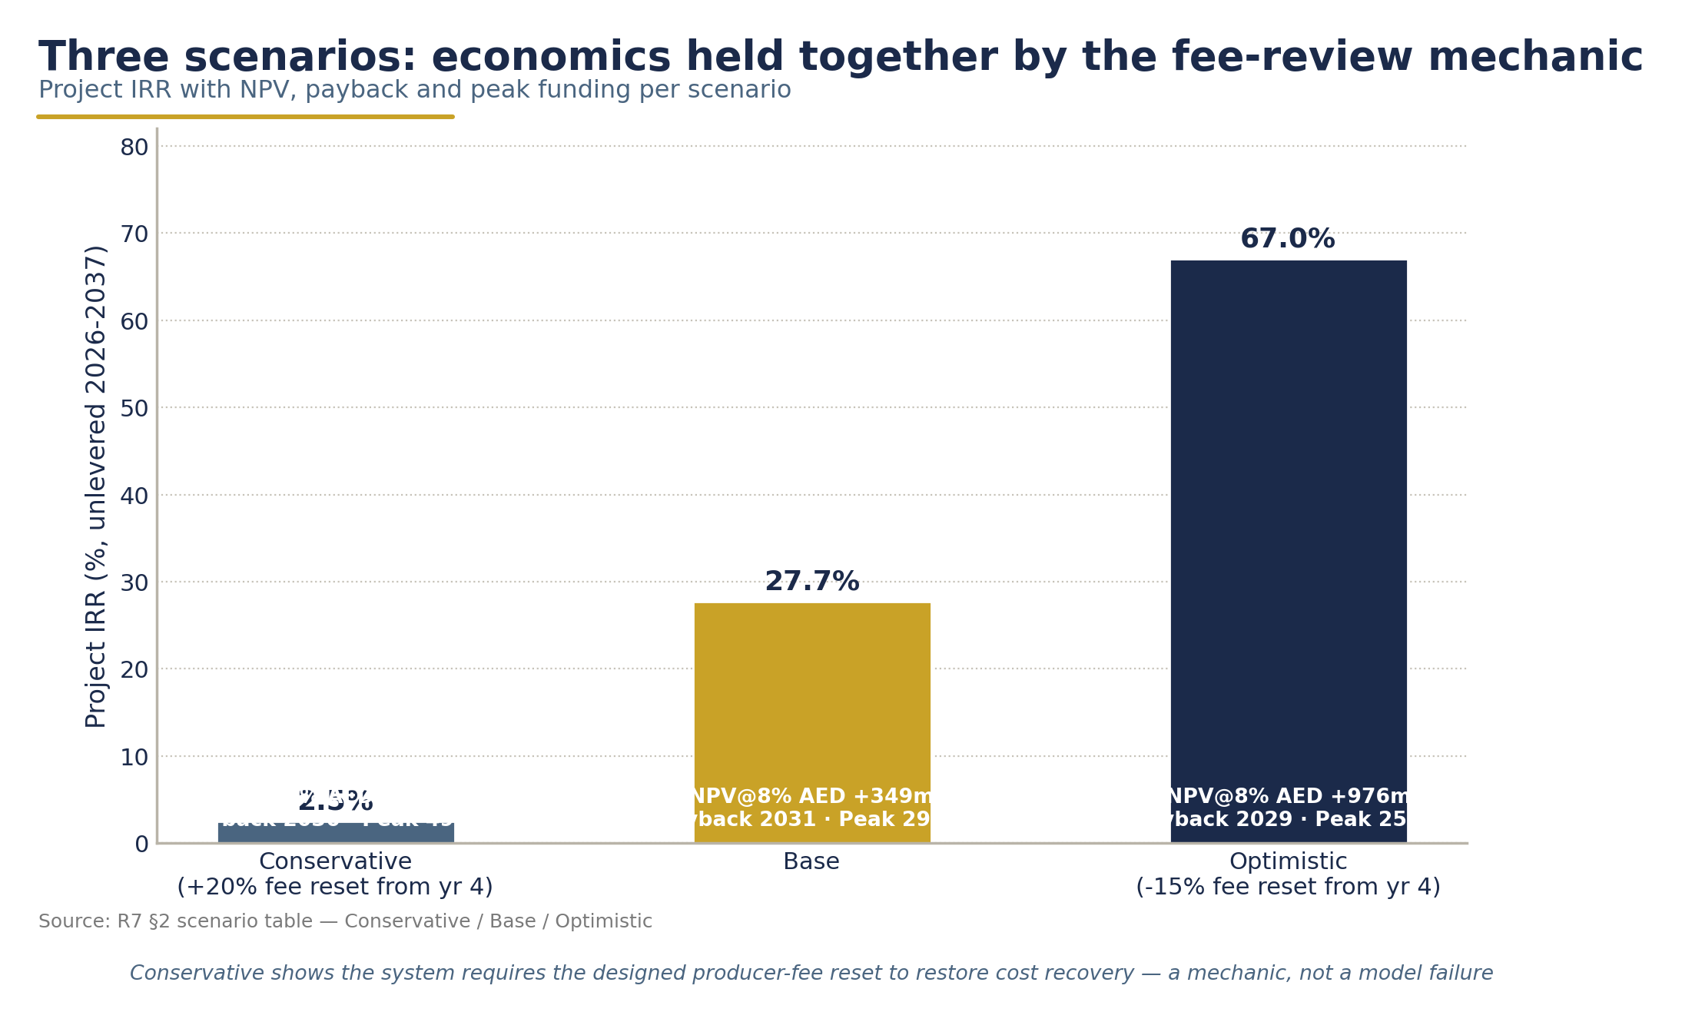
Scenario robustness - conservative / base / optimistic system economics with the fee-reset mechanic (source: R7 financial model, 2026).

4. Revenue Stream Analysis & Durability

4.1 Stream-by-stream assessment
Operations Management Fee - AED 25m/yr fixed.
The anchor. At ~9% of steady-state OPEX it sits within the normal range for operator administration shares (Lithuania's expense mix allocates ~14% to administration (R1 benchmark via R7, 2026)). Because it is fixed, Segen's largest single income line does not care whether rPET trades at $900 or $2,100 per tonne, or whether the return rate is 55% or 90%. Proposed terms (to be negotiated): initial 10-year management agreement with a 5-year renewal option, 2% annual escalation, termination only for material breach with cure periods. [DATA GAP: no verified European benchmark for national DSO management-contract durations; Hungary's MOHU holds a 35-year national concession (KCG Partners, 2023), which indicates the upper end of state-granted tenures.]
Material success fee - 20% of recovered-material sales.
System material revenue reaches AED 331m/yr at steady state (R7 base), implying ~AED 66m/yr to the success-fee pool at maturity - less in ramp-up. Durability drivers:
- DRS bales command a 15-25% quality premium over curbside MRF bales (Polyestertime, 2026) - a structural, not cyclical, advantage.
- Aluminium is the margin engine: UBC at a $1,800/t base (range $1,200-2,050 (Fastmarkets, 2025; Okon Recycling, 2026)) against ~13.5 g/can, with LME aluminium rallying from $2,683 to $3,180/t between October 2025 and January 2026 (SMM/AlCircle, 2026).
- Domestic offtake anchors exist: EGA's Al Taweelah recycling plant (185,000 t/yr, started 2026) for cans, and the Repeet/BEEAH/Agthia food-grade rPET plant (12,000 t/yr) in Abu Dhabi for PET (EGA, 2026; MoIAT, 2023).
- Risk: rPET fell ~12% YoY into late 2025 and German recycled PET touched $1,105/t in Q1 2026 (IMARC, 2026); the model carries ±30% commodity sensitivities and sets the rPET base low at $1,200/t.
Equity dividends.
Residual but compounding: 51% of a 60% payout on SPV profits, with system steady-state EBITDA margin of ~9-10% of revenue. Retained earnings fund the contingency reserve that Ireland was forced to build reactively out of year-1 surpluses (Re-turn, 2024).

4.2 Downside protection architecture
1. Fixed-fee core: OMF pays irrespective of volumes, prices or redemption performance.
2. Cost-recovery fee formula: producer fees are reset annually on audited cost recovery (Ireland/Latvia precedent), so system solvency does not depend on any single assumption.
3. Inverted-sensitivity immunity: because unredeemed deposits are not operator revenue, higher return rates are margin-dilutive to the system at fixed fees - the fee-review mechanic neutralises this for the SPV, and Segen's OMF is indifferent to it entirely.
4. 60% payout cap: 40% of SPV profit is retained, building a self-funded buffer against commodity downturns.
5. Escrow separation: deposit liabilities can never contaminate operator finances - by statute-level design, not policy.
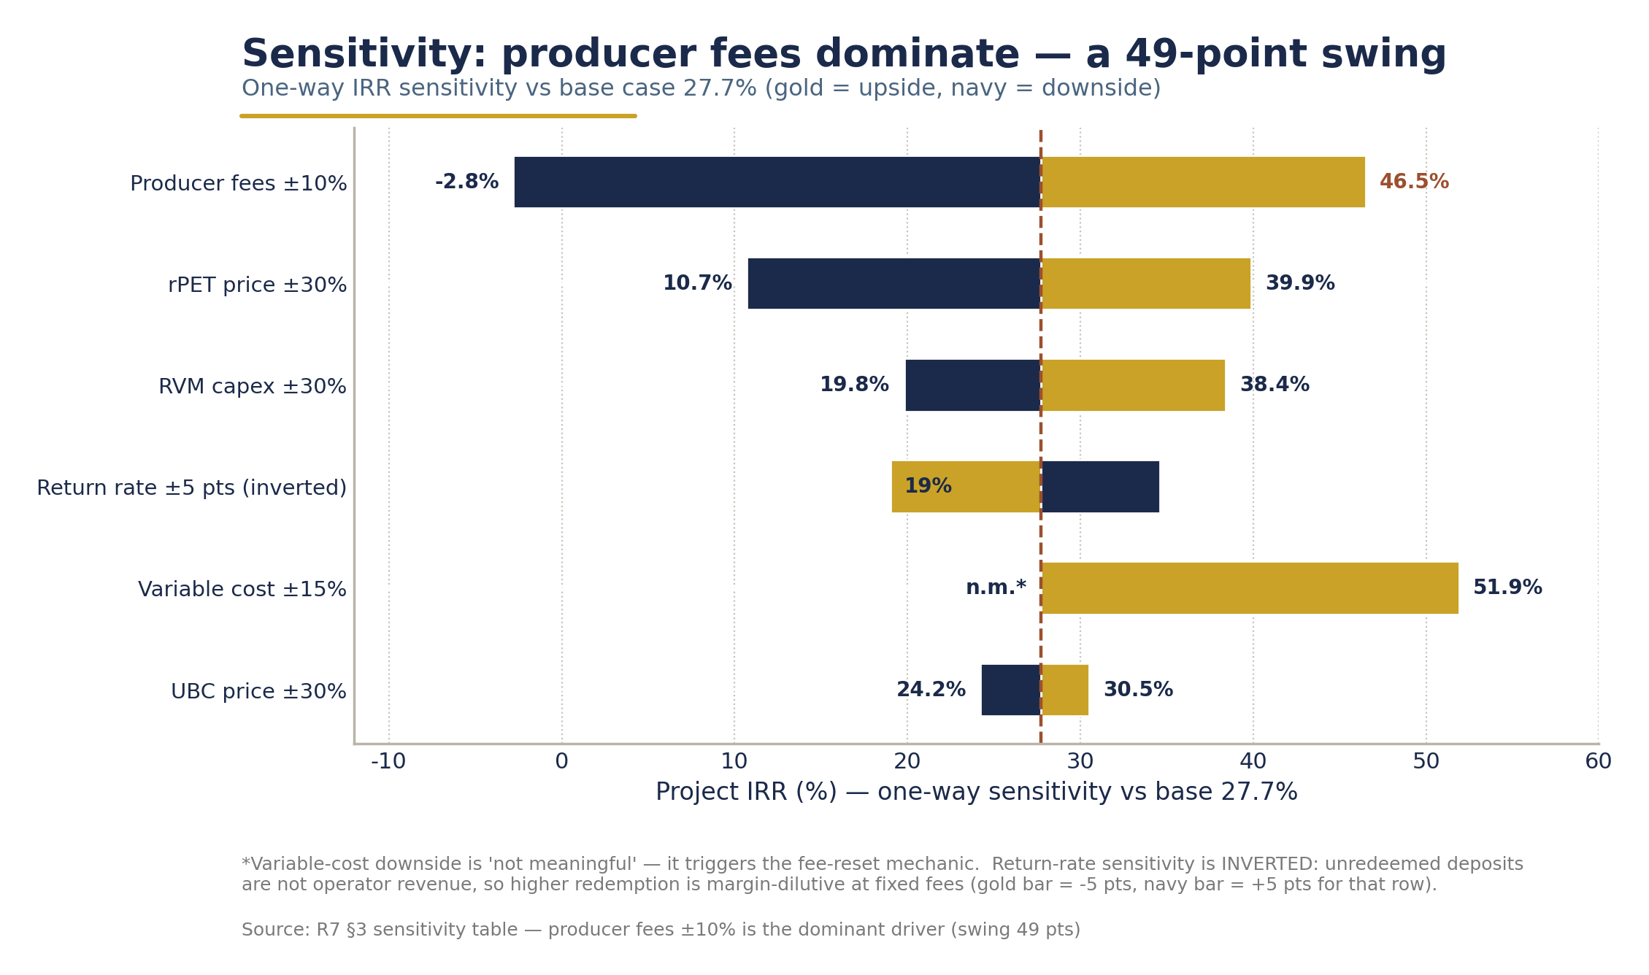
Sensitivity of system IRR to key variables - the fixed OMF insulates Segen from each swing (source: R7 financial model, 2026).

5. Market Opportunity & First-Mover Position in the GCC

5.1 The UAE window - why now
Five verified signals converge in 2026:
1. The legislative runway is clear. The final phase of Ministerial Decision No. 380 of 2022 took effect 1 January 2026, banning single-use plastic cups, cutlery, plates, straws, stirrers and foam containers nationwide - and leaving beverage containers as the dominant remaining single-use packaging stream (Plastics News, 2026).
2. EPR machinery exists. MOCCAE's July 2025 pilot with Tadweer Group as PRO covers packaging across Abu Dhabi and Dubai with 26 companies enrolled (Gulf News, 2025) - exactly the producer-registration and reporting infrastructure a deposit system nests into; UAE advisors already describe DRS as "the foundation for EPR" (Waste & Recycling MEA, 2026).
3. Consumers are proven. Abu Dhabi's incentive-based scheme collected 130+ million bottles through ~150 RVMs with no deposit at all - peak days of 8,500 items per machine (Abu Dhabi Media Office, 2024).
4. Industry is pre-aligned. Coca-Cola Middle East sponsors RVMs with Carrefour and Sparklo; Agthia already markets a 100% rPET bottle; Coca-Cola's global target is 70-75% collection by 2035 (Majid Al Futtaim, 2025; Agthia, 2025; Coca-Cola, 2026).
5. Vendors are on the ground. TOMRA established permanent UAE and Saudi entities in April 2025 and holds an MoU with Tadweer Group for a nationwide voluntary bottle-return programme covering PET, cans and glass (TOMRA, 2025; WAM, 2024).
The addressable base: 3.74 billion containers placed on market at 2028 launch (2.90bn PET, 0.66bn cans, 0.18bn glass), growing 2%/yr, in a country of 11.29 million residents that grew 5.7% in 2024 alone (FCSC via Gulf News, 2024; R7, 2026). [DATA GAP: all PET volumes are modelled, pending producer/importer SKU validation - flagged in every source document.]

5.2 GCC white space

Market | Status (verified as of July 2026) | Implication
UAE | No mandatory national DRS; advanced voluntary schemes; EPR pilot live (R2, 2026) | First-mover position open now
Saudi Arabia | Sector restructured under MWAN (regulator) and PIF-owned SIRC (investor/operator); 82% landfill-diversion target by 2035; SIRC acquired 60% of PET-flake producer Masab (Dec 2025); no confirmed national beverage-container DRS (EnterpriseAM, 2025; ITA, 2026) | Largest regional follow-on market; a Reloop (2024) reference to a KSA deposit policy could not be confirmed
Qatar | No verifiable DRS or container-deposit activity found in 2024-2026 sources (R2, 2026) | White space
Singapore | Licensed-operator national DRS from 1 April 2026 (NEA via Eunomia, 2025) | Proof that the licensed-operator model is moving beyond Europe
Türkiye | ₺1 deposit launched 1 July 2026 (R1 via R7, 2026) | Closest structural analogue (hot climate, tourism, app refunds); year-1 results will inform the UAE year-2 review

The strategic prize extends beyond the UAE P&L: the operator that delivers the first GCC national DRS becomes the reference counterparty for the second and third. Segen's stated primary market - UAE and wider GCC, including Riyadh and Doha (Segen Company Profile, 2026) - maps one-to-one onto this expansion path.

6. Earth Care Consulting Partnership Structure
This section describes a proposed structure for negotiation; nothing below represents executed agreements.

6.1 Complementary roles

 | Segen | Earth Care Consulting
Role | Sponsor, operator, alliance architect, government interface | DRS design & implementation consultancy
Contribution | Capital (AED 150m), GCC stakeholder access, SPV leadership, producer/retailer alliance-building | Technical design, implementation methodology, operating playbooks, expert personnel
Proof base | Alliance-architecture practice across seven GCC sectors (Segen Company Profile, 2026) | 13 years DRS-specialised; founder 10 yrs CEO of Estonian Deposit Organization; 15+ countries; implementation in Lithuania, Latvia, Slovakia, Austria, Portugal; current UK DEFRA mandate (Earth Care Consulting, 2025)

The pairing mirrors Segen's own positioning language: Earth Care is precisely the "international capability" that Segen's mission exists to connect with "Gulf ambition" (Segen Company Profile, 2026). Segen's Project Description independently cites Lithuania - Earth Care's flagship implementation - as its proof example (Project Description, 2026). All live operational photography and video used in the deliverable package derives from Lithuanian/European operations and is presented strictly as European benchmark operations, never as UAE assets.

6.2 Proposed governance, workshare and commercial terms
Governance. A joint Programme Steering Committee (3 Segen / 2 Earth Care during Phases 1-3; rebalancing to 4/1 post-launch as operations nationalise), with defined escalation to the two principals. Key-person clause on the founder level during design and implementation phases.
Workshare (aligned to Earth Care's four-phase roadmap - Feasibility & Design 4-6 months; Legislation & DSO formation 4-10 months; Infrastructure & Technology 8-14 months; Launch & Optimisation 12+ months (Earth Care Consulting, 2025)):
- Phase 1-2: Earth Care leads technical design, fee methodology, handling-fee analysis and IT architecture; Segen leads government negotiation, producer/retailer alliance, capital raising and SPV incorporation.
- Phase 3-4: Earth Care provides implementation support, process and document drafts, fraud/antifraud training and after-go-live support; Segen staffs and runs the SPV.
- Post-launch: Earth Care retained on a declining advisory retainer (proposed 3 years) for fee reviews, eco-modulation design and audit support.
Fees & IP. Proposed: fixed consultancy fee per phase plus a modest success component at financial close and go-live - keeping Earth Care's economics advisory-grade rather than equity-grade, so that operating control and returns sit unambiguously with the sponsor. All UAE-specific design IP (fee models, handling-fee schedules, UAE IT specifications, Arabic/English consumer materials) assigned to the SPV; Earth Care retains its generic methodology and templates. [DATA GAP: no internal document specifies Earth Care's commercial terms; all fee, exclusivity and IP provisions above are proposals for negotiation.]
Exclusivity considerations. Proposed mutual exclusivity for the UAE engagement: Earth Care commits not to advise competing UAE DRS consortia during the engagement; Segen commits to Earth Care as its sole DRS technical partner for the UAE. GCC follow-on markets (KSA, Qatar) to be addressed by a right-of-first-offer framework rather than blanket exclusivity, preserving both parties' regional optionality.

7. Risk Analysis - Segen-Specific

# | Risk | Probability / Impact | Mitigation
1 | Regulatory delay - no federal DRS bill exists today; go-live depends on legislation, which must precede the final business plan (Earth Care Consulting, 2025) | Medium / High | 18-36-month legislation-to-launch norm built into the plan (R4, 2026); phased CAPEX (only AED 41m in 2026) caps pre-legislation exposure; EPR pilot provides a voluntary-regime fallback path via the Tadweer-TOMRA nationwide initiative (WAM, 2024); stage-gate: full equity draw only after law passage
2 | Fee-review risk - the annual cost-recovery reset could compress producer fees and SPV margins | Medium / Medium | Segen's fixed OMF is outside the fee-review mechanism; the conservative scenario shows the reset works upward when needed (+20%) and only downward when the system is in surplus - both directions protect system solvency
3 | Material price cycles - rPET −12% YoY into late 2025; Germany $1,105/t Q1 2026 (IMARC, 2026) | High / Medium | Success fee is only ~one-third of modelled Segen income; rPET base set low ($1,200/t); aluminium cross-subsidy (LME +18.5% Q4-25→Jan-26 (SMM/AlCircle, 2026)); domestic offtake (EGA, Repeet) reduces export-price exposure; ±30% commodity sensitivity modelled
4 | Counterparty / consortium risk - producers, retailers or Tadweer alignment shifts; competing operator bids | Medium / High | Producer-controlled SPV governance gives industry co-ownership from day one (the European key to success (Earth Care Consulting, 2025)); early MoUs via the Bottled Water Business Group and Dubai Chamber channel (R5, 2026); Coca-Cola/Agthia/Majid Al Futtaim already publicly invested in container-return behaviour
5 | Execution risk - first-in-region build; 3,500 RVMs across a hot climate; Segen's first operating mandate | Medium / High | Earth Care implementation playbook (7 national implementations); proven regional vendors (TOMRA licensed in UAE/KSA (TOMRA, 2025); Sensoneo multi-country IT); 10% capex contingency (AED 56m); Gulf-specific installation/shading costed into the AED 110k installed unit price; backhaul-first logistics limits fleet exposure
6 | New-sector credibility risk - ministries question a 2023-founded advisor as operator | Medium / Medium | Addressed in §1.3: escrow pledge, Earth Care credentials, capital-at-risk structure, experienced SPV hires; the UK DEFRA precedent shows governments do entrust DRS design to specialist advisors backed by capable sponsors
7 | Deposit-integrity / fraud risk - cross-border containers from non-DRS GCC neighbours; double redemption | Medium / Medium | Registered-barcode database, RVM compaction at point of return, real-time central reconciliation, unique UAE DRS marking (Romania/Slovakia precedent (Reloop, 2024)); AED 0.25 deposit deliberately kept below fraud-optimising levels (USAD principle); quantified fraud rates are a known global data gap (R4, 2026)
8 | Political economy of deposits - public or media misreads escrow balances as operator profit | Low / High | The zero-deposit-income pledge is contractual, not rhetorical; Slovakia-model transparent account; annual public reporting; Ireland's €66.7m controversy (CSNA, 2025) is the cautionary tale this design pre-empts

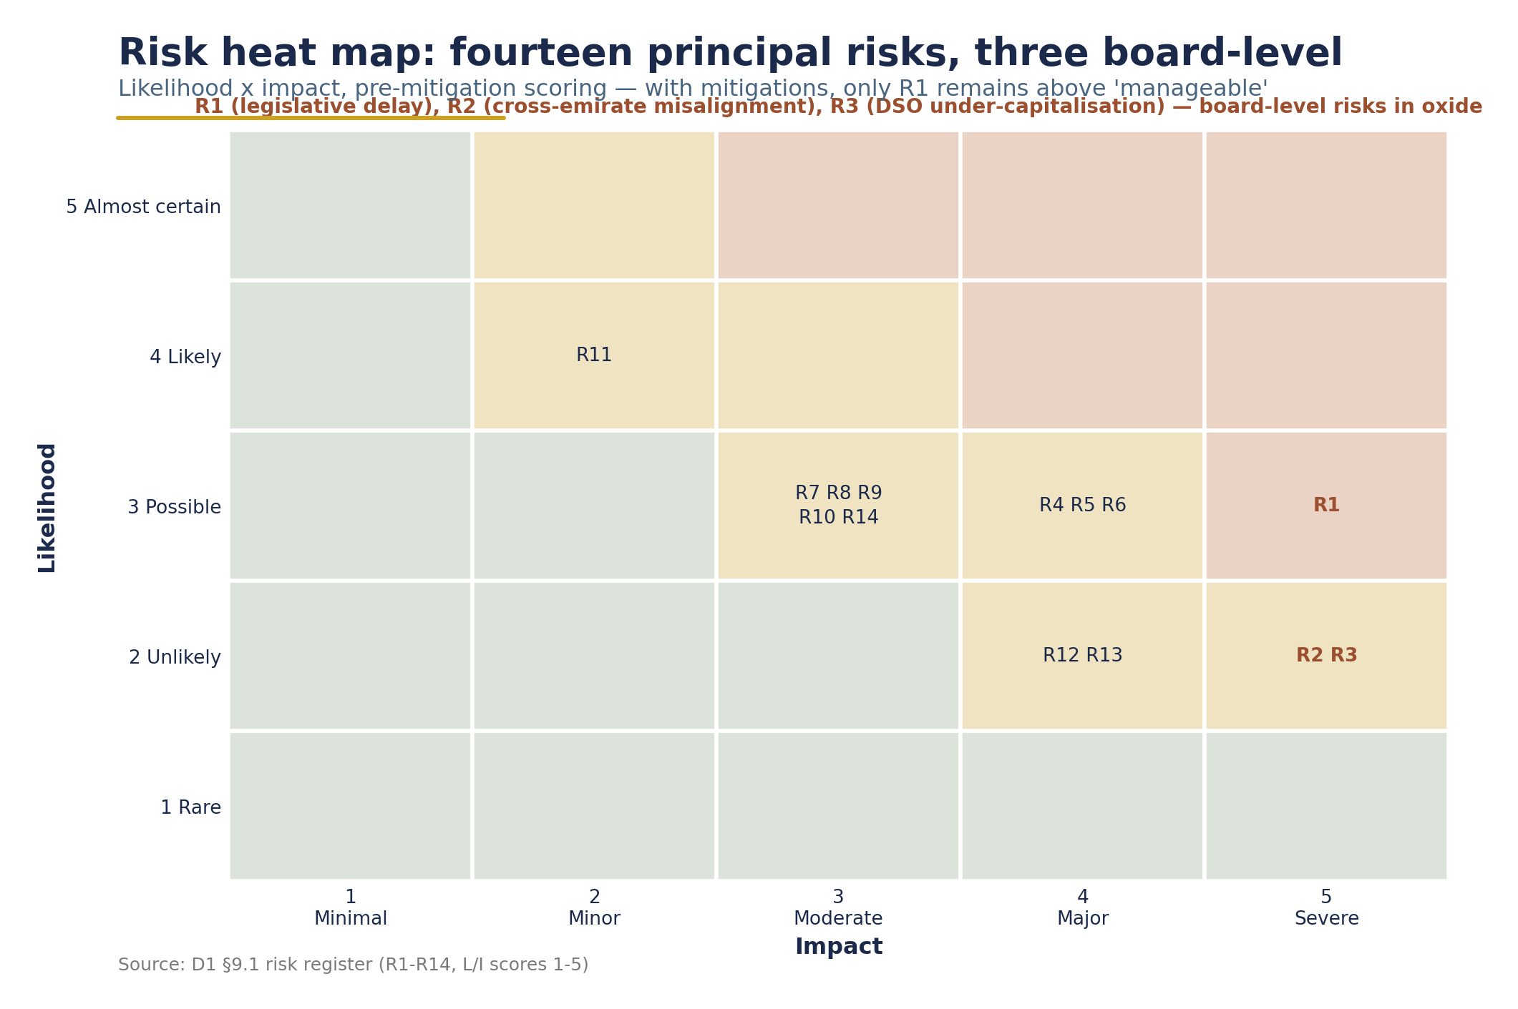
Risk heat map - probability vs impact for the register above, post-mitigation positions (source: D1 risk register / R7, 2026).

8. Funding Plan & Sources

8.1 Sources and uses
Uses (system level): AED 664m CAPEX phased 2026-2029 (41 / 247 / 279 / 97), peak funding requirement AED 294m, covered by the 60/40 structure below plus ramp-up operating surpluses - the documented Ireland pattern, where the operator repaid setup costs from year-1 surpluses (Re-turn, 2024).
Sources (system level):

Source | Share | Anchor
Senior debt | 60% (~AED 398m) | Green-loan structure; 5.5%, 10-year repayment from 2029; RetuRO's €85-90m ING green loan guaranteed by shareholder producers is the direct precedent (Retail-FMCG, 2024)
Equity | 40% (~AED 266m) | Segen 51% of the equity tranche (AED 135m); balance from producer shareholders and co-investors

Segen's own AED 150m (AED 135m equity + AED 15m pre-operating) is planned to be funded from partner capital and Segen's principal network - the firm's Strategic Introductions practice spans sovereign-linked entities, large family offices and institutional capital across the GCC (Segen Company Profile, 2026). Proposed structure, to be confirmed at mandate: a dedicated holding vehicle with staged drawdowns keyed to the legislative stage-gates, so that no more than the AED 15m pre-op tranche is at risk before law passage, and peak cumulative exposure never exceeds AED 74m after SPV-level distributions begin. [DATA GAP: no internal document specifies Segen's own funding sources or co-investor commitments; the above is the proposed plan for negotiation.]

8.2 Why this is financeable
- Concession-grade cash flows: a fixed OMF plus cost-recovery-guaranteed system fees resemble regulated-utility economics more than commodity economics.
- Proven lender precedent: commercial banks have already financed exactly this asset class in Europe (ING/RetuRO), and green/ESG loan frameworks map naturally onto a 90%-capture recycling system with measurable CO₂ avoidance.
- Peak funding is modest: AED 294m system-wide peak - against a steady-state revenue base of AED ~1.10bn/yr - and payback by 2031, inside the 2-10-year international DRS norm (Lakhan meta-analysis via Eunomia, 2025).

9. Five-Year Action Plan for Segen (2026-2031)

Phase | Window | Segen actions | Gate / milestone
0. Mandate & design | H2 2026 - H1 2027 | Execute Earth Care partnership agreement; deliver feasibility & design package to both ministries; open producer dialogue via Bottled Water Business Group / Dubai Chamber; commission producer/importer SKU validation study (closes the PET data gap) | Government endorsement of design; deposit & fee parameters tabled
1. Legislation & SPV formation | 2027 | Support drafting of the DRS decree (DSO mandate, escrow statute on the Slovakia model, fee-review formula); incorporate SPV; sign producer shareholders; appoint CEO & CTO | DRS law enacted - full equity stage-gate opens
2. Build | 2027 - 2028 | Close AED ~398m green debt facility; procure RVM fleet (3,500) and IT platform (6-12-month build (Sensoneo, 2022)); contract 3 counting/sorting centres; sign retail network agreements (Carrefour, LuLu, Spinneys/Waitrose, Union Coop, Choithrams, ADNOC stations (R5, 2026)) | Financial close; network ≥50% contracted
3. Launch | 2028 | National go-live on 3.74bn-unit POM; consumer campaign; year-1 return target 55% | Go-live; escrow account live and audited from day one
4. Ramp & optimise | 2029 - 2031 | Drive return-rate ramp 55%→70%→78%→83%; execute year-2 statutory fee review; introduce eco-modulation; publish annual transparency report; begin KSA/Qatar feasibility watch | Segen payback 2030; system payback 2031; return rate on path to 90% by 2034

Throughout all phases, the same discipline applies: deposits in escrow, fees on cost recovery, surplus retained in the system, and Segen paid for operations and recovered material - nothing else.

10. Conclusion & Recommendation
This study set out to answer a narrow commercial question: is the UAE national DRS a sound business for Segen? The answer is yes, on three independent grounds.
Financially, the base case is unambiguous: AED 150m commitment, AED 74m peak exposure, ~50% IRR, AED +229m NPV @ 10%, payback 2030 - underpinned by a fixed AED 25m/yr management fee that is indifferent to commodity cycles, and by a system whose own economics (27.7% IRR, +AED 349m NPV @ 8%) are built on conservative volume, price and cost decks with an engineered fee-review safety valve.
Structurally, the model converts Segen's two potential weaknesses - youth as a firm and absence from the waste sector - into strengths: the escrow pledge makes it the most trustworthy counterparty in the room, and the proposed Earth Care partnership supplies a decade-deep operating pedigree that no competing GCC consortium can currently match.
Strategically, the UAE is the first move in a GCC sequence. Saudi Arabia and Qatar are verified white space; the operator that proves the model in the Emirates will hold the reference position for the region's largest markets.
Recommendation: PROCEED - subject to three conditions precedent: (i) executed Earth Care partnership on the terms proposed in §6; (ii) ministerial endorsement of the legislative pathway and the escrow/fee-review architecture; and (iii) staged capital drawdowns keyed to the legislative gates defined in §9, capping pre-legislation exposure at AED 15m.
The architecture between governments and operators, between international capability and Gulf ambition - applied, this time, to the bottle in every consumer's hand.

Annex A - Key Figures Register (consistency control)

Figure | Value | Source
System CAPEX | AED 664m | R7 (2026)
RVM fleet | 3,500 machines / AED 385m | R7; MDPI (2023)
Producer fees (non-binding) | AED 0.20 PET / 0.08 aluminium / 0.24 glass | R7 (2026)
Recommended deposit (non-binding) | AED 0.25 flat | R7 (2026)
System IRR / NPV @ 8% / payback | 27.7% / +AED 349m / 2031 | R7 (2026)
Segen commitment / peak outlay | AED 150m / AED 74m | R7 (2026)
Segen IRR / NPV @ 10% / payback | ~50% / +AED 229m / 2030 | R7 (2026)
Segen income model | OMF AED 25m/yr + 20% material success fee + dividends; zero deposit income | R7; Project Description (2026)
Deposit float (memo only) | AED 935m gross yr-1; unredeemed AED 421m yr-1 → ~AED 110m/yr at 90%; escrow ~AED 1.8bn cumulative by 2037 | R7 (2026)
POM at 2028 launch | 3.74bn units (PET 2.90 / cans 0.66 / glass 0.18) | R7 (2026); survey modelled, pending validation
Financing | 60/40 debt/equity, 5.5%, 10-yr from 2029 | R7 (2026); RetuRO precedent (2024)

All operational imagery referenced in the deliverable package depicts European benchmark operations (Lithuanian system), never UAE assets.
End of document - D2 Segen Business Feasibility Study, 26 July 2026.

