
UAE National Beverage Container Deposit Return System (DRS)
Executive Summary for Ministers
Prepared by Segen in partnership with Earth Care Consulting - for the Ministry of Economy & Tourism and the Ministry of Climate Change & Environment
July 2026 · CONFIDENTIAL - for official use only

The opportunity
The UAE places an estimated 3.7 billion single-use beverage containers on its market each year - consumption intensity unmatched anywhere in the world - yet today's voluntary schemes recover only a low-single-digit share of that flow. With the final phase of the federal single-use plastics ban in force since 1 January 2026, beverage containers are the dominant remaining single-use stream - and the only one that can be recovered at 90%+ rates as high-grade industrial feedstock rather than prohibited. Deposit return is the proven instrument for exactly this: a 91% median return rate across European DRS countries against sub-50% for kerbside collection, with more than 400 million people already living in deposit jurisdictions.

The proposal
Segen (Dubai) and Earth Care Consulting (European DRS specialists, with implementation roles in the Lithuanian, Slovak, Austrian and Portuguese launches and a current advisory mandate to the UK Government) propose to design, finance, build and operate the UAE's national DRS as a public-private initiative under federal sponsorship and supervision. The system is deliberately simple for consumers and rigorous for industry:
- A small, fully refundable deposit - recommended reference AED 0.25 flat per container (non-binding, for policymakers' consideration) - applied at purchase and refunded in full on return;
- A national return network of 3,500 reverse vending machines plus ~5,500 manual and HoReCa collection points - approximately 9,000 return points, one per ~1,250 residents - across supermarkets, malls, petrol stations, transit hubs and public locations;
- Three counting and sorting centres (Dubai, Abu Dhabi, Sharjah/Northern Emirates) and a central clearing platform registering every eligible container, deposit transaction and recycled tonne;
- Producer funding: recommended fees of AED 0.20 / 0.08 / 0.24 per PET / aluminium / glass container (non-binding), calibrated for steady-state cost recovery with an annual statutory fee review;
- Governance: a single, not-for-profit Deposit System Operator under two-ministry supervision, with all deposit funds held as pass-through liabilities in transparent escrow. Segen earns zero from unredeemed deposits - its income derives exclusively from operations management and the value of recovered materials.

Headline numbers
# | Metric | Base case
1 | Containers placed on market (2028 launch) | 3.74 billion/yr (PET 2.90 / cans 0.66 / glass 0.18)
2 | Total CAPEX (2026-2029, phased) | AED 664 million (~AED 59 per resident)
3 | Reverse vending machine fleet | 3,500 machines
4 | Return-rate path | 55% (year 1) → 90% by 2034
5 | System project IRR (unlevered) | 27.7%
6 | NPV @ 8% discount rate | +AED 349 million
7 | Payback / peak funding need | 2031 / AED 294 million
8 | Employment | ~1,200-1,500 jobs
All figures per the study's financial model (R7 assumptions memo, 2026). The year-1 deposit float (~AED 935 million gross) is escrowed consumer money - a memo item, never revenue. PET volumes are modelled, pending producer/importer validation.

Strategic alignment
▪ UAE Circular Economy Policy 2021-2031 - delivers the policy's missing operational loop: clean, food-grade recyclate returned to domestic manufacturing, with a ready-made governance home in the Circular Economy Council. | ▪ Net Zero 2050 and NDC 3.0 (−47% GHG by 2035) - a quantified, annually reported waste-sector contribution with audit-grade MRV data under the 2024 Climate Change Law.
▪ The 2025 MOCCAE-Tadweer EPR pilot - the DRS nests directly into the pilot's producer-registration and reporting machinery; DRS producer fees discharge EPR obligations for beverage containers, with no double-charging. | ▪ Regional first mover - the first national, legislated DRS in the GCC; Abu Dhabi's EAD Bottle Return Scheme (23 million units collected in 2024, 100+ RVMs, 2,000+ tonnes recovered since launch) has already proven UAE consumer acceptance - without any deposit.
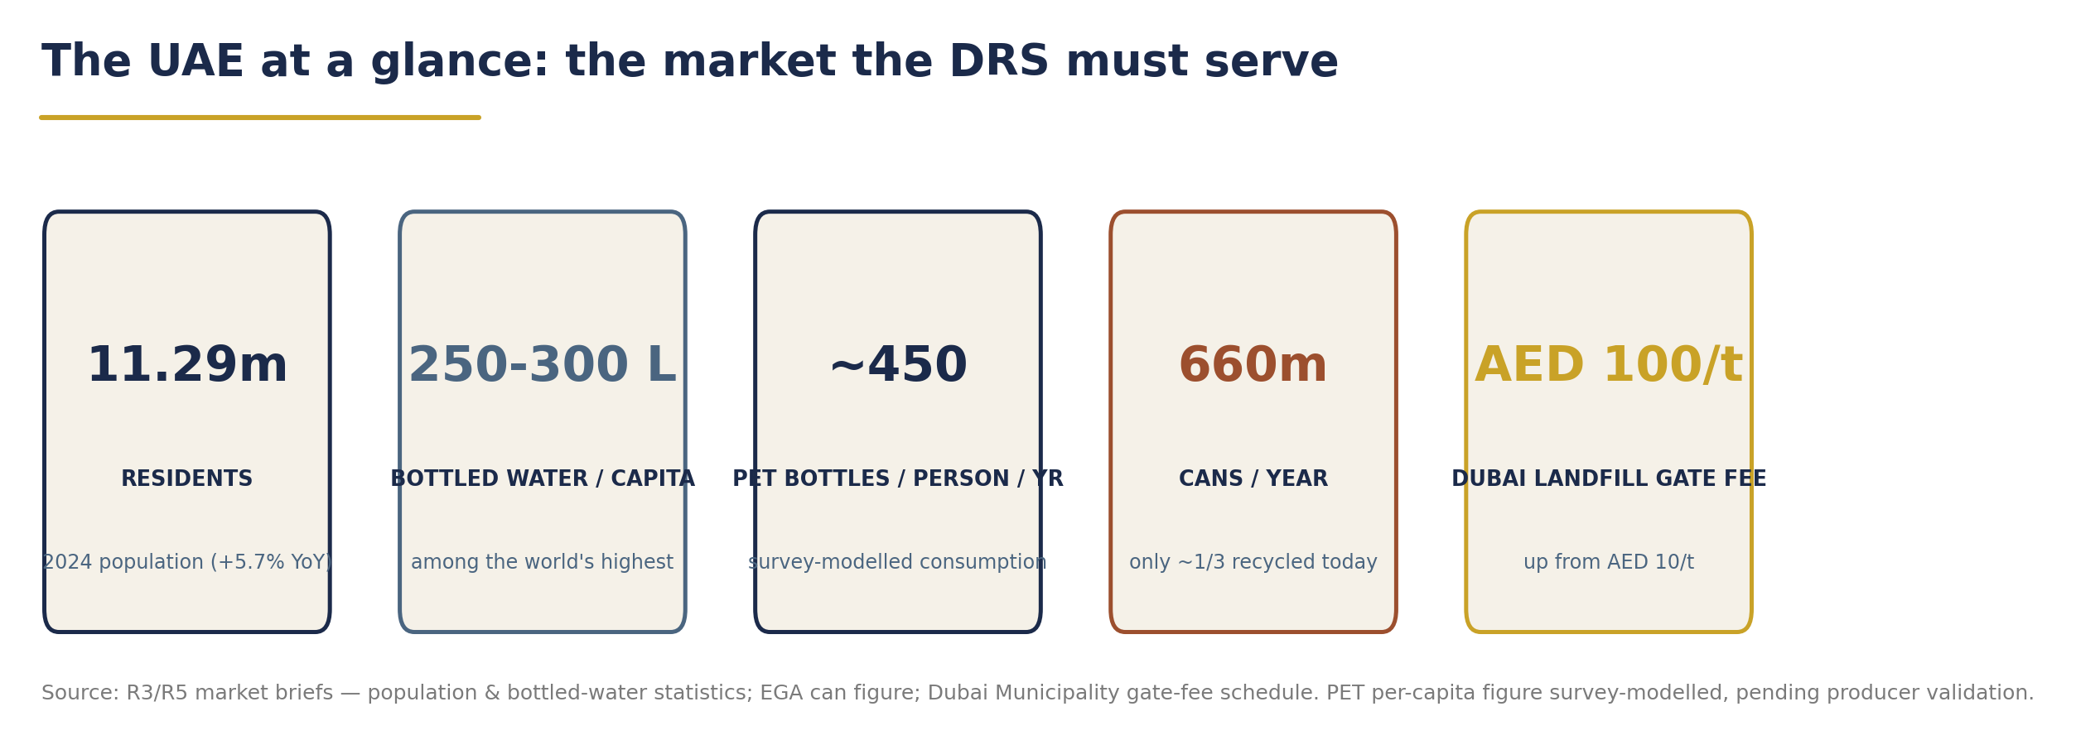
The UAE at a glance - population, consumption intensity and disposal economics (data: R3/R5 market research; full source notes on chart).

The ask
This study respectfully requests that the Ministry of Economy & Tourism and the Ministry of Climate Change & Environment:
1 | Adopt the DRS as the beverage-container instrument of the national Extended Producer Responsibility framework, building directly on the 2025 MOCCAE-Tadweer pilot;
2 | Sponsor enabling legislation - a Cabinet Resolution under Federal Law No. 12 of 2018 establishing the deposit, the system-operator licence and the escrow regime for unredeemed deposits; international experience indicates 18-24 months from political decision to go-live, supporting a 2028 national launch;
3 | Stand up a joint ministerial programme office in H2 2026 to run mobilisation (Phase 0): drafting instructions, emirate engagement and structured stakeholder consultation;
4 | Convene producers, importers and retailers into a design working group under the UAE Circular Economy Council, so the final deposit level, fee schedule and return-network obligations are set with - not for - industry;
5 | Commission validation of container volumes through mandatory producer/importer SKU-level reporting, converting this study's modelled estimates into a verified statutory baseline before fees are fixed.

Why Segen × Earth Care
▪ Local architect, proven implementer. Segen brings UAE alliance architecture and principal representation; Earth Care has designed and launched national deposit systems across 15+ countries - including Lithuania, the closest design template to the UAE proposal (92.3% return rate, built in under two years). | ▪ A binding financial pledge. Zero income from unredeemed deposits - stated in Segen's own Project Description and hard-wired into not-for-profit governance, statutory escrow and independent audit.
▪ Financeable without public subsidy. 60/40 debt/equity on the Romanian green-loan precedent; Segen commits AED 150 million; the system pays back by 2031 and operates at cost recovery under a transparent annual fee review. | ▪ A complete, decision-ready package. Market research, 60-jurisdiction benchmark evidence, a draft legislative outline, a formula-driven financial model, an implementation roadmap and a 14-item risk register - all delivered in the accompanying Master Study.
The window is now. The 2026 plastics ban has cleared the field; the EPR pilot has built the regulatory machinery; consumer behaviour is proven at pilot scale. A national DRS is the logical - and financially self-sustaining - next act of the UAE's circular-economy agenda, and the only major circular-economy deliverable the UAE can bring to 90% performance within a single policy cycle. | 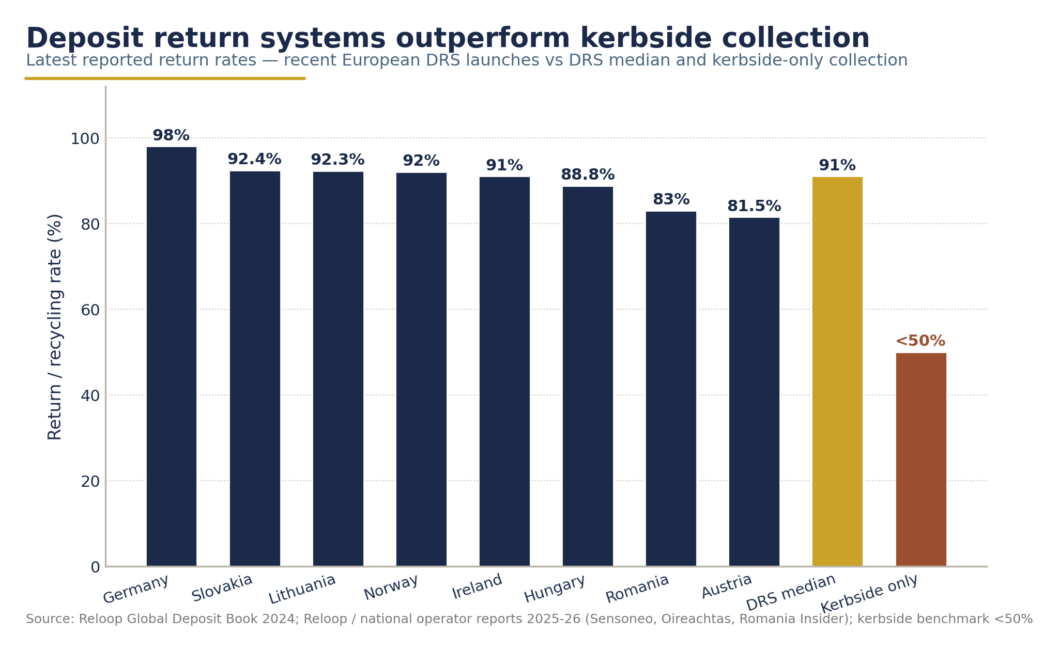  Deposit systems outperform - return rates, DRS vs kerbside (Reloop Global Deposit Book 2024; operator reports 2025-26).
Deposit level and producer fees are non-binding recommendations for policymaker consideration. This summary is derived from Deliverable D1 (Master Study, July 2026); all financial figures trace to the R7 financial assumptions memo and the companion financial model.

