

UAE National Beverage Container
Deposit Return System
Government Approval Pack
Submitted to | Ministry of Economy & Tourism (MOET) · Ministry of Climate Change & Environment (MOCCAE)
Submitted by | Segen Strategic Advisory, with Earth Care Consulting (European DRS experts)
Date | July 2026 (26 July 2026)
Classification | CONFIDENTIAL - for ministerial decision only

CONFIDENTIAL - FOR MINISTERIAL DECISION ONLY

Pack Contents
Part | Document | Purpose | Print format
A | Ministerial Cover Letters (A.1 MOET · A.2 MOCCAE) | Formal submission to each Minister | One page each, ready for signature
B | Decision Memorandum | The decision case: situation, proposal, options, asks, timeline | ≤ 3 pages
C | Draft Regulatory Framework Summary | Instrument pathway + 11-article legislative outline | Reference annex
D | Governance Model Proposal | Not-for-profit DSO, board, supervision, transparency, escrow rules | Reference annex
E | Stakeholder Engagement & Consultation Plan | Stakeholder map, consultation calendar, MoU templates | Reference annex
F | The Ask | Six numbered requests, each assigned to a specific ministry | One page

Financial figures are drawn from the accompanying feasibility-study financial model (base case, July 2026); benchmark evidence from 60 operating deposit-return jurisdictions worldwide.

PART A - Cover Letters to the Ministers


Formal ministerial submissions
A.1 - To the Minister of Economy & Tourism · A.2 - To the Minister of Climate Change & Environment
One page each, ready for signature.
Segen Strategic Advisory - GCC & International
BK Building, Oud Metha, Dubai, United Arab Emirates
Our Ref: SEG/DRS/2026-001/MOET 26 July 2026
His Excellency Abdulla bin Touq Al Marri
Minister of Economy & Tourism
Ministry of Economy & Tourism, Dubai, United Arab Emirates

Subject: Request for ministerial sponsorship of a national public-private Beverage Container Deposit Return and Recycling System (DRS) for the United Arab Emirates
Your Excellency,
Under your chairmanship, the UAE Circular Economy Council has established circularity as "one of the key pillars of the country's new economic model based on knowledge and innovation" (UAE Ministry of Economy, 2024). We write to propose the single most consequential delivery instrument available to that agenda: a national Deposit Return System (DRS) for PET, metal and glass beverage containers, structured as a national public-private initiative under government sponsorship and supervision.
Deposit return systems now operate in 60 countries, states and territories covering more than 396 million people, and are the highest-performing collection instrument ever measured: a 91% median return rate across European DRS countries, against municipal collection programmes that rarely exceed 50% (Reloop, 2024/2026). The policy runway in the UAE is complete - the Circular Economy Policy 2021-2031, the final phase of the single-use plastics ban (in force 1 January 2026), and MOCCAE's first national EPR pilot (July 2025). Beverage containers are the dominant remaining single-use packaging stream, and the logical next step.
Segen, together with Earth Care Consulting - European specialists who have designed and implemented deposit systems in more than 15 countries, including Lithuania, Slovakia, Austria and advisory mandates to the UK Government - has completed a full feasibility and implementation study. The proposed system is producer-funded at no cost to the federal budget: approximately AED 664 million of private capital investment, 3,500 reverse vending machines, roughly 1,200-1,500 jobs, and a financially self-sustaining not-for-profit operating structure. Deposit funds are never operator revenue: they circulate between producers, retailers, consumers and a transparent escrow account, in which Segen holds no interest (Part D.1).
We respectfully request that the Ministry of Economy & Tourism:
1. Sponsor the initiative and present it to the UAE Circular Economy Council for endorsement;
2. Co-champion, with MOCCAE, the regulatory pathway described in the enclosed Decision Memorandum;
3. Nominate a focal point to the joint government working group proposed in Part F.
A decision memorandum, regulatory framework summary, governance proposal and consultation plan are enclosed. We would be honoured to present the full study to Your Excellency at your convenience.
Respectfully,
___________________________ | ___________________________
Saif Bin Khadia | Amr Konsowa
Managing Partner, Segen | Managing Director, Segen
Enclosures: Parts B-F of this Approval Pack; Feasibility & Implementation Study (companion volume)
Segen Strategic Advisory - GCC & International
BK Building, Oud Metha, Dubai, United Arab Emirates
Our Ref: SEG/DRS/2026-002/MOCCAE 26 July 2026
Her Excellency Dr. Amna bint Abdullah Al Dahak
Minister of Climate Change & Environment
Ministry of Climate Change & Environment, Dubai, United Arab Emirates

Subject: Request for regulatory approval and supervisory mandate for a national Beverage Container Deposit Return and Recycling System (DRS)
Your Excellency,
Under your leadership, the UAE has completed the region's most ambitious single-use plastics phase-out - culminating in the nationwide ban in force since 1 January 2026 - and launched the country's first Extended Producer Responsibility pilot, with packaging in scope and 26 companies participating (Gulf News, 2025). Your Excellency framed that agenda as designing "waste and pollution out of its systems". We write to propose the instrument that completes it for the highest-risk litter stream of all: beverage containers.
Beverage packaging ranks first in litter studies worldwide (Earth Care Consulting, 2025). Abu Dhabi's incentive-based scheme has proven public willingness - more than 130 million bottles collected without any deposit obligation (Abu Dhabi Media Office, 2024) - but voluntary schemes plateau near 50% capture, against a 91% median for deposit systems; the country evidence (Lithuania, Hungary, Ireland) is set out in Part B (Reloop, 2026).
The enclosed proposal nests directly inside your existing architecture: it operates as the delivery mechanism for EPR on beverage packaging under Federal Law No. 12 of 2018 on Integrated Waste Management, contributes measurably to the National Agenda for Integrated Waste Management and NDC 3.0, and places supervision where it belongs - with your Ministry. The system is not-for-profit and producer-funded; deposit monies are held in a protected escrow account outside the operator's balance sheet, and Segen will earn nothing - directly or indirectly - from deposits, the float, or unredeemed balances (binding pledge, Part D.1).
We respectfully request that the Ministry of Climate Change & Environment:
1. Grant regulatory approval in principle for a national DRS covering PET, metal and glass beverage containers;
2. Assume the federal supervisory mandate over the system's operator, targets and escrow, as detailed in Parts C and D;
3. Integrate the DRS into the national EPR framework as the compliance pathway for beverage packaging;
4. Nominate a focal point to the joint government working group proposed in Part F.
We would be privileged to present the study to Your Excellency and your technical teams.
Respectfully,
___________________________ | ___________________________
Saif Bin Khadia | Amr Konsowa
Managing Partner, Segen | Managing Director, Segen
Enclosures: Parts B-F of this Approval Pack; Feasibility & Implementation Study (companion volume)

PART B - Decision Memorandum

To: The Minister of Economy & Tourism; The Minister of Climate Change & Environment
From: Segen Strategic Advisory × Earth Care Consulting
Purpose: Decision on sponsorship, regulatory approval and supervision of a national beverage-container DRS
Length: 3 pages

B.1 Situation
• The UAE has no federal DRS legislation and no binding beverage-container collection target as of July 2026 (ESG WISE, 2025). The final phase of Ministerial Decision No. 380 of 2022 banned single-use cups, cutlery, plates, straws and foam containers from 1 January 2026 - leaving PET, metal and glass beverage containers as the dominant remaining single-use packaging stream (Plastics News, 2026).
• The UAE generates an estimated 1.76-2.3 kg of municipal waste per person per day, among the world's highest (Razaviarani et al., 2025). Modelled DRS-eligible flows are ~3.74 billion containers per year (2.90bn PET, 0.66bn cans, 0.18bn glass) at 2028 launch; only about one-third of aluminium cans are recycled today and no verified national PET bottle recycling rate exists (Emirates Global Aluminium, 2024; UAE DRS Market Survey, 2026). [DATA GAP: no official UAE beverage-container recycling baseline; survey volumes are modelled and require producer/importer validation]
• The institutional machinery is ready: MOCCAE's EPR pilot with Tadweer Group as Producer Responsibility Organisation (packaging in scope, 26 companies, July 2025) creates the producer-registration and reporting spine into which a deposit system nests naturally (Gulf News, 2025). Regional momentum is real: Türkiye launched a nationwide system on 1 July 2026; Saudi Arabia is restructuring its waste sector.

B.2 Proposal
A national, day-one Deposit Return System covering PET, metal and glass containers (0.1-3 L), operated by a single, centralised, not-for-profit Deposit System Operator (DSO) under federal supervision, financed by producer fees and recovered-material value, with:

Headline | Value
Total private CAPEX | AED 664m (~AED 59 per resident), phased 2026-2029
Infrastructure | 3,500 RVMs + ~5,500 manual/HoReCa points ≈ 9,000 return points; 3 counting/sorting centres (Dubai, Abu Dhabi, Sharjah/Northern Emirates)
Recommended deposit | AED 0.25 flat (non-binding reference for policymakers)
Producer fees (reference) | AED 0.20 PET / 0.08 aluminium / 0.24 glass per container
System economics | IRR 27.7% · NPV @8% +AED 349m · payback 2031 · peak funding AED 294m
Steady state (2034) | Revenue ~AED 1.10bn/yr (70% producer fees, 30% material sales); OPEX ~AED 1.08bn/yr; 90% return rate
Employment | ~1,200-1,500 jobs
Deposit float (memo - never revenue) | Gross AED 935m in year 1, held in transparent escrow; cumulative escrow ~AED 1.8bn by 2037

IRR is front-loaded by ramp-up surpluses (producer fees accrue on all units placed on market while costs accrue only on returned units); steady-state EBITDA margin is ~9-10% of revenue. Deposit funds are pass-through liabilities held in escrow; unredeemed balances accrue to a transparent system reserve, never to Segen or the operator - the binding pledge is set out verbatim in Part D.1.

B.3 Options considered
Option | Assessment
1. Voluntary-only continuation | Rejected - the evidence is a plateau, not a pathway. Abu Dhabi's best-in-region scheme collected ~130m bottles over two years - a single-digit share of a multi-billion-unit annual flow (Abu Dhabi Media Office, 2024). Voluntary and kerbside programmes rarely exceed 50% against the 91% DRS median (Reloop, 2024); the Netherlands imposed a mandatory deposit after voluntary measures failed, and every fast-ramping new system - Romania 83%, Hungary 88.8%, Austria 81.5% year 1 - is mandatory and deposit-based (Reloop, 2026).
2. Extended EPR without deposit (fee-only PRO) | Rejected as primary route. Fee-only EPR funds collection but does not change consumer behaviour at the point of disposal; Spain's fee-only system achieved 41.3% plastic-bottle collection against a 70% statutory target, triggering a mandatory-DRS decision (RTVE, 2024). A DRS is the compliance mechanism that makes EPR targets achievable; UAE advisors themselves describe DRS as "the foundation for EPR" (Waste & Recycling MEA, 2026).
3. Emirate-by-emirate adoption | Rejected. Beverage distribution is national; fragmented schemes create label, fraud and clearing chaos. Scotland's solo launch - ahead of UK-wide alignment - collapsed with £86.2m in liabilities (Insider, 2023). All recent successful launches (Lithuania, Slovakia, Malta, Romania, Hungary, Ireland, Austria, Türkiye) were national from day one (Reloop, 2026).
4. National mandatory DRS (recommended) | Adopt. Single not-for-profit DSO; producer-funded; federal supervision; day-one national scope covering PET, metal and glass. Proven in 60 jurisdictions; closest structural analogue (Türkiye - hot climate, tourism-heavy, app-based refunds) launched this month (Trbusiness, 2026).

B.4 What is requested from each ministry
Ministry | Requested action
Economy & Tourism | Sponsor the initiative; table it at the UAE Circular Economy Council; co-champion the Cabinet instrument; support siting facilitation with major retail groups
MOCCAE | Approve in principle; take the federal supervisory mandate; integrate the DRS into the national EPR framework as the beverage-packaging compliance pathway; lead the Cabinet Resolution process
Joint | Form a joint working group within 30 days; confirm the instrument pathway (Part C) within 90 days

B.5 Decision timeline
Milestone | Date
Ministerial in-principle decision | September 2026
Joint working group constituted | October 2026
Instrument pathway confirmed + consultation opens (Part E) | Q4 2026
Cabinet instrument adopted; DSO licensed | Mid-2027
Infrastructure build-out & registration | 2027-H1 2028
National go-live | 2028 (international norm: 18-24 months from political decision - Earth Care, 2025; Lithuania needed ~18, USAD 2019)

Decision sought: approval in principle to proceed on the timeline above. Every month of delay defers ~90% capture of a ~3.7-billion-unit annual stream and cedes first-mover position in the GCC.
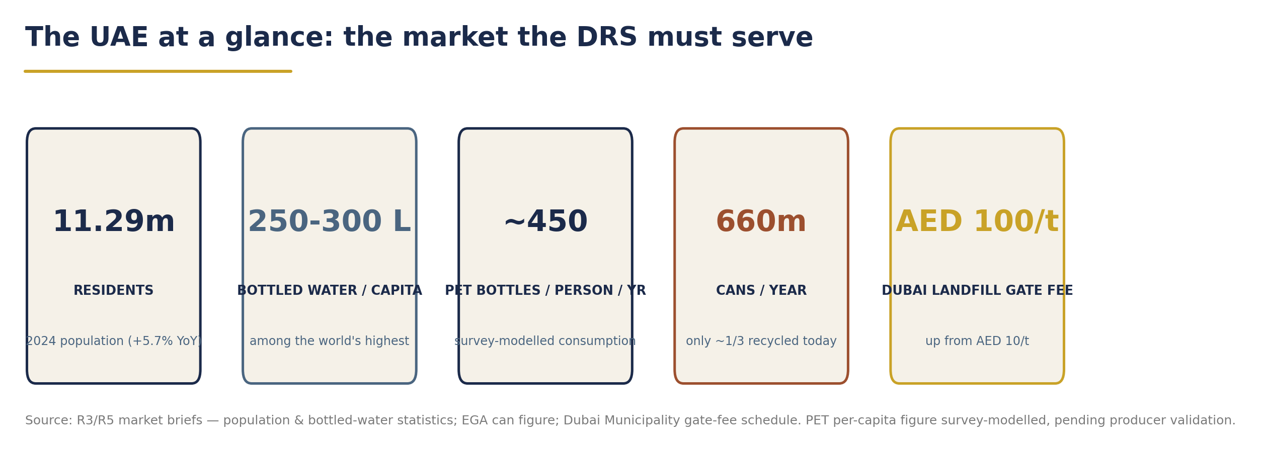
Exhibit B-1 - The UAE market at a glance (modelled estimates; see the Part B.1 data-gap note).
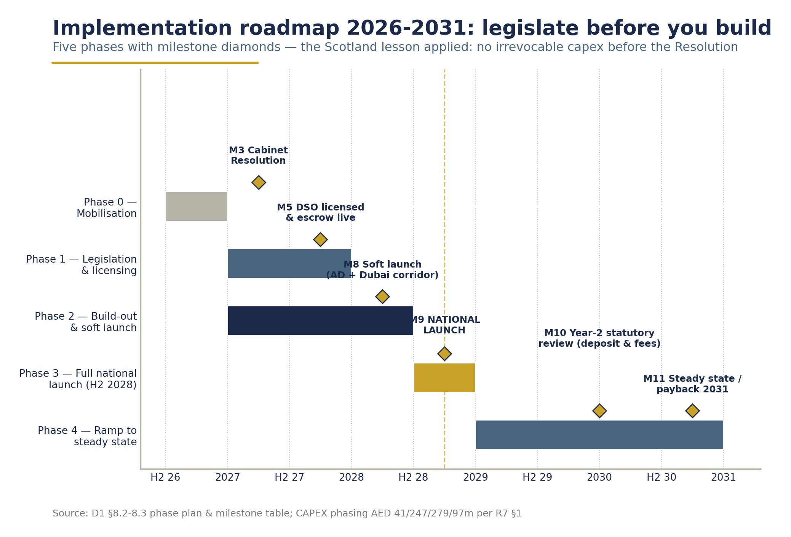
Exhibit B-2 - Decision-to-launch roadmap, 2026-2028 (political decision to national go-live).

PART C - Draft Regulatory Framework Summary
Plain-language legislative outline for policymaker review. Not a draft law; the instrument text would be developed with ministerial legal teams.

C.1 Proposed instrument pathway
Route | Characteristics | Recommendation
Cabinet Resolution under Federal Law No. 12 of 2018 on Integrated Waste Management | Fastest route; the 2018 law is the anchor federal statute standardising waste management across all seven emirates and is the cited legal basis of the incoming EPR framework (ESG WISE, 2025); precedent: Ministerial Decision No. 380 of 2022 delivered the phased single-use plastics bans without a new primary law | Recommended primary route. A Cabinet Resolution can establish the DRS mandate, scope, targets, DSO licensing and escrow rules, in direct continuity with the 380/2022 playbook
Federal Decree-Law | Heavier, slower; appropriate if government prefers to embed DRS and EPR together in primary legislation, or to legislate penalty regimes beyond existing powers | Fallback: a combined "Circular Economy Implementation" decree-law, aligned with the national EPR framework expected from 2026 (ESG WISE, 2025)

Recommendation: adopt the Cabinet Resolution route now, and let the forthcoming national EPR framework formally recognise the DRS as the beverage-packaging compliance mechanism. This preserves speed (Lithuania legislated-to-launch in ~18 months, USAD 2019) while the EPR architecture matures around it.

C.2 Legislative outline (11 articles, plain language)
1. Purpose & scope. A national deposit return obligation on one-way PET, metal and glass beverage containers of 0.1-3 L placed on the UAE market; beverages in scope: water, soft drinks, juices, energy and sports drinks, beer and malt beverages. (Lithuania/Romania/Hungary all three-material precedents, GDB 2024.)
2. The deposit. A refundable deposit, set by the Cabinet on ministerial recommendation - the study's non-binding reference is AED 0.25 flat (strong enough to change behaviour at UAE income levels, low enough to limit cross-border fraud incentive; Lithuania's fraud-balance principle, USAD 2019). Deposit value reviewable every two years.
3. Obligated parties. Producers and importers must register every SKU (barcode-level) with the DSO, mark containers with the national deposit mark, and pay producer fees on all units placed on market (Hungary MOHU monthly-fee model, GDB 2024).
4. Retail take-back duty. Retailers above a shop-floor threshold must accept returns of all in-scope materials (return-to-retail norm; exemptions for small formats, with alternative return points - Lithuania 150 m rule, GDB 2024). Retailers receive a cost-only Retail Handling Fee (~AED 0.10/container reference level, Ireland-calibrated).
5. The DSO. A single, licensed, not-for-profit Deposit System Operator operates the system: registration, clearing, logistics, counting centres, data, reporting. Licensing conditions in Part D.
6. Deposit protection & escrow. All deposit monies are segregated pass-through liabilities, held in a ring-fenced escrow account under supervision-approved banking arrangements; unredeemed deposits accrue to a transparent system reserve for system benefit (Slovakia "transparent account" model; Portugal's transfer of excess unredeemed balances to a state environment fund is an alternative, GDB 2024). No unredeemed deposit may flow to the operator or any private party as income.
7. EPR alignment. DRS participation constitutes compliance with beverage-packaging obligations under the national EPR framework (building on the MOCCAE-Tadweer pilot, Gulf News 2025); fees are set on an annual cost-recovery formula with ministerial approval (Ireland/Deloitte methodology precedent).
8. Data & reporting. DSO publishes audited annual returns: units placed on market, return rates by material and emirate, material destiny, escrow movements. Data architecture compatible with Federal Decree-Law No. 11 of 2024 (Climate Change Law) MRV needs.
9. Enforcement & penalties. Graduated administrative penalties for non-registration, free-riding, deposit-mark counterfeiting and escrow breaches. [DATA GAP: penalty bands to be settled with legal counsel; the AED 100,000-1,000,000 EPR range circulating in advisory material comes from a single secondary source (ESG WISE, 2025) and must be verified against the final EPR regulation]
10. Emirate implementation. Federal framework executed through implementation agreements with each emirate - Tadweer Group (Abu Dhabi), Dubai Municipality under Law No. (18) of 2024, BEEAH (Sharjah) and the Northern Emirates authorities - covering siting, logistics integration and municipal interfaces (Tadweer 2025; Dubai Legislation Portal, 2024).
11. Review. Statutory review at year 2: deposit level, fee reset, scope extensions (eco-modulation, additional streams).

PART D - Governance Model Proposal

D.1 The operating entity: a single, not-for-profit DSO
International best practice is unambiguous: the highest-performing systems are run by one centralised, not-for-profit, industry-participating operator - Lithuania (USAD), Norway (Infinitum), Slovakia, Estonia, Ireland (Re-turn), Malta (GDB 2024). Romania adds a 20% state shareholding (Environment Ministry) alongside 80% industry - the closest governance analogue to the proposed UAE public-private structure (Climate Change Summit, 2025). We propose:
UAE DSO - a not-for-profit special-purpose entity, licensed by MOCCAE, operating under a federal DRS charter.
• Surplus rule: any operating surplus is retained in the system (fee reductions, network investment, awareness) - the non-profit principle behind every top performer (Earth Care, 2025).
• Segen's role: alliance architect and operations manager under a transparent management contract. Segen's income = operations management fee + share of recovered-material value. Segen earns nothing - directly or indirectly - from deposits, the float, or unredeemed balances. This is a binding design pledge, stated verbatim in the Project Description: "Segen will not generate profit from unclaimed or unredeemed deposits… deposit funds move between producers, importers, retailers, consumers, and the system administrator and are not treated as operating revenue for the project operator."
• Because unredeemed deposits are not operator income in the UAE design, producer fees are calibrated for steady-state cost recovery - the deliberate reason UAE reference fees (AED 0.20/0.08/0.24) sit toward the top of the EU range (Lithuania funds 17% of system costs from unredeemed deposits; the UAE replaces that share with fees).

D.2 Proposed board composition (9 seats)
Seat | Holder | Rationale
1 (Chair) | Independent, jointly appointed by the two ministries | Public-interest anchoring
2-3 | MOCCAE + MOET observers/representatives (Romania 20%-state precedent) | Supervisory line-of-sight without operational burden
4-5 | Producer/importer associations (incl. the Bottled Water Business Group under Dubai Chamber) | Producer-controlled PRO is a global success key (Earth Care, 2025)
6 | Retail association representative | Return-to-retail network stewardship
7 | Recycling/waste-management sector (Tadweer, BEEAH or emirate counterparties) | Logistics and material-destiny integration
8 | Consumer/public-interest representative | Accountability to the public
9 | DSO Chief Executive (ex officio, non-voting) | Management accountability

D.3 Government supervisory role
• MOCCAE: licensing and revocation; approval of producer-fee schedules (annual cost-recovery review); target-setting (recommended statutory ramp: 55% year 1 → 80% by year 4 → 90% by year 7 (2034) - aligned with the financial-model base case and consistent with Romania's legislated trajectory, Interreg Europe 2025); escrow oversight; enforcement.
• MOET / Circular Economy Council: strategic alignment, retail-sector facilitation, periodic performance review at Council level.
• Emirate authorities: siting approvals, municipal integration, local enforcement support via implementation agreements (Part C.2, Art. 10).

D.4 Transparency & reporting duties
1. Annual audited report (public): POM units, return rates by material/emirate, fee income, material income, cost breakdown, escrow reconciliation.
2. Quarterly supervisory dashboard to MOCCAE/MOET (real-time machine-level data - standard in modern DRS IT, e.g., Slovakia's central system).
3. Escrow rules: ring-fenced account at a supervision-approved UAE bank; monthly reconciliation published; unredeemed balances visible as a system reserve line; independent annual escrow audit. Precedents: Slovakia transparent account; Portugal state-fund transfer (GDB 2024).
4. Anti-fraud architecture: centralised barcode registration, mandatory deposit mark, single clearing entity, moderate deposit - the standard stack; higher fees for non-registered international barcodes (Estonia/Slovakia/Malta precedent).

PART E - Stakeholder Engagement & Consultation Plan

E.1 Stakeholder map and engagement objectives
Group | Key counterparts | What they need to hear | Evidence in hand
Producers & importers | Agthia/Al Ain, Mai Dubai, Masafi, Coca-Cola Al Ahlia, PepsiCo/Dubai Refreshment, Nestlé Waters, NFPC/Oasis; Bottled Water Business Group (Dubai Chamber) | A DRS delivers their own announced commitments (Coca-Cola's 70-75% global collection goal by 2035; Agthia's 100% rPET bottle) and guarantees food-grade feedstock; fees are cost-recovery-calibrated and annually reviewed | Coca-Cola already sponsors RVMs with Carrefour/Sparklo (Majid Al Futtaim, 2025)
Retailers | Carrefour/Majid Al Futtaim, LuLu, Spinneys/Waitrose, Union Coop, Choithrams, Grandiose, ADNOC Distribution | Cost-only handling fee (~AED 0.10/unit); footfall uplift (EUR 300m+ additional retail revenue per 3bn returned packages at €0.10 - Earth Care, 2025); space/power/shading design support; small-format exemptions | Carrefour, LuLu, Choithrams, Grandiose already host RVM pilots; up-to-95% bag-reduction partnership precedent (EAD, 2023)
Recyclers & waste operators | Tadweer Group, BEEAH, EGA (Al Taweelah 185,000 t/yr), Repeet rPET plant (12,000 t/yr), FARZ MRF | Guaranteed clean, high-value streams: DRS material is "very pure, not contaminated" and commands price premiums (USAD, 2019); bottle-to-bottle and can-to-can loops | EGA: only ~1/3 of cans recycled today - the DRS feeds Al Taweelah (EGA, 2024/2026)
Consumers | General public across seven emirates | Deposit is a refundable incentive, not a tax; instant cash/voucher/app refunds; proven public acceptance | Lithuania: 97% support, 90% see less litter (USAD, 2019); Abu Dhabi: 130m+ bottles returned voluntarily (Abu Dhabi Media Office, 2024); operational visuals available from European benchmark operations
Government/emirate | MOCCAE, MOET, EAD, Dubai Municipality, Tadweer, BEEAH, chambers | Parts C and D of this pack | -
Existing RVM operators | Sparklo, TOMRA, Veolia RECAPP, Nadeera | Integration pathway into the national network (accredited-machine standards) rather than displacement | Tadweer×TOMRA MoU already contemplates nationwide PET/can/glass returns (Tadweer, 2024)

E.2 Consultation calendar (from 26 July 2026)
Phase | Window | Activity
0. Ministerial engagement | Aug-Sep 2026 | Bilateral briefings to both ministries; in-principle decision
1. Producer & retail roundtables | Oct-Nov 2026 | Dubai Chamber / Bottled Water Business Group forum; CSD bottlers bilaterals; top-6 retail groups; SKU-level data request issued (the survey's critical data need)
2. Emirate implementation workshops | Nov 2026-Jan 2027 | Tadweer (Abu Dhabi), Dubai Municipality, BEEAH (Sharjah), Northern Emirates authorities; siting and logistics mapping
3. Public consultation | Q1 2027 | 8-week open consultation on the draft Cabinet Resolution; consumer-awareness pre-campaign
4. Operator & recycler alignment | Q1-Q2 2027 | RVM-operator integration standards; recycler offtake term sheets
5. Statutory finalisation | Mid-2027 | Cabinet instrument adopted; DSO licensed; registration opens
6. Pre-launch | H2 2027-H1 2028 | Network build-out, producer marking transition, national consumer campaign; go-live 2028

E.3 MoU / agreement templates to be prepared
1. Ministerial sponsorship MoU (MOET × MOCCAE × Segen) - sponsorship, supervision, working group.
2. DSO licence agreement (MOCCAE × DSO) - charter, targets, reporting, escrow terms.
3. Emirate implementation agreements (DSO × Tadweer / Dubai Municipality / BEEAH / N. Emirates).
4. Producer accession agreement (registration, fees, marking duties).
5. Retail participation agreement (take-back duty, handling fee, siting terms).
6. Escrow bank agreement (ring-fencing, reconciliation, audit access).
7. Recycler offtake framework agreements (PET/UBC/cullet).
8. RVM-operator integration/accreditation agreement.

PART F - The Ask

Segen and Earth Care Consulting respectfully request that the Government of the United Arab Emirates:
1. Sponsorship - Ministry of Economy & Tourism. Adopt the national beverage-container DRS as a sponsored national public-private initiative and table it at the UAE Circular Economy Council, co-championed by MOCCAE - mirroring the initiative's own framing: the state provides sponsorship, regulatory approval, supervision and the legal framework; Segen builds and operates the operational and technology infrastructure with producers, importers, retailers, waste-management companies and recycling facilities (Project Description).
2. Legal framework - MOCCAE (lead), MOET (co-champion). Enact the regulatory framework summarised in Part C - preferably by Cabinet Resolution under Federal Law No. 12 of 2018 - establishing the deposit obligation, scope (PET, metal, glass), the not-for-profit DSO, retail take-back duties, escrow protection and enforcement.
3. Supervision mandate - MOCCAE. Vest federal supervision of the DSO - licensing, fee approval, target-setting, escrow oversight and enforcement - in MOCCAE, with strategic review by the UAE Circular Economy Council chaired by MOET (Part D.3).
4. Siting and utilities facilitation - MOET, with emirate authorities. Facilitate access for return-point infrastructure at retail locations, petrol stations, malls, transit hubs and public sites, including utility connections (power, water, data) and municipal permitting through the emirate implementation agreements (Part C.2, Art. 10).
5. EPR integration - MOCCAE. Recognise the DRS within the national EPR framework as the compliance mechanism for beverage packaging, building on the July 2025 MOCCAE-Tadweer pilot - so that producer registration, reporting and fees flow through one coherent system rather than two.
6. Joint working group - MOET × MOCCAE (joint). Constitute a joint working group with Segen and Earth Care within 30 days, mandated to confirm the instrument pathway within 90 days and to hold the 2028 national go-live timeline.

What the government is not being asked for: budget funding. The system's AED 664 million capital cost is privately financed; operations are producer-funded; deposits are the public's money, moving through a transparent escrow the state supervises but never has to capitalise.

Prepared by Segen Strategic Advisory with Earth Care Consulting. Benchmark evidence: Reloop Global Deposit Book 2024 and 2026 updates; USAD (Lithuania); Oireachtas (Ireland); Romanian, Hungarian, Maltese and Austrian official 2025-2026 results. UAE policy evidence: MOCCAE, UAE Ministry of Economy, WAM, EAD, Tadweer Group, Dubai Legislation Portal. Financial assumptions: Segen DRS Financial Model (July 2026), base case. Volume figures are modelled estimates pending producer/importer validation, as flagged in the UAE DRS Market Survey (June 2026).

