
UAE National Beverage Container
Deposit Return System (DRS)
Feasibility & Implementation Study

in partnership with Earth Care Consulting
Prepared for the Ministry of Economy & Tourism
and the Ministry of Climate Change & Environment
July 2026 · Deliverable D1 - Master Study
CONFIDENTIAL. This document contains commercially sensitive information of Segen and Earth Care Consulting. Circulation is restricted to the addressed ministries and their designated advisers. Deposit levels and producer fees herein are non-binding recommendations for policymaker consideration.
Contents

Part I - Framing & Strategic Case 6
Chapter 1 - Executive Summary 7
1.1 The opportunity 7
1.2 The proposal 7
1.3 Headline economics 8
1.4 The ask from government 9
Chapter 2 - Introduction & Project Overview 10
2.1 Project description 10
2.2 Sponsors and delivery partners 10
2.3 Scope 11
2.4 Guiding principles 11
Chapter 3 - Strategic Alignment with the UAE National Agenda 13
3.1 Alignment map 13
3.2 The 2026 single-use plastics ban: beverage containers are the next stream 14
3.3 The EPR pilot as the regulatory gateway 14
3.4 The Circular Economy Council: the governance home 14
3.5 A regional first-mover position 14
Part II - International Evidence & the UAE Market 16
Chapter 4 - International Evidence & Benchmarks 17
4.1 The Global Landscape in 2026 17
4.2 Deep Dive: Lithuania (USAD) - the Closest Design Template 19
4.3 The Newest Wave: Proof That 80-90% Is Achievable Within 24 Months 21
4.4 Mature Systems: What Twenty Years of Operation Teaches 23
4.5 Türkiye: The Most Relevant Regional Analogue - Live Since 1 July 2026 23
4.6 Scotland and Spain: Governance Cautionary Tales 24
4.7 Ten Design Patterns for the UAE 24
Chapter 5 - UAE Market Assessment 25
5.0 Chapter Summary 25
5.1 Population & Consumption Context 26
5.2 Containers Placed on Market, by Material 27
5.3 Producer & Importer Landscape 28
5.4 Retail Landscape & Return-Channel Readiness 29
5.5 Existing Recycling Infrastructure 30
5.6 Voluntary Collection Today - and Why It Plateaus 31
5.7 Waste-Flow Economics 32
5.8 Implications for DRS Design 33
Annex 5.A - Data Provenance Register 33
Part III - System, Legal & Delivery Design 35
Chapter 6 - System Design & Operating Model 36
6.0 Chapter overview 36
6.1 System scope and deposit model 36
6.2 Governance: a single, centralised, not-for-profit DSO under government supervision 38
6.3 Collection network design 39
6.4 Logistics, counting and sorting 41
6.5 Recycling and material offtake 41
6.6 The central IT platform: the system's single source of truth 42
6.7 Consumer experience and refund channels 43
6.8 Unredeemed deposits policy: transparent escrow, zero operator benefit 45
6.9 Chapter summary: the operating model at a glance 45
Chapter 7 - Regulatory & Legal Framework 46
7.1 The legal starting point: an empty shelf, a prepared runway 46
7.2 Two viable instrument pathways - and a recommended hybrid 47
7.3 Institutional roles: a two-ministry sponsorship 47
7.4 Emirate-level implementation agreements 48
7.5 Alignment with the expected 2026 national EPR framework 48
7.6 Timeline: 18-24 months from legislation to launch 49
7.7 Draft Legislative Outline (structured annex) 49
Chapter 8 - Implementation Roadmap 2026-2030 51
8.1 Design principles for the national rollout 51
8.2 Phase plan 51
8.3 Milestones, owners and dependencies 54
Chapter 9 - Risk Register, KPI Framework & Stakeholder Engagement Plan 55
9.1 Risk register & mitigation 55
9.2 KPI framework & MRV protocol 56
9.3 Stakeholder engagement plan 57
Part IV - Financial Case 60
Chapter 10 - Financial Model & Economic Impact 61
10.1 Chapter Summary 61
10.2 Market Sizing: Units and Value 62
10.3 Capital Expenditure: AED 664 Million, Phased 2026-2029 63
10.4 Operating Expenditure: Trajectory to ~AED 1.08bn/yr 65
10.5 Revenue Architecture: Designed for the Steady State 66
10.6 The Deposit Float: What It Is - and What It Is Not 68
10.7 System Returns: IRR 27.7%, NPV +AED 349m, Payback 2031 69
10.8 Scenario Analysis: Honest Bounds on the Base Case 70
10.9 Sensitivity: Fees Dominate - and the Return Rate Bites Inverted 71
10.10 Macro-Economic Impact 72
10.11 Conclusion 73
Part V - Sources & Annexes 75
Chapter 11 - Sources & Methodology 76
11.1 Research basis 76
11.2 Citation style 77
11.3 Data-status labels 77
11.4 Standing data gaps and Phase-1 validation actions 77
11.5 Financial conventions 77
Annex A - Register of [INFOGRAPHIC] Markers 78

PART I

Framing & Strategic Case

CHAPTER 1

Executive Summary

1.1 The opportunity
The UAE has legislated waste and pollution out of the easiest streams first. The final phase of the federal single-use plastics ban (Ministerial Decision No. 380 of 2022) entered into force on 1 January 2026, removing single-use cups, lids, cutlery, plates, straws, stirrers and foam food containers from import, production and trade (Plastics News, 2026; USDA FAS, 2023). One high-volume, high-visibility stream remains: single-use beverage containers - an estimated 3.7 billion PET bottles, aluminium cans and glass bottles placed on market (POM) in the UAE each year (Segen/Earth Care market survey, 2026; figures modelled pending producer/importer validation). These containers are the number-one item in litter studies worldwide and are linked to over half of marine plastic pollution (Earth Care Consulting, 2025).
Deposit Return Systems (DRS) are the proven answer. More than 400 million people already live in DRS jurisdictions, and mature systems achieve 85-98% return rates - Lithuania 92.3%, Slovakia 92.4% in its first full year, Germany above 98% (Earth Care Consulting, 2025). Abu Dhabi's incentive-based Bottle Return Scheme - run by the Environment Agency-Abu Dhabi (EAD) with Sparklo since 2023 - has already recovered more than 2,000 tonnes of beverage containers since launch, including 23 million units collected in 2024 alone, through a network of 100+ reverse vending machines - all without any deposit - proving UAE consumer acceptance of machine-based returns (Abu Dhabi Media Office, 2025).

1.2 The proposal
Segen, a Dubai-based strategic advisory and project-development firm, together with Earth Care Consulting - European specialists with implementation roles in the Lithuanian, Slovak, Austrian and Portuguese DRS launches and a current advisory mandate to the UK Government (Earth Care Consulting, 2025) - proposes to design, finance, build and operate the UAE Beverage Container Deposit Return and Recycling System as a national public-private initiative under the sponsorship and supervision of the federal government.
The system is deliberately simple for consumers and rigorous for industry:
• A small, fully refundable deposit - recommended reference level AED 0.25 flat per container (non-binding; for policymakers' consideration) - applied at purchase and refunded in full on return;
• A national return network of 3,500 Reverse Vending Machines (RVMs) plus manual and HoReCa (hotel, restaurant and café) collection points - approximately 9,000 return points, one per ~1,250 residents - across supermarkets, malls, petrol stations, transit hubs and public locations;
• Three counting and sorting centres (Dubai, Abu Dhabi, Sharjah/Northern Emirates) and a central technology platform registering every eligible container, deposit transaction and recycled tonne;
• Producer funding: recommended producer fees of AED 0.20 / 0.08 / 0.24 per container for PET / aluminium / glass (non-binding), calibrated for steady-state cost recovery with an annual statutory fee review.
A binding design principle: deposit funds are pass-through liabilities, never operator revenue. Segen will earn zero income from unredeemed deposits: every dirham of deposits on containers that are never returned is held in a transparent, supervised escrow reserve. Segen's commercial benefit comes solely from managing the collection, sorting, processing and recycling operations and from the value of the recovered materials - stated in its own Project Description and hard-wired into the financial structure.

1.3 Headline economics

Metric | Value
Total CAPEX (2026-2029, phased) | AED 664 million (~AED 59 per resident)
RVM fleet | 3,500 machines (AED 385m)
Counting/sorting centres, IT, logistics, setup, contingency | AED 279m
Containers placed on market at 2028 launch | 3.74 billion/yr (PET 2.90 / cans 0.66 / glass 0.18)
Return-rate path | 55% (year 1) → 90% by 2034
Steady-state system revenue / cost (2034) | ~AED 1.10bn / ~AED 1.08bn per year
System project IRR (unlevered) / NPV @ 8% | 27.7% / +AED 349m
Payback / peak funding need | 2031 / AED 294m
Deposit float, year 1 (memo - escrowed, never revenue) | AED 935m gross
Employment | ~1,200-1,500 jobs
Segen commitment / Segen-level IRR | AED 150m / ~50% (asset-light management model)

All financial figures per the study's financial model (R7 assumptions memo, 2026). The 27.7% IRR is front-loaded by ramp-up surpluses - producer fees are charged on 100% of containers placed on market while costs are incurred only on returned units - and converges to a steady-state EBITDA margin of ~9-10%, consistent with audited European systems.

1.4 The ask from government
This study respectfully requests that the Ministry of Economy & Tourism and the Ministry of Climate Change & Environment:
1. Adopt the DRS as the beverage-container instrument of the national Extended Producer Responsibility (EPR) framework, building directly on the 2025 MOCCAE×Tadweer EPR pilot;
2. Sponsor enabling legislation establishing the deposit, the system operator mandate, and the escrow regime for unredeemed deposits - international experience indicates 18-24 months from political decision to go-live (Earth Care Consulting, 2025);
3. Convene producers, importers and retailers into a design working group under the Circular Economy Council, so the final deposit level, fee schedule and return-network obligations are set with - not for - industry;
4. Commission validation of container volumes through producer/importer SKU-level reporting, converting this study's modelled estimates into a verified statutory baseline.
The window is now. The 2026 plastics ban has cleared the field; the EPR pilot has built the regulatory machinery; consumer behaviour is proven. A national DRS is the logical - and financially self-sustaining - next act of the UAE's circular-economy agenda.
"Deposit funds move between producers, importers, retailers, consumers, and the system administrator and are not treated as operating revenue for the project operator." - Project Description, Segen commitment to the UAE Government

CHAPTER 2

Introduction & Project Overview

2.1 Project description
The UAE Beverage Container Deposit Return and Recycling System (DRS) is a national public-private initiative under which Segen will develop and operate an integrated system for the collection, return and recycling of used beverage containers across all seven emirates, under the sponsorship and supervision of the relevant government authorities (Project Description, 2026).
The mechanism is proven and transparent:
1. Deposit applied. A small refundable deposit is added to the price of an in-scope beverage container at the point of purchase.
2. Refund on return. Consumers receive the full deposit back when they return the empty container through any approved collection point or Reverse Vending Machine.
3. Back-end recovery. Returned containers are transported to counting, sorting and processing facilities and sold as clean, high-grade recyclate - bottle-to-bottle PET, can-to-can aluminium.
4. Money follows the container. Deposit funds move between producers, importers, retailers, consumers and the system administrator as pass-through liabilities. They are not operating revenue for the operator.
Physical infrastructure comprises RVMs and collection points in shopping centres, supermarkets, retail outlets, petrol stations and public locations, supported by a central technology platform that registers eligible containers, tracks returns, manages deposit transactions and reports quantities collected and recycled to the supervising authorities.

2.2 Sponsors and delivery partners
Government sponsors. The study is addressed jointly to the Ministry of Economy & Tourism and the Ministry of Climate Change & Environment (MOCCAE). This dual sponsorship mirrors the UAE's own institutional architecture: MOCCAE owns federal environment and waste policy, single-use plastics regulation and the EPR programme, while the Ministry of Economy & Tourism chairs the UAE Circular Economy Council and co-authored the Circular Economy Policy 2021-2031 (MOCCAE, 2021; Ministry of Economy, 2024). A national DRS sits precisely at their intersection.
Segen (Dubai, est. 2023) is the local architect, operator and public-private counterparty - applying its alliance-architecture and principal-representation model to environmental infrastructure. Segen would develop the operational and technology infrastructure, operate the collection network and manage recycling activities in cooperation with beverage producers, importers, retailers, waste-management companies and recycling facilities.
Earth Care Consulting is the technical design partner: a DRS-specialised consultancy active since 2013 across more than 15 countries, with implementation references including Lithuania (first planning through launch and after-go-live), Slovakia (implementation partner to the Deposit System Operator, DSO), Austria (implementation plus after-go-live support, 2023-2025), Portugal, and an ongoing expert mandate to the UK Government (DEFRA) on DRS implementation (Earth Care Consulting, 2025).

2.3 Scope
• Materials: PET plastic, metal (aluminium and other beverage cans) and glass beverage containers - using automated and manual collection methods depending on the location and size of the retail outlet.
• Geography: national, all seven emirates, from launch.
• Language: English (consumer-facing materials to follow government language policy).
Note on glass: glass is in scope by design - the Tadweer Group×TOMRA memorandum for a nationwide bottle-return programme likewise covers PET, cans and glass (WAM, 2024) - but UAE glass-container market volumes are not publicly reported. The financial model's glass estimate (~0.18bn units/yr, ~5% of PET+can volume) is an analyst assumption. [DATA GAP: no verified UAE glass-container market data; requires producer/importer validation.]

2.4 Guiding principles
Five principles govern the design, drawn from international best practice (producer-controlled, non-profit, single centralised operator) and from Segen's own commitments:
1. Full-refund deposit, never a tax. The deposit is a returnable incentive; every returned container refunds 100% of its deposit.
2. Zero operator income from unredeemed deposits - stated precisely. Deposits attached to containers that are never returned remain in a transparent, supervised escrow reserve within the system (the Slovakian "transparent account" and Portuguese state-fund models are the governance precedents). Segen takes no income, profit or financing benefit from these balances. Its commercial benefit derives exclusively from (a) managing the collection, sorting, processing and recycling operations and (b) the value of the recyclable materials recovered. This reconciles explicitly with the international design in which unredeemed deposits make a DRS "largely self-financing": in the UAE design, that self-financing role is replaced by producer fees calibrated for steady-state cost recovery - which is why the recommended UAE producer fees sit toward the top of the European range.
3. Producer-funded, non-profit system. Producers and importers fund the system through per-container fees; any structural surplus is returned to producers or reinvested through the annual fee-review mechanism, never distributed as operator profit beyond the contracted management model.
4. Single national operator, one data standard. One central platform registers every eligible container and transaction, giving government real-time, audit-grade visibility of collection and recycling.
5. Return-to-retail convenience. Return points where people already shop - with a target density of roughly one point per 1,250 residents, matching the density band of Europe's best-performing systems.
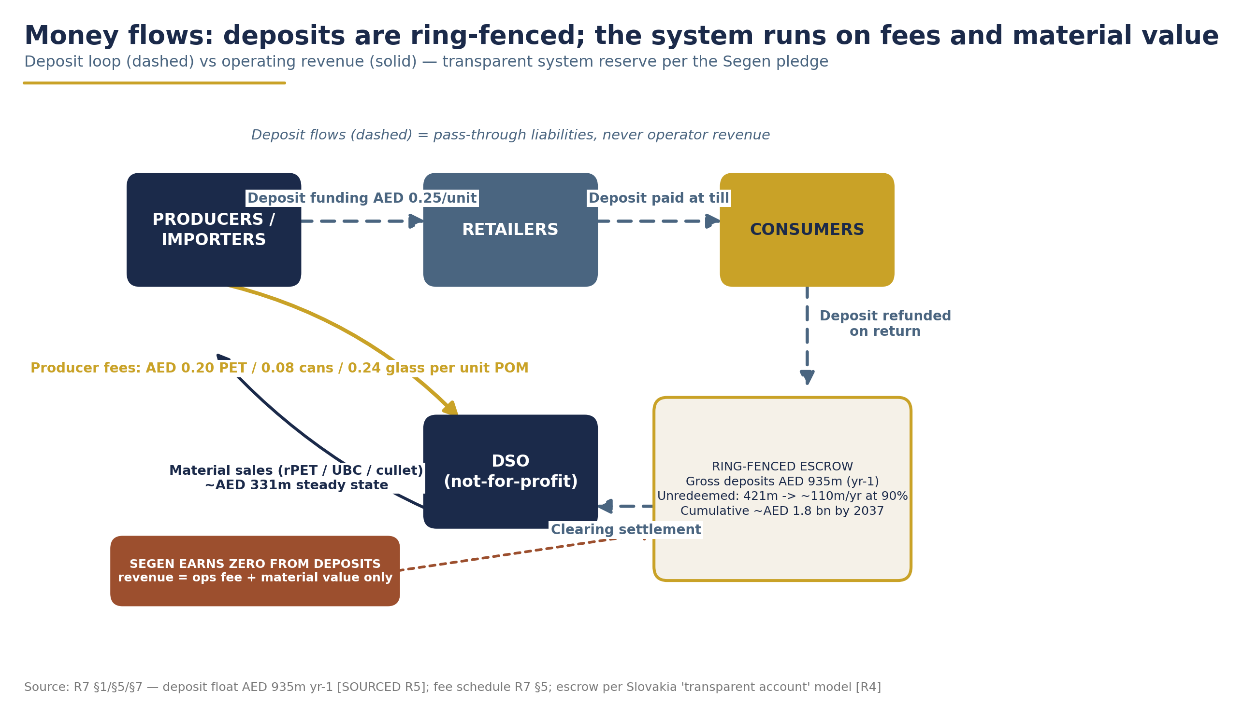
Money and material flow - deposits circulate as pass-through liabilities; unredeemed balances sit in a ring-fenced escrow reserve, never operator revenue.
CHAPTER 3

Strategic Alignment with the UAE National Agenda
A national DRS is not a new policy direction for the UAE - it is the missing operational instrument inside policies the UAE has already adopted. Each pillar of the national agenda below gains a concrete delivery mechanism from this project.

3.1 Alignment map

National instrument | Commitment | What the DRS delivers
UAE Circular Economy Policy 2021-2031 (Cabinet-approved 26 Jan 2021) | Circular approaches across four priority areas incl. sustainable manufacturing and food production & consumption (MOCCAE, 2021) | A functioning national circular loop for beverage packaging - clean, food-grade recyclate returned to domestic manufacturing
UAE Net Zero by 2050 Strategic Initiative (first MENA net-zero pledge, 2021) | Waste-sector net-zero pathway under the first Long-Term Strategy (UAE LTS, 2023) | Measurable GHG avoidance from recycled PET, aluminium and glass displacing virgin production; auditable under the 2024 Climate Change Law's reporting regime
NDC 3.0 (submitted Nov 2024) | −47% GHG by 2035 vs 2019 (UNFCCC, 2024) | A quantified, annually reported waste-sector contribution - deposit-system data provides exactly the monitoring, reporting and verification (MRV) granularity NDC accounting requires
Dubai Integrated Waste Management Strategy 2021-2041 | Zero waste to landfill by 2041; ≥56% recycling (Dubai Municipality) | Removes the highest-volume recyclable consumer stream from residual waste at source
Ministerial Decision No. 380 of 2022 (single-use products) | Final ban phase in force 1 January 2026 (Plastics News, 2026) | Addresses the dominant remaining single-use stream after cups, cutlery, plates, straws and foam are banned
National Agenda for Integrated Waste Management 2023-2026 | Treat 80% of municipal solid waste (WAM, 2024) | Diverts ~3+ billion containers/yr at maturity from the municipal stream
MOCCAE×Tadweer EPR pilot (3 July 2025) | First UAE EPR pilot: packaging, EEE and batteries; Tadweer as PRO; 26 companies (Gulf News, 2025) | The regulatory gateway - a DRS is EPR's most effective beverage-container instrument and nests directly into the pilot's producer-registration and reporting machinery

3.2 The 2026 single-use plastics ban: beverage containers are the next stream
The federal ban was sequenced deliberately: shopping bags in January 2024, then - from 1 January 2026 - cups, lids, cutlery, plates, straws, stirrers and foam food containers (Ministerial Decision No. 380 of 2022; USDA FAS, 2023; Plastics News, 2026). MOCCAE framed the final phase as designing "waste and pollution out of its systems" (Gulf News, 2025). The emirates moved even earlier: Abu Dhabi eliminated 364 million plastic bags under its 2022 ban (Abu Dhabi Media Office, 2024); Dubai's Resolution No. 124 of 2023 phased out bags, stirrers, straws and tableware through January 2026.
What remains - by volume, by litter visibility, and by recyclate value - is the beverage container. Unlike the banned items, beverage containers are not being prohibited; they are being recovered, at 90% rates, as industrial feedstock. The DRS completes the single-use agenda rather than duplicating it.

3.3 The EPR pilot as the regulatory gateway
On 3 July 2025, MOCCAE signed a memorandum with Tadweer Group launching the UAE's first Extended Producer Responsibility pilot: six months across Abu Dhabi and Dubai, covering packaging, electrical and electronic equipment and batteries, with Tadweer acting as Producer Responsibility Organisation and 26 companies participating - signed in the presence of H.E. Dr. Amna bint Abdullah Al Dahak, Minister of Climate Change and Environment (Gulf News, 2025; Packaging MEA, 2025). Advisory sources indicate a national EPR framework in 2026 built on this pilot and on Federal Law No. 12 of 2018 (ESG WISE, 2025).
This is the institutional runway for a DRS. Producer registration, packaging reporting and a functioning PRO are precisely the machinery a deposit system plugs into; regional practitioners themselves describe DRS as "the foundation for EPR" (Waste & Recycling MEA, 2026). The proposed operator model - producer-funded, non-profit, single centralised administrator - is the standard European DSO structure that the pilot's participants already understand.
[DATA GAP: the 2026 national EPR framework's final scope, fees and treatment of beverage containers are not yet public; this study assumes - and recommends - a dedicated deposit regime for beverage containers within it.]

3.4 The Circular Economy Council: the governance home
The UAE Circular Economy Council, chaired by H.E. Abdulla bin Touq Al Marri, Minister of Economy and Tourism, held its first meeting after restructuring on 9 December 2024, discussing successive packages of circular-economy policies, an Aluminium Recycling Coalition and a Circular Economy Innovation Platform (Ministry of Economy, 2024). The Council is the natural convening body for the DRS design working group requested in Chapter 1: its membership spans exactly the ministries, producers and recyclers whose alignment determines DRS success, and its aluminium agenda connects directly to the can stream - the UAE consumes ~660 million cans per year, of which only about one-third are recycled today (Emirates Global Aluminium, 2024).

3.5 A regional first-mover position
No GCC state operates a national beverage-container DRS. Saudi Arabia's waste sector is being restructured around SIRC and MWAN with headline diversion targets but no confirmed container-deposit law; no verifiable Qatari scheme exists (R2 policy brief, 2026). With Türkiye's national DRS launching only in July 2026, a UAE decision in 2026-2027 would make the Emirates the first GCC state - and one of the first in the wider region - with a national, legislated DRS: a position of policy leadership consistent with hosting COP28 and with the Net Zero 2050 pledge's first-mover character.
Strategic summary: every instrument the UAE has already legislated - circular economy, net zero, EPR, single-use plastics, emirate waste strategies - points at the same remaining gap. A national DRS closes it with a self-financing, internationally proven mechanism, and it is the only major circular-economy deliverable the UAE can bring to 90% performance within a single policy cycle.

PART II

International Evidence & the UAE Market

CHAPTER 4

International Evidence & Benchmarks
Deposit return is no longer an experiment. It is the global default for high-performing beverage-container collection - and the evidence base the UAE can design from is deeper in 2026 than at any point in history.

4.1 The Global Landscape in 2026
By the end of 2025, more than 396 million people across 60 countries, states and territories lived in jurisdictions operating a deposit return system (DRS) - up from 38 jurisdictions and 280 million people in 2016. The period 2020-2024 alone saw ten new systems launch, a record five-year window, and the momentum has not slowed: Austria (January 2025), Tasmania (May 2025), Poland (October 2025), Singapore (April 2026) and Türkiye (July 2026) have all gone live since. By end-2027, a further ~189 million people gain access as Türkiye, Singapore, Portugal, Uruguay and the UK complete their roll-outs, taking the world toward ~70 jurisdictions covering ~641 million people (Reloop, 2024; Reloop, 2026).
The performance case is unambiguous:
• Median return rate in European DRS countries: 91%. Kerbside and municipal collection programmes, after material losses, rarely exceed 50% (Reloop, 2024; Reloop, 2026).
• The world's top ten systems in 2025 - led by Finland (99%), Germany (98%), Denmark (93%) and Norway (92%) - all operate deposits (TOMRA, 2025).
• Reloop's cross-jurisdiction analysis identifies three factors most associated with high return rates: deposit level, programme scope, and convenience of the return network (Reloop, 2026).
Policy tailwinds reinforce the trend. The EU Packaging and Packaging Waste Regulation (PPWR) requires 90% separate collection of plastic bottles and cans ≤3 L by 1 January 2029 - with a DRS mandatory unless a member state can demonstrate 80% collection by other means - alongside recycled-content mandates of 25% in PET bottles from 2025 and 30% from 2030 (Reloop, 2026). Deposit return is becoming the compliance mechanism of choice for exactly the materials the UAE system will target.
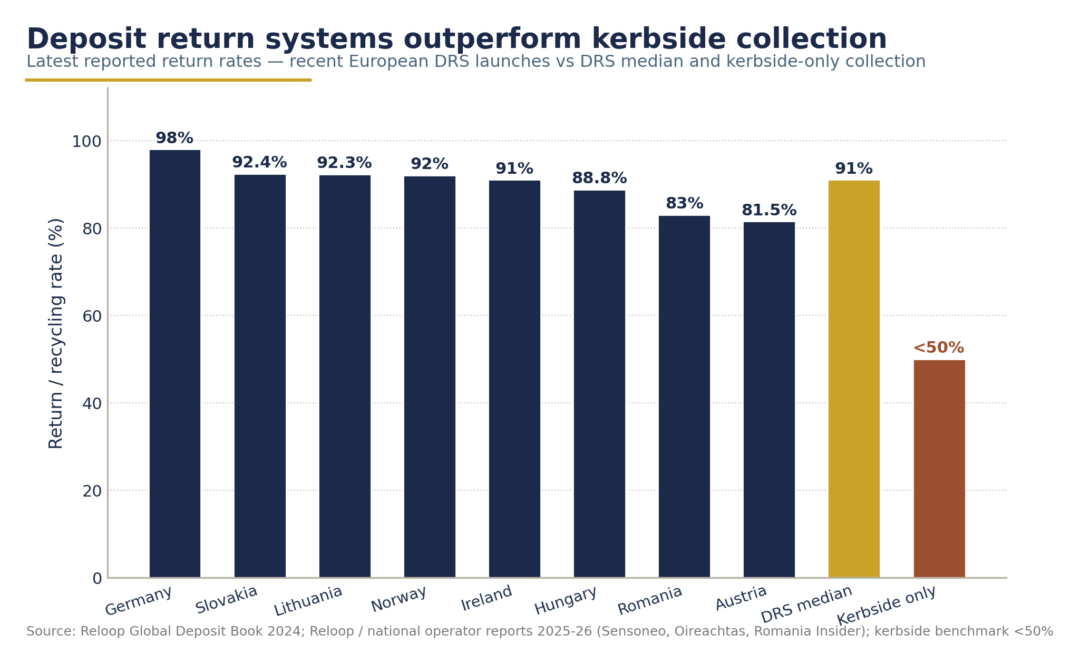
Deposit systems outperform - return rates across benchmark DRS markets vs kerbside collection (Reloop Global Deposit Book 2024; operator reports 2025-26).
Table 4.1 - Benchmark systems: deposit values and return rates

Jurisdiction | Launch | Deposit (local ≈ EUR) | Scope | Latest return rate
Finland | 1996 | €0.10-0.40 by size; cans €0.15 | PET, cans, glass | 99% (TOMRA, 2025)
Germany | 2003 | Flat €0.25 single-use | PET, metal, glass | 98% (TOMRA, 2026)
Denmark | 2002 | DKK 1-3 by type/size | PET, metal, glass | 93% (TOMRA, 2025)
Norway | 1999 | NOK 2 / NOK 3 by size | PET, metal | ~92-93% (Circular X, 2023; Sustainability MEA, 2026)
Lithuania | 2016 | Flat €0.10 | PET, metal, glass | 92.3% 2023; ~90% 2025 (GDB 2024; TOMRA, 2025)
Slovakia | 2022 | Flat €0.15 | PET, metal | ~90% stabilised (SZS, 2025)
Hungary | 2024 | Flat HUF 50 (€0.13) | PET, metal, glass | 88.8% yr-2 (Diplomacy & Trade, 2026)
Sweden | 1984/1994 | SEK 1-2 | PET, cans | 88% (TOMRA, 2025)
Ireland | 2024 | €0.15 / €0.25 by size | PET, cans | 91% recycling by yr-2 (Oireachtas, 2025)
Romania | 2023 | Flat RON 0.50 (€0.10) | PET, metal, glass | 83% yr-2 (Romania Insider, 2026)
Austria | 2025 | Flat €0.25 | PET, cans | 81.5% yr-1 (Sensoneo, 2026)
Malta | 2022 | Flat €0.10 | PET, metal, glass | 85% yr-3 (Malta Independent, 2026)
Estonia | 2005 | Flat €0.10 | PET, metal, glass | 87.6% 2024 (Sensoneo, 2026)
Türkiye | 2026 | ₺1 (~€0.025) payout | PET, metal, glass | Launched 1 Jul 2026 - no data yet

Two patterns matter for UAE design. First, flat deposits of €0.10-0.15 dominate the newest, fastest-ramping systems - simplicity wins at launch. Second, the highest mature rates sit where deposits are larger or networks densest; the three levers - deposit, scope, convenience - compound.

4.2 Deep Dive: Lithuania (USAD) - the Closest Design Template
Lithuania is the benchmark most frequently cited to the UAE team for one reason: it is the cleanest documented example of a national, day-one, three-material DRS built from nothing in under two years - and its governance and financing architecture is the reference design for the system proposed in this study. The European benchmark operations photographed and filmed for this engagement are from this system.
Speed of execution. The Law on Packaging and Packaging Waste Management was enacted in May 2014; the operator was appointed that August; and the full national system - return infrastructure at shops, RVMs, counting centres - launched on 1 February 2016, roughly 18 months after the political decision. As USAD Director General Gintaras Varnas put it: "All of the collection infrastructure at shops, including RVMs at retailers, was ready, as well as the counting centres" (USAD, 2019).
Deliberate, proven scope. Lithuania did not innovate on scope - it copied Estonia's. "We didn't want to reinvent the wheel. We wanted to implement something that we knew would work 100%" (USAD, 2019). Scope: PET, metal (aluminium and steel), one-way and refillable glass, 0.1-3 L, across beer, cider, water, soft drinks, juices and nectars - essentially the scope proposed for the UAE.
Results. Pre-DRS, Lithuania's PET recycling rate was below 33% (2015). The system reported 74% in its first year (2016 - depressed by pipeline-fill effects, with the real rate estimated above 90%), reached 92% from 2017, and recorded 92.3% in 2023 (PET 91.2%, aluminium 94.1%, steel 93.9%, glass 88.8%) (USAD, 2019; Reloop GDB, 2024). It has held ~90% since - roughly 600 million containers placed on market annually, with 1.5 billion containers (56,000 tonnes) returned in the first three years alone (USAD, 2019).
The deposit decision. A flat €0.10, unchanged since 2016. Varnas's rationale is a design principle this study adopts directly: the deposit "needs to be motivating enough… but you don't want to set it too high because you want to minimize fraud. It's all about finding the right balance" (USAD, 2019). (Note: €0.10 has lost over 20% of its real value to inflation since 2016; several systems have since raised or indexed deposits - relevant to the UAE's year-2 review clause.)
Governance. USAD is a private, not-for-profit producer responsibility organisation (PRO) founded by the brewers' association (~60% of packaged beverage volume), the retailers' association and the natural mineral water manufacturers - together representing >80% of containers sold. Centralised clearing, barcode-based registration, one counting centre for the whole country (USAD, 2019; Reloop GDB, 2024).
Financing mix - the reference architecture:

Stream | Share of revenue |  | Stream | Share of costs
Producer fees | 53% |  | Retailer & RVM compensation | 74%
Material sales | 30% |  | Logistics & materials | 12%
Unredeemed deposits | 17% |  | Administration & operations | 14%

(Source: USAD, 2019. Absolute annual € totals are not published - [DATA GAP: Lithuania total system cost in €/year].)
The UAE design deliberately mirrors this mix with one principled deviation: the ~17% unredeemed-deposit share is replaced by producer fees, because under the Segen model unredeemed deposits are never operator revenue - they accrue to a transparent escrowed system reserve. The steady-state UAE revenue mix therefore targets ~70% producer fees / ~30% material sales (see Chapter 10). Producer fee benchmarks (2024): Lithuania PET €0.044, aluminium €0.019, glass €0.055 - the direct anchors for the recommended UAE fees of AED 0.20 / 0.08 / 0.24 for PET, aluminium and glass respectively (Reloop GDB, 2024).
Network. Return-to-retail: any retailer selling in-scope drinks must accept all brands, with small-format exemptions. The result: 2,600 retail + 700 HoReCa points, ~1,110 people per return point, 91% automated - built in under a year. Refunds by cash, voucher or charity donation (Reloop GDB, 2024).
Public acceptance - the decisive evidence. A 2018 consumer survey found 97% of Lithuanians believed introducing the DRS was the right decision; 97% were satisfied with its convenience; 90% saw visibly less litter; and 93% reported the DRS made them sort all their waste more responsibly - directly rebutting the claim that deposit systems cannibalise kerbside behaviour. Notably, 14% would accept a higher deposit (USAD, 2019).
Material quality. The DRS stream is "very pure, not contaminated" and commands premium prices - a Lithuanian glass factory reported it had "never in their history seen such high quality glass," and global aluminium recyclers compete for USAD material (USAD, 2019). This quality premium underpins the material-revenue assumptions in Chapter 10.
"We didn't want to reinvent the wheel. We wanted to implement something that we knew would work 100%."
- Gintaras Varnas, Director General, USAD (2019)

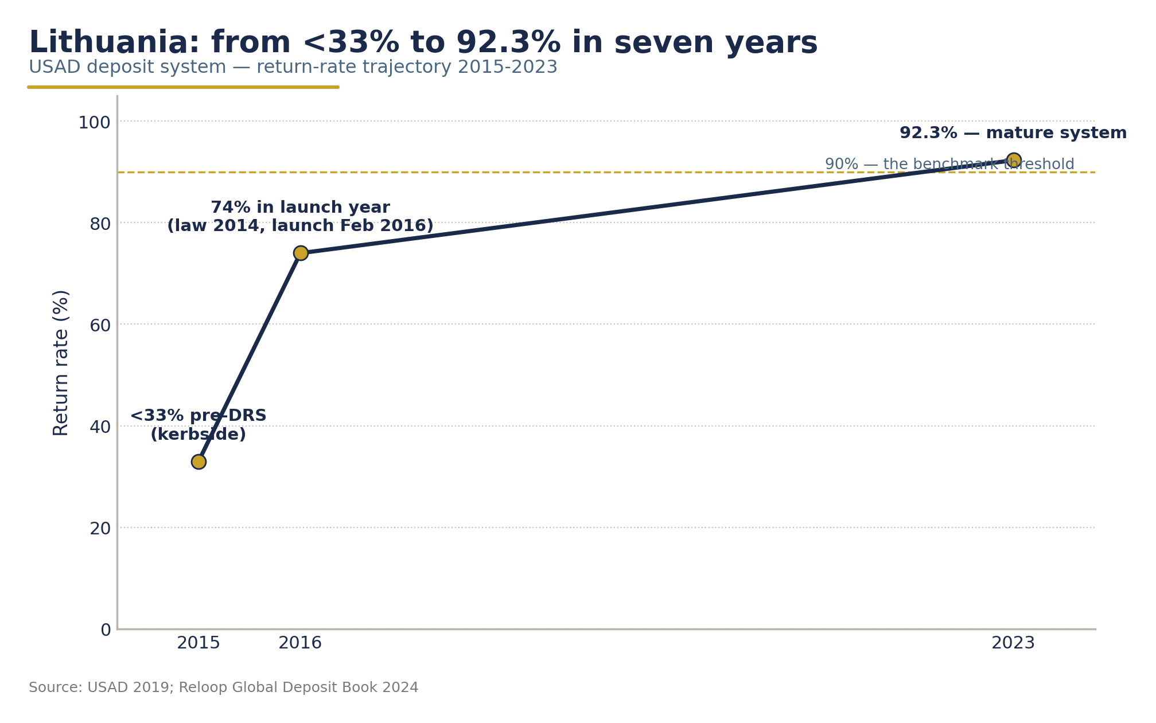
Lithuania (USAD) - from below 33% (2015) to 92.3% (2023): the fastest proven design template (USAD 2019; Reloop GDB 2024).

4.3 The Newest Wave: Proof That 80-90% Is Achievable Within 24 Months
The systems launched since 2022 are the most instructive for the UAE, because they show what a well-designed launch achieves immediately, in markets with no deposit culture.
Table 4.2 - Launch ramp-ups: the newest systems

System | Launch | Deposit | Year-1 result | Year-2+ result
Romania (RetuRO) | Nov 2023 | Flat €0.10 | 84% monthly rate by month 11 (Plastech, 2024) | 83% full-year 2025; 5.2bn containers; 387,000 t to recyclers (Romania Insider, 2026)
Hungary (MOHU REpont) | Jan 2024 | Flat HUF 50 (€0.13) | 500m containers by Oct 2024 (GDB, 2024) | 88.8% in 2025; >3bn containers - from a ~30% pre-DRS baseline (Diplomacy & Trade, 2026)
Ireland (Re-turn) | Feb 2024 | €0.15/€0.25 by size | 980m containers; 73% monthly rate by day 200 (Re-turn, 2025; gov.ie, 2024) | Recycling rate 49% → 91%; 1.6bn containers by Jul 2025 (Oireachtas, 2025)
Austria (EWP) | Jan 2025 | Flat €0.25 | 81.5% in year 1 (Sensoneo, 2026) | On track to 90% target by 2027
Malta (BCRS) | Nov 2022 | Flat €0.10 | 76% (2023) (GDB, 2024) | 85% by 2025; >98% voucher redemption (Malta Independent, 2026)
Slovakia (SZS) | Jan 2022 | Flat €0.15 | 60% statutory ramp hit (SZS, 2025) | ~90-92% stabilised, 90% statutory target reached a year early (NATUR-PACK, 2024)
Latvia (DIO) | Feb 2022 | Flat €0.10 | - | 80% at two-year mark (TOMRA, 2024)

Four observations:
1. The ramp is fast and predictable. Every well-resourced recent launch reached 80%+ within 12-24 months. This is the empirical basis for the UAE ramp assumed in Chapter 10 - 55% in year 1 rising to 90% by year 7 (2034) - which is deliberately slower than Romania, Hungary, Austria and Ireland achieved, reflecting first-in-region status and network build-out. The benchmark evidence suggests the UAE assumption is conservative.
2. Flat deposits dominate. Every fast-ramping system launched with a single flat deposit. Variable-by-size structures (Finland, Germany, Norway) are features of mature systems, not launch systems. This supports the recommended flat, non-binding AED 0.25 reference deposit for the UAE.
3. Governance is the differentiator. Romania (20% state / 80% industry, not-for-profit), Ireland (industry-led non-profit) and Slovakia (non-profit consortium ~80% of market) all pair industry ownership with statutory targets. Hungary's state-concession model (MOHU, a MOL Group subsidiary holding a 35-year national waste concession) delivered 88.8% - but with publicly documented retailer friction over handling-fee economics (Budapest Business Journal, 2025). Ownership model matters less than mandate clarity and fair retail compensation.
4. Retailer readiness is the launch bottleneck. Romania's early challenges were retailer-readiness and consumer communication, resolved by H2 2024 (Climate Change Summit, 2025). Ireland addressed this directly with RVM support grants of €3,000/€2,000/€1,000 to small retailers across years 1-3 (Reloop GDB, 2024).
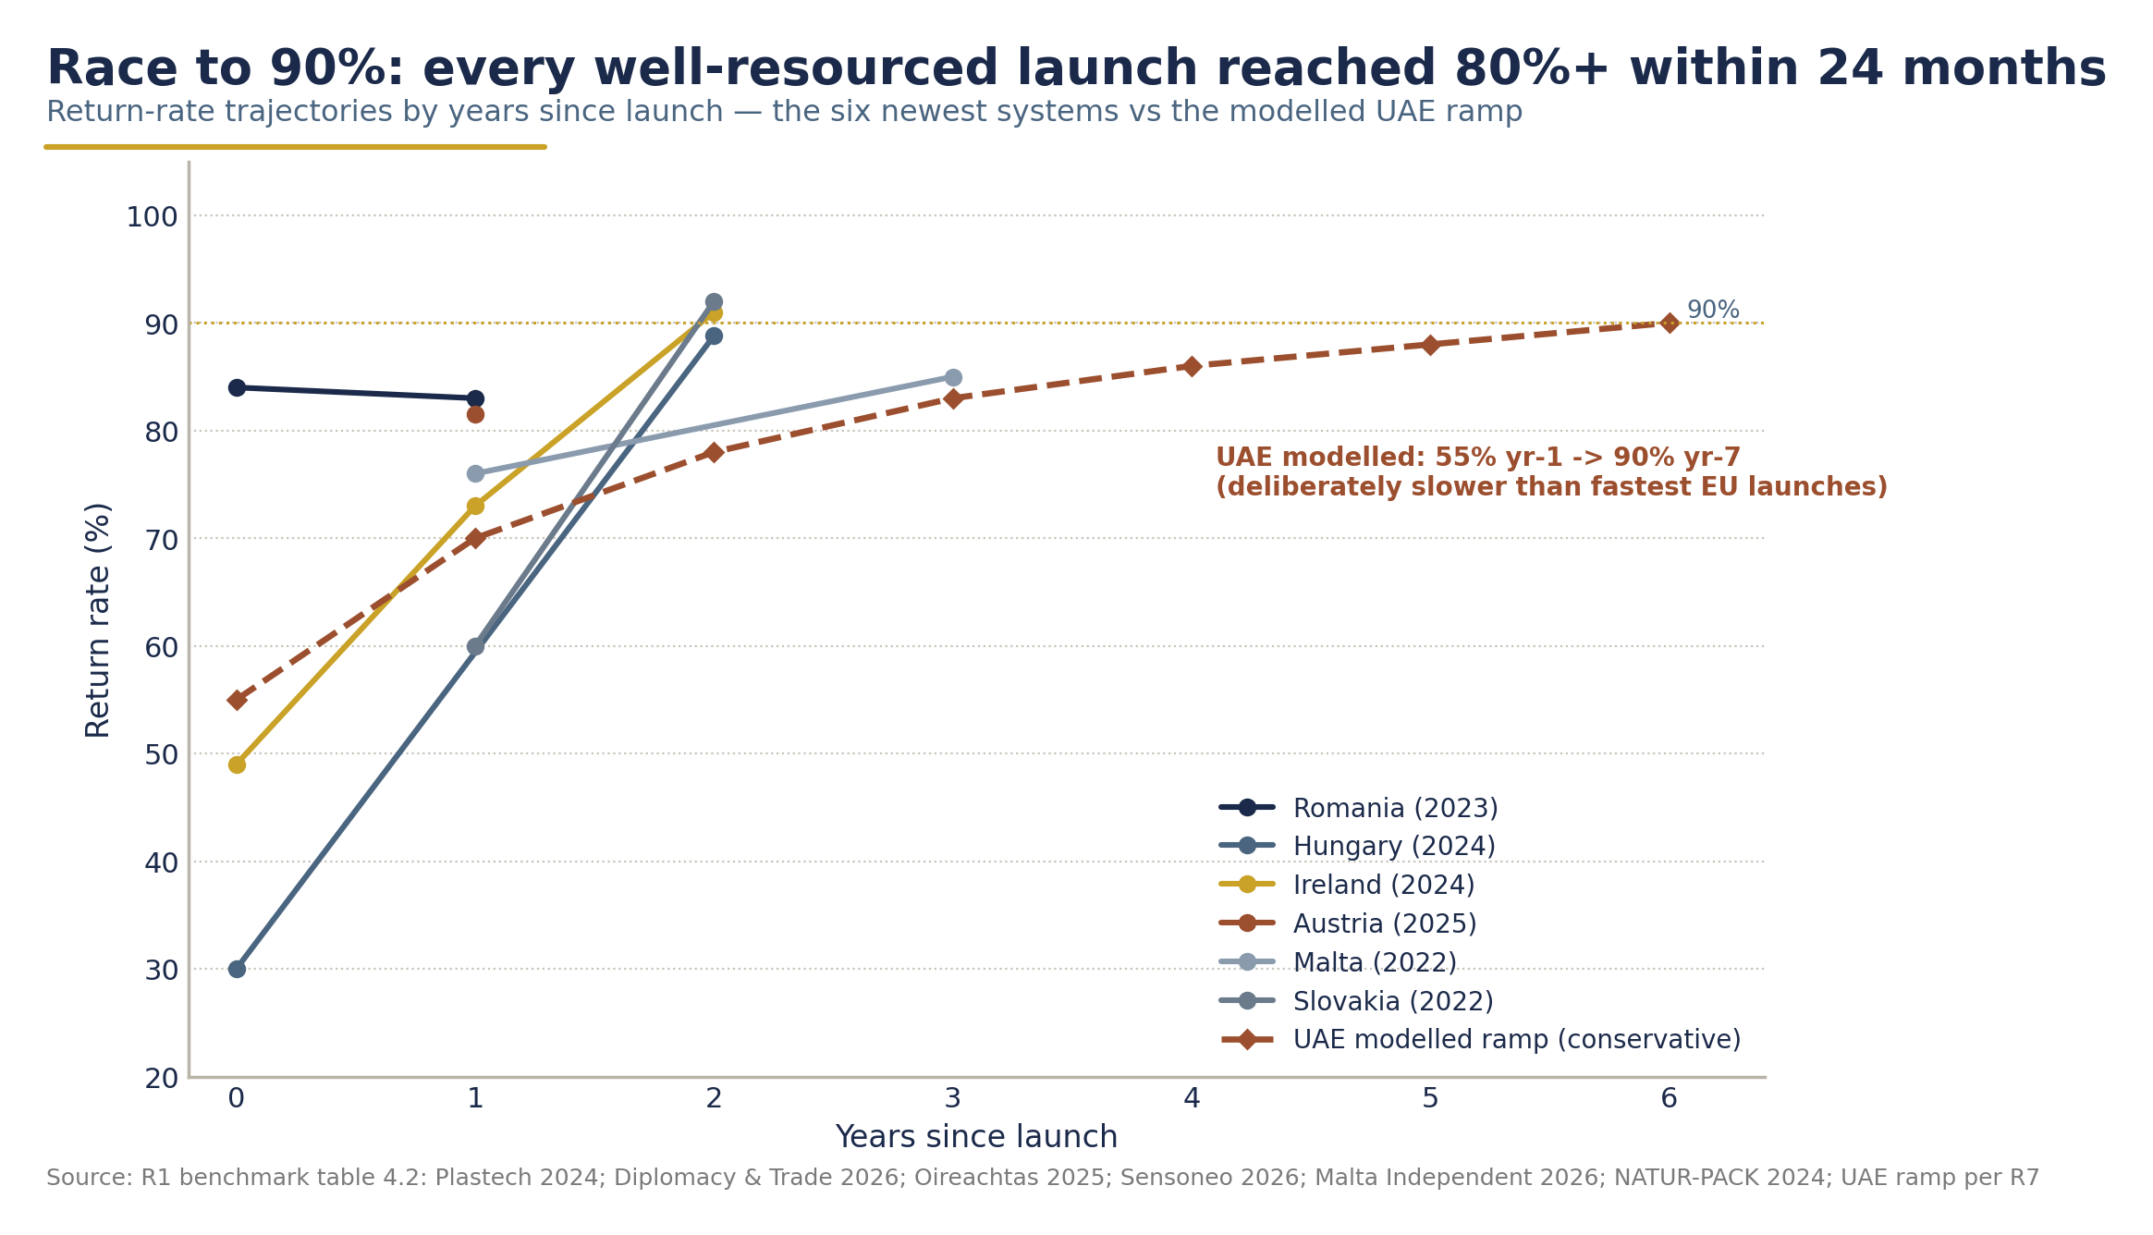
The race to 90% - launch ramp-ups of the newest systems, with the UAE's modelled conservative ramp overlaid (sources per Table 4.2).

4.4 Mature Systems: What Twenty Years of Operation Teaches
The Nordic and German systems show where a DRS plateaus - and what sustains 90%+ for decades.
• Finland (99%, world's best). PALPA, a non-profit owned 50/50 by retailers and producers, is technically voluntary - but non-participants pay a €0.51/litre packaging tax, a quasi-mandate of remarkable force. Deposits vary by size (€0.10-0.40); ~4,000 RVMs plus 9,000 HoReCa points; producer fees are eco-modulated, with clear PET at €0.021 and aluminium at €0.0097 (Reloop GDB, 2024; TOMRA, 2025).
• Germany (98%, world's largest). A flat €0.25 on single-use containers since 2003, ~130,000 collection points (~642 people/point, 90% automated). Uniquely decentralised: no single operator, no producer or handling fees - and unredeemed deposits stay with producers/retailers, an estimated €3 billion windfall since 2003 that has drawn sustained criticism (Reloop GDB, 2024; Wikipedia/bliptext, 2025). The UAE design explicitly rejects this feature: deposit funds are pass-through liabilities held in transparent escrow, never operator or producer income.
• Norway (~92-93%). Infinitum, an industry-owned non-profit, runs the world's densest network (~370 people/point) and a distinctive fiscal lever: members achieving ≥95% are exempt from the environmental packaging tax. Aluminium's producer fee is negative (−NOK 0.06) - scrap value subsidises the system (Reloop GDB, 2024; Circular X, 2023).
• Sweden (88%) and Denmark (93%) confirm the pattern: non-profit industry PROs, variable deposits, dense return-to-retail networks, and can fees at or near zero because used-beverage-can value carries the stream (Reloop GDB, 2024; TOMRA, 2025).
Three durable lessons: (i) plateau rates of 90-99% are normal for well-run systems, not exceptional; (ii) aluminium's material value means it typically needs zero or negative producer fees - the basis for the UAE's low AED 0.08 can fee; (iii) where unredeemed deposits leak to private parties (Germany), legitimacy suffers - the UAE's escrow-and-reserve design avoids this by construction.

4.5 Türkiye: The Most Relevant Regional Analogue - Live Since 1 July 2026
Türkiye launched its nationwide DRS ("Depozitosu Olan Ambalajlar", DOA) across all 81 provinces on 1 July 2026 - three weeks before this report. It is the closest structural analogue to a UAE launch: a hot-climate, tourism-heavy MENA-region economy, government-led, mobile-first.
Key design facts: a uniform ₺1 payout per container (PET, glass, aluminium, 0.1-3.01 L), funded entirely by producer recycling fees - no deposit is charged at the till, making the system cost-neutral to consumers at purchase. Refunds flow through the DOA mobile app to a digital wallet (bank transfer, ATM, retail spend). The national goal is to lift container collection from 35% to 90%, recovering ~25 billion containers a year with an estimated ₺30 billion (~US$930m) in annual economic savings. Infrastructure is planned to scale from 5,000 return points (2025) to 30,000 by 2028, with RVMs mandated at universities, municipalities, >400 m² supermarkets, malls and hotels. Administration sits with the Turkish Environment Agency (TÜÇA), a government-run model with trade-association collaboration (AdsaleCPRJ, 2026; Trbusiness, 2026; Reloop GDB, 2024).
Two caveats for UAE policymakers:
• Timeline risk is real even with legislation in place. Türkiye's launch was delayed repeatedly - 2021 → 2022 → 2023 → 2024 → 2025 → July 2026 - before going live (Reloop, 2026).
• No performance data exists yet. [DATA GAP: Türkiye first-year return rate and redemption performance - system live only since 1 Jul 2026; monitor quarterly.] The study's deposit review clause explicitly ties the UAE's year-2 review to Türkiye's first-year results, and Türkiye's ₺1 (~AED 0.11) payout is treated as unproven evidence in the deposit-value debate - one reason the recommended UAE reference deposit is AED 0.25 rather than AED 0.10.
Türkiye also demonstrates a financing point the UAE should note: a payout-funded-by-fees architecture is viable, but it removes the consumer's skin-in-the-game that a deposit creates. The UAE model retains a classic deposit precisely because the behavioural evidence (Section 4.1) links deposit level to return rates.

4.6 Scotland and Spain: Governance Cautionary Tales
Not every DRS story is a success, and the failures are as instructive as the triumphs.
Scotland - how not to govern a launch. Scotland's scheme was announced for April 2021 and then deferred five times - July 2022, August 2023, March 2024, October 2025 - before being folded into a UK-wide scheme now due 1 October 2027. The post-mortem identifies three root causes (Insider, 2023; Insider, 2025; Interpath Advisory, 2024):
1. Legal misalignment across an internal market. Launching ahead of the rest of the UK created a conflict with the UK Internal Market Act; Westminster granted only a partial exclusion, blocking glass - the scope fracture that made the scheme unviable. Court testimony in October 2025 revealed that a January 2022 parliamentary warning that the scheme could be "disapplied" was never shared with the operator - "the material facts were kept from us" (CEO David Harris, quoted in Insider, 2025).
2. An under-capitalised operator. Circularity Scotland entered administration in June 2023 with £86.2m liabilities against £2.1m assets; 66 jobs lost.
3. Irrevocable contracts before legal certainty. Logistics contractor Biffa is suing the Scottish Government for £166m over the delay.
Spain - incumbent resistance. Spain legally mandated a DRS by November 2026 after collecting only 41.3% of plastic bottles in 2023 against a 70% statutory target - yet as of mid-2026 operator authorisation remains unresolved amid competing applicants and incumbent-PRO resistance, and industry doubts the deadline will hold (RTVE, 2024; PPWR Atlas, 2026).
Implications for the UAE. A federation, like the UK, is an internal market: scope and legal framework must be aligned across all seven emirates before operator contracts are signed; the operating entity must be capitalised for delay scenarios; and incumbent waste-sector interests must be mapped and engaged early. The national, federally-coordinated approach proposed in this study - rather than emirate-by-emirate launches - is precisely the architecture Scotland lacked.

4.7 Ten Design Patterns for the UAE
Distilling the evidence of 60 jurisdictions - and especially the systems profiled above - ten patterns emerge. These are the load-bearing design choices of the system presented in Chapters 5-10.

# | Pattern | Evidence anchor | UAE application
1 | Launch nationally, day one | Lithuania, Slovakia, Malta, Romania, Hungary, Ireland, Austria, Türkiye all launched nationally in one step; Lithuania needed ~18 months law-to-launch (USAD, 2019) | National scope across all emirates from launch; avoids Scotland's internal-market fracture
2 | Target 80-90% within 24 months; plan the ramp conservatively | Romania 84% month-11; Hungary 88.8% yr-2; Austria 81.5% yr-1; Ireland 91% yr-2 | Modelled UAE ramp 55% → 90% by yr-7 is deliberately below demonstrated performance - upside, not risk
3 | Flat, meaningful deposit at launch | All fast-ramping systems launched flat (€0.10-0.15); deposit level is the top performance lever (Reloop, 2026) | Recommended flat AED 0.25 (non-binding reference): ~25% of a typical AED 1 water-bottle price - behaviour-changing, fraud-moderate, simple
4 | Cover all three materials - PET, metal, glass - in one system | Proven in Lithuania, Romania, Hungary, Malta, Croatia, Estonia, Iceland; glass runs 5-10 pts below PET/metal (GDB, 2024) | UAE scope: PET + aluminium + glass from day one; glass carries the highest fee (AED 0.24) as a net-cost stream
5 | Single, centralised, not-for-profit system operator with industry ownership | Dominant best practice: Lithuania, Norway, Sweden, Finland, Estonia, Slovakia, Ireland, Malta; state-shareholding variant Romania 20% (GDB, 2024) | Central SPV with industry participation and transparent public reporting
6 | Producer fees calibrated to steady-state cost recovery, reviewed annually | Lithuania 53/30/17 mix; Ireland's lesson: "fees must be set for the steady state, not the ramp-up" | UAE fees AED 0.20 PET / 0.08 aluminium / 0.24 glass, replacing Lithuania's 17% unredeemed-deposit share - because Segen earns zero from unredeemed deposits, which sit in transparent escrow as a system reserve
7 | Aluminium pays little or nothing - its material value carries it | Norway −NOK 0.06; Sweden SEK 0; Slovakia €0.0001 (GDB, 2024) | Low AED 0.08 can fee; used-beverage-can (UBC) value cross-subsidises glass
8 | Density is destiny: <1,000-1,500 people per return point | Norway 370, Denmark 448, Romania 545, Germany 642, Lithuania 1,110 (GDB, 2024) | UAE plan: ~9,000 return points (~1,250 people/point) - 3,500 RVMs + ~5,500 manual/HoReCa points
9 | Centralised barcode registration, deposit logo, single clearing entity | Standard fraud control across all benchmark systems; international-barcode surcharges price cross-border risk (Estonia, Slovakia, Malta, Ireland) | Central IT clearing platform (AED 30m CAPEX); mandatory UAE deposit mark; moderate deposit limits fraud incentive (USAD balance principle)
10 | Secure legal and stakeholder alignment before contracts | Scotland: £86m operator collapse, £166m lawsuit; Spain: mandated but stalled (Insider, 2023; PPWR Atlas, 2026) | Federal scope alignment, operator capitalisation for delay, early retail-compensation design, incumbent-sector engagement - sequenced in the implementation roadmap (Chapter 8)

The strategic conclusion. The international evidence is no longer about whether deposit return works - a 91% European median versus sub-50% kerbside collection settles that question - but about how fast a well-designed system reaches 90% and how cleanly it is governed. Every design choice that history rewards is embedded in the UAE proposal that follows; every failure mode history records - Scotland's legal misalignment, Spain's incumbent capture, Hungary's retailer friction, Germany's unredeemed-deposit leakage - is engineered out by design.
CHAPTER 5

UAE Market Assessment

5.0 Chapter Summary
The United Arab Emirates presents one of the world's most compelling structural cases for a Deposit Return System (DRS): the highest per-capita bottled-water consumption globally, a young and growing population concentrated in three emirates, a modern but under-utilised recycling asset base, and a policy architecture - EPR pilot, single-use plastics ban, tiered sugar excise - already moving decisively toward producer responsibility. Our central estimate places 2.8-4.5 billion DRS-eligible containers on the market each year (PET 2.1-3.8 billion, aluminium cans ~660 million, glass pending validation), against a voluntary collection infrastructure that today captures only a low-single-digit share of that flow. The gap between consumption scale and collection reality is the market opportunity this study addresses.
The UAE consumes beverage containers at world-leading intensity - and recovers them at world-lagging rates. That asymmetry is the DRS business case in a single sentence.

Data discipline. Throughout this chapter, figures are labelled [PUBLISHED] (government, corporate-primary, or academic sources) or [ESTIMATE] (market-research models and analyst estimates). Where no credible figure exists, we flag a data gap rather than invent one. All modelled container volumes carry the market survey's standing caveat: estimates require validation with producer/importer SKU-level data before policy design (UAE DRS Market Survey, 2026).
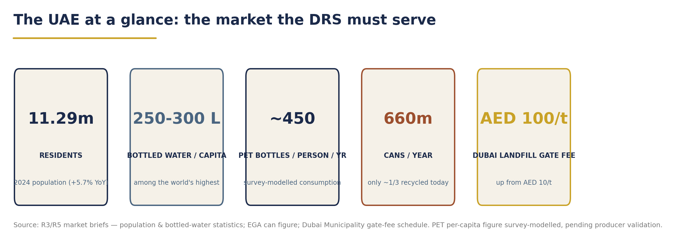
The UAE at a glance - population, consumption intensity, container flows and disposal economics.

5.1 Population & Consumption Context

5.1.1 Demographics and demand drivers
The UAE's population reached 11,294,243 residents in 2024, up 5.7% year-on-year [PUBLISHED] (FCSC via Gulf News, 2025), concentrated overwhelmingly in Abu Dhabi, Dubai and Sharjah; Dubai alone passed four million residents in September 2025. Tourism adds a large transient consumption layer - approximately 19.6 million visitors in 2025 [ESTIMATE] (IMARC, 2026) - alongside GDP per capita of roughly USD 50,000 (World Bank via Mordor Intelligence, 2025).
Three structural forces make beverage-container consumption uniquely intense:
1. Climate and hydration demand. Extreme heat drives year-round cold-beverage consumption through on-the-go channels.
2. Tap-water distrust. Desalination-based supply has entrenched bottled water as the default drinking-water source; WAM has reported UAE per-capita bottled-water consumption of 265 litres/year - the highest in the world [PUBLISHED, undated] (WAM), with market-research estimates clustering at 250-300 litres per capita [ESTIMATE] (MarkNtel; Verified Market Research, 2026).
3. A large on-trade. Dubai alone operates 800+ hotels and 140,000+ rooms (IMARC, 2026), sustaining a hospitality channel with distinct container flows (glass, premium formats).
Academic measurement corroborates the intensity: the typical UAE resident uses approximately 450 plastic water bottles per year [PUBLISHED - academic] (Alhosani, JESTEC, 2023; EcoMENA).

5.1.2 Beverage market value - directional, not precise
Syndicated estimates of the UAE bottled-water market diverge by a factor of 2.4× - USD 1.61 billion (IMARC, 2026) versus USD 3.81 billion (Mordor Intelligence, 2026) for 2025 - and carbonated soft drink (CSD) value estimates stand at USD 8.5 billion (Grand View Horizon, 2026). We treat these as [ESTIMATE - directional only] and deliberately build the DRS sizing on unit volumes, not value. Energy-drink estimates show a 3-4× inter-source spread and are excluded from planning.

5.1.3 Policy tailwinds already in force
The consumption context is inseparable from a rapidly tightening policy frame:
• Federal single-use plastics ban (Ministerial Decision No. 380 of 2022): Phase 2 took effect 1 January 2026, banning plastic beverage cups, lids, cutlery, straws, stirrers, Styrofoam containers and all bags below 50 microns [PUBLISHED] (Gulf News, 2025; Zawya, 2025).
• EPR pilot (MOCCAE + Tadweer Group as PRO): a six-month packaging/EEE/batteries pilot launched July 2025 in Abu Dhabi and Dubai with 26 signatory companies - including Bee'ah, Carrefour, Lulu, Tetra Pak, CANPACK, Tomra, Veolia and Sparklo - with a national EPR framework expected in 2026 [PUBLISHED] (Packaging MEA, 2025; Waste & Recycling ME, 2025).
• Tiered sugar excise from January 2026 (AED 0.79-1.09/L by sugar content; energy drinks remain at 100%), shifting the beverage mix further toward water [PUBLISHED] (Aletihad, 2025; Cabinet Decision No. 197 of 2025).
• National targets: 75% landfill-volume reduction by 2031; 80% diversion in Abu Dhabi; Dubai's Integrated Waste Management Strategy 2041 targets 100% landfill diversion (WAM; Dubai Municipality).
A DRS is the natural operational instrument for this policy trajectory: it is EPR made tangible at the point of sale.

5.2 Containers Placed on Market, by Material
This is the sizing foundation for the entire system. The table below separates published counts from modelled estimates explicitly.

Material | Best available figure | Status | Source
PET bottles (all beverages) | 2.1-3.8 billion units/yr | [ESTIMATE - modelled] | UAE DRS Market Survey (2026), Appendix A sizing chain
- of which water bottles | 1.7-3.0 billion units/yr | [ESTIMATE - modelled] | Survey: 55% one-way PET share ÷ 0.60L avg
- cross-check (water only) | ~5 billion 0.5L bottles/yr (~58 kt PET resin) | [ESTIMATE - academic, bottler-based] | Jadayil et al., MDPI Recycling (2023)
Aluminium cans | ~660 million units/yr (60+ per resident; ~8,910 t at 13.5 g/can) | [PUBLISHED] | EGA (2024); corroborated by IAI (2025)
Glass beverage bottles | No credible national figure | [DATA GAP] - estimation approach below | R3/R5 both confirm absence
Total PET + cans | ~2.8-4.5 billion units/yr | [ESTIMATE - range] | Survey §2.3

5.2.1 PET: the dominant stream
The survey's sizing chain - population × packaged-water volume (1.8-3.2 billion litres; Ken Research and EcoMENA) × 55% assumed DRS-eligible one-way PET share (sensitivity 45-70%, excluding HOD/returnable formats) ÷ 0.60 L average bottle, plus 0.45-0.85 billion non-water PET units (CSD, juices, iced tea, sports/energy drinks, flavoured water) - yields 2.1-3.8 billion PET bottles per year [ESTIMATE]. An independent academic estimate from UAE bottler data arrives at ~5 billion 0.5 L water bottles annually (Jadayil et al., 2023), suggesting the modelled range is, if anything, conservative at the top end. The financial model in Chapter 10 adopts a base case of 2.90 billion PET units at 2028 launch - mid-range, pending producer/importer validation.
[DATA GAP: no official UAE count of DRS-eligible PET containers placed on market exists; total non-water PET volumes by material are not published. First-priority action in Phase 1: mandatory SKU-level producer/importer data reporting (material, size, one-way vs reusable, barcode, annual units, channel split).]

5.2.2 Aluminium: the best-measured stream
EGA publishes the cleanest figure in the market: ~660 million cans per year, of which only about one-third are recycled - more than 440 million cans go to landfill annually [PUBLISHED] (EGA, 2024). The International Aluminium Institute corroborates the gap: 67% of UAE cans reach landfill, and only ~20% of cans placed on market are recycled can-to-can [PUBLISHED] (IAI, 2025). This is the stream where a DRS converts the most certain loss into the most certain value.

5.2.3 Glass: a quantified gap, not an omission
No public or internal source provides a national glass beverage-container count [DATA GAP]. Glass is present but niche - premium water, juices and the hospitality channel. Our estimation approach for planning purposes: set glass at ~5% of combined PET + can volume (~0.18 billion units) [ESTIMATE - analyst], consistent with the Tadweer-TOMRA MoU's inclusion of glass in a nationwide return programme (WAM, 2025), and validate in Phase 1 through hospitality-channel and importer data. Glass economics are addressed in Chapter 10; the key market fact is that the UAE has no container-glass furnace with high cullet intake - DRS glass would initially be an aggregation-and-export play (R3, 2026).
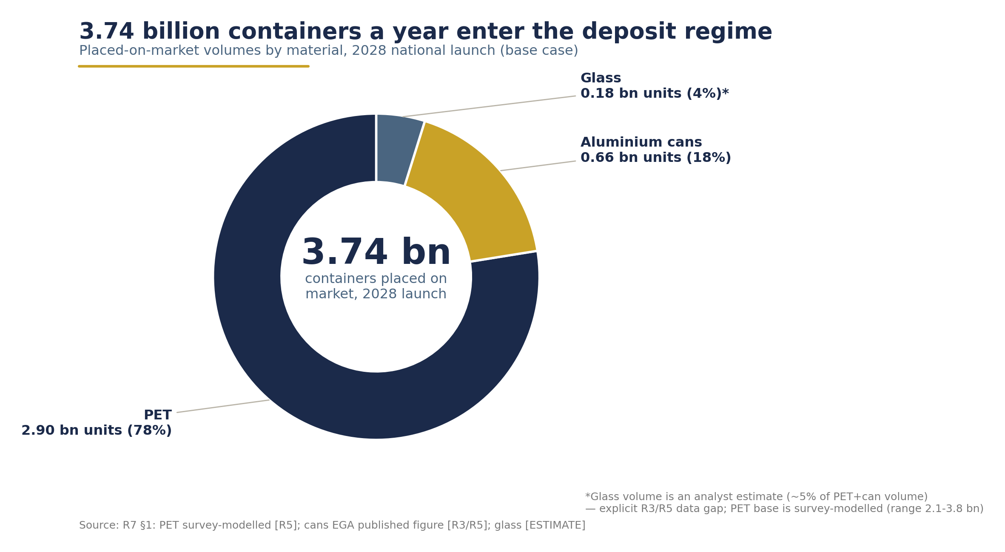
Containers placed on market by material - ~3.74bn units per year (modelled; survey caveat noted on-chart).

5.3 Producer & Importer Landscape
The producer base is concentrated, sophisticated, and - critically - already publicly committed to the outcomes a DRS delivers. A producer-funded DRS should be framed to this audience as delivery of existing ESG commitments, not a new burden (UAE DRS Market Survey, 2026).

Producer / bottler | Position & capacity | Sustainability commitments (published)
Agthia Group PJSC (Al Ain Water, Al Ain Zero, Alpin) | UAE bottled-water market leader; Al Ain Water capacity expanded 32m → 52m cases/yr (WAM) | Launched the UAE's first locally produced 100% recycled-PET (rPET) bottle; 7-year rPET offtake partner to the Repeet plant; RECAPP partner (Abu Dhabi Media Office; Agthia, 2024-25)
Mai Dubai (DEWA-owned, est. 2014) | Region's fastest bottling line - 86,000 bottles/hour; sells water in aluminium cans | Region's only 100% solar-powered water plant; net-zero energy two consecutive years; Sparklo RVM partnership (30 machines, 2025)
Masafi (est. 1976) | >100 million gallons/yr; PET line 34,000 bottles/h | UAE's lightest 500 ml bottle - 23% less plastic (Masafi)
Coca-Cola Al Ahlia Gulf Line | Licensed Coca-Cola bottler for UAE & Oman; Al Ain plant since 1990 (Arwa water + Coke portfolio); Aujan JV owns Rani and Barbican | Solar at Al Ain (Masdar/Emerge); Coca-Cola global goal: collect 70-75% of equivalent bottles and cans placed on market annually by 2035 (Coca-Cola, 2025)
PepsiCo / Dubai Refreshment Co. (est. 1959) | 5 production lines, 120 million raw cases/annum incl. 355 ml can line; Abu Dhabi Refreshment Co. second franchise | ESG reporting since 2023; 3.7 MW solar at Dubai Investment Park; PepsiCo is a founding member of the UAE Circular Packaging Association
NFPC (Oasis, Lacnor, Milco) | KIZAD mega-plant; 5-gallon line 12,000 bottles/h | In-house recycling plant in phase-2 plan (Waste & Recycling MEA)
Importers | Almarai (KSA), Nestlé/Danone waters, Red Bull/Monster (import-led) | Covered by DRS producer-fee obligation at import point

Engagement architecture. The Bottled Water Business Group under Dubai Chamber of Commerce represents most UAE bottled-water companies and is the natural first door, alongside the Dubai and Abu Dhabi Chambers and direct approaches to the two CSD bottlers (Survey, 2026) [survey reference S18 unverified in its Appendix B - treat as indicative].
Every major UAE producer has already made a public collection, recycled-content or circularity pledge. None has a mechanism to honour it at scale. The DRS is that mechanism.

5.4 Retail Landscape & Return-Channel Readiness
A return-to-retail DRS lives or dies on the store network. The UAE's modern trade is compact enough to anchor a national return network with a manageable number of counterparties.

Retailer | UAE footprint | DRS-relevant posture
Carrefour (Majid Al Futtaim) | ~38 stores (directories, 2025); 467 across 14 MENA/CIS markets (AGBI, 2024) | EPR Pledge signatory (2025); RVM partnership with Coca-Cola Middle East & Sparklo targeting 1.8M bottles/yr; 18 RVMs/Smart Bins committed in Abu Dhabi & Al Ain under EAD initiatives; ~70% single-use-bag reduction post-ban
Lulu Retail | ~42 stores; ~AED 27 bn revenue; +20 GCC outlets planned | EPR Pledge signatory; Sparklo pilot of 14 RVMs in Dubai and Abu Dhabi; biodiesel delivery fleet
Spinneys / Waitrose (Albwardy) | ~30 Spinneys (12 Dubai, 10 Abu Dhabi) + ~6 Waitrose | "Better Together 2030" strategy; net-zero operations by 2040
Union Coop | 24-27 branches + 7 malls | Publicly backs Dubai's single-use bag ban
Choithrams | ~30 stores | "Bring It Back" bottle-return campaign with Bounz loyalty rewards; Emirates Nature-WWF partnership
Fuel retail (ADNOC Distribution, ENOC/EPPCO) | [DATA GAP: verified 2025-26 station and convenience-store counts not obtained this pass] | Critical on-the-go return channel; counts to be verified in Phase 1
Traditional trade (baqala) | Thousands of independents | Manual counter-collection tier; shop-floor-area thresholds per European practice

Channel structure reinforces the design: supermarkets/hypermarkets hold ~38.6% of bottled-water channel share, off-trade 65.3% overall, with direct/HOD delivery growing fastest (~10.8% CAGR) [ESTIMATE] (IMARC/Mordor, 2026). The survey's operational guidance for return points - space, power, shading/air-conditioning, storage, servicing frequency, odour control, connectivity, queue management and anti-fraud - should anchor site-selection criteria (Survey, 2026).
For scale context: the recommended national network is 3,500 RVMs plus ~5,500 manual/HoReCa return points (~9,000 points total, ~1,250 people per point) (Chapter 6 base case, per the MDPI 2023 UAE study's 3,500+ RVM requirement and European density benchmarks). Against that requirement, the entire installed voluntary base - detailed in §5.6 - is roughly 150-200 machines. The delta between ~150 voluntary machines and ~9,000 mandated return points is, in physical terms, the whole argument for a regulated system.

5.5 Existing Recycling Infrastructure
The UAE's processing backbone is real, modern, and materially under-fed by clean feedstock - precisely the problem a DRS solves.

Asset | Capacity / status | Notes
Farz materials recovery facility (MRF) (Imdaad, Dubai, 2020) | 1,200 t/day MSW + C&I; 45,322 m²; six TOMRA AUTOSORT units | 25-30% recovery rate; ~13% of Dubai's daily waste; recovers PET, HDPE, metals, OCC [PUBLISHED]
BEEAH (Sharjah) | MRF >600,000 t/yr (world's 3rd largest); C&I plant with AI/robotics (34% recovery); SRF 73,000 t/yr; WtE 300,000 t/yr expanding to 600,000 t | Sharjah reports 93% landfill diversion [PUBLISHED] (BEEAH; Zawya, 2024)
Tadweer Group (Abu Dhabi, ADQ-owned) | Existing MRF ~300,000 t/yr; new greenfield MRF awarded to Urbaser (July 2026): 400,000 t/yr, operations from 2028, optical/AI sorting | Also operates 25 RVMs + Tadweer Rewards app [PUBLISHED] (Tadweer, 2026)
DGrade (KIZAD, 2022) | Up to 1 billion bottles/yr PET flake; TOMRA sorting; 80% process-water recycling | Bottle-to-fibre (open loop) - output leaves the bottle stream
Veolia Repeet rPET (announced Jan 2023) | 12,000 t/yr food-grade rPET, Abu Dhabi; Bee'ah 7-yr feedstock; Agthia 7-yr offtake; 18,000 t CO₂ avoided/yr | [DATA GAP: commissioning status unverified - no confirmed operational date found] (MoIAT, 2023)
EGA Al Taweelah | 185,000 t/yr aluminium recycling - UAE's largest - started production 2026; scrap sorting up to 150,000 t/yr | First domestic sink for can-to-can recycling [PUBLISHED] (EGA, 2026)

The feedstock arithmetic is stark. Against a PET water-bottle stream alone of ~58 kt/yr (MDPI, 2023), existing bottle-to-fibre capacity (DGrade, ~1 bn bottles/yr maximum) plus announced food-grade rPET (Repeet, 12 kt/yr) is structurally short - and DGrade's output is open-loop fibre, not bottle resin. Academic analysis indicates a maximum of 60% recycled content is achievable from the 0.5 L stream alone; higher food-grade content requires capturing the wider PET container pool - which only a high-capture system can deliver (Jadayil et al., 2023). On aluminium, EGA's Al Taweelah plant (185 kt/yr) now provides the domestic remelt sink that exported cans previously lacked. On glass, no container-glass furnace exists: DRS cullet would initially be aggregated for export or downcycling.
The UAE has built the back end of a circular economy - MRFs, rPET, aluminium remelt - without building the front end that feeds it. A DRS is the missing feedstock engine.

5.6 Voluntary Collection Today - and Why It Plateaus
The UAE is not starting from zero. It is starting from a decade of well-intentioned voluntary schemes whose combined results demonstrate, with unusual clarity, why voluntary networks plateau.
What exists today:
• EAD Bottle Return Scheme (Abu Dhabi, with Sparklo, since 2023): more than 2,000 tonnes of bottles recovered since launch; 23 million recyclables collected in 2024 alone (544 t plastic, 18 t aluminium) through 100+ Sparklomat RVMs [PUBLISHED] (Abu Dhabi Media Office). EAD has also announced RVM roll-outs with retailers (70 machines announced 2023; 18 committed at Carrefour stores). [Note: this study uses only the published EAD/Sparklo series; Phase 1 should reconcile EAD's cumulative figures beyond 2024.]
• Tadweer RVMs (Abu Dhabi): 25 machines (400 L each, PET + cans) at ADNEC, airport and parks, plus a rewards app (Waste & Recycling MEA, 2024). Tadweer has signed an MoU with TOMRA - which established permanent Middle East entities in Abu Dhabi and Riyadh in April 2025 - for a nationwide voluntary PET/can/glass return programme (WAM, 2025).
• Sparklo ("Sparklomats"): reward-based PET/can RVMs; Mai Dubai partnership (30 AI-powered machines across 5 emirates, 2025); Tabreed partnership (16 machines, projected >4M containers/yr; single-machine record >13,000 containers/day, 2025). [DATA GAP: total national Sparklomat count and cumulative collections not published.]
• RECAPP by Veolia (since Nov 2020): free door-to-door collection; year 1: 10,000 users / 85 t; 1,200 t cumulative by 2023; ~70,000 users; pilot partners include Agthia, Coca-Cola, Nestlé, PepsiCo, Unilever (Veolia, 2021-23). RECAPP has itself built a voluntary deposit return scheme with rewards for brands - evidence that even operators see deposit logic as the endgame (Plastics News, 2023).
• Retailer initiatives: Carrefour × Coca-Cola × Sparklo (1.8M bottles/yr target); Lulu × Sparklo (14 RVMs); Choithrams "Bring It Back" with loyalty rewards.
• Industry drives: EGA's Aluminium Recycling Coalition and Every Can Counts UAE (with Crown and CANPACK, 2024), targeting ≥80% can recycling by 2030; EGA-RECAPP school collections (145,000 cans year 1); EEG Can Collection Drive (13,988 kg in one day, Nov 2024).
Why voluntary networks plateau - the evidence. The cleanest natural experiment is Bee'ah Rewards: RVMs deployed 2017-18 collected only ~250,000 containers in six months across six locations (MDPI, 2023) - roughly 7,000 containers per machine per month, against a national flow of hundreds of millions of units per month. The pattern is consistent across every scheme above:
1. Reward economics cap participation. Points, vouchers and raffle entries are weak incentives relative to UAE disposable incomes; a refundable deposit converts the container itself into stored value - "the deposit is a returnable incentive, not a tax" (Earth Care Consulting, 2025).
2. Coverage is boutique, not universal. ~150-200 machines against a requirement of ~9,000 return points means most consumers are never within convenient reach - and convenience, not intent, drives return behaviour.
3. No obligation, no funding base. Voluntary schemes rely on CSR budgets; they cannot finance national logistics. A mandated, producer-funded system can - producer fees of AED 0.20 / 0.08 / 0.24 per PET / aluminium / glass container (recommended, non-binding) fund the steady state (Chapter 10).
4. Fragmented brands and apps impose registration friction that a single national clearing system eliminates.
The benchmark contrast is decisive: European deposit systems achieve 85-98% collection - Lithuania 92.3%, Slovakia 92.4% in its first full year, Germany 98%+ (Earth Care Consulting, 2025) [benchmark figures; independent verification recommended for final deck] - because deposits make returns universal, convenient and financially meaningful. Every UAE voluntary pilot, however well run, operates an order of magnitude below that ceiling.
The UAE's voluntary schemes have done their job: they have proven consumer willingness, retailer cooperation and technology viability - at pilot scale. What they cannot do, by construction, is scale. That requires the deposit.

5.7 Waste-Flow Economics
The cost of inaction is measurable at the landfill gate.
• Dubai landfill gate fees: general/municipal waste AED 100/t; hazardous/special AED 550/t; clean C&D AED 20/t - up from ~AED 10/t before 2018 (Executive Council Resolution 58/2017; Dubai Law No. 18 of 2024) [PUBLISHED - vendor compilation consistent with Dubai Municipality schedule] (dubaiwaste.com, 2026).
• Inter-emirate arbitrage: landfill charges range from USD 13.61/t (Sharjah) to USD 61.27/t (Abu Dhabi), creating cross-hauling incentives that fragment national waste planning [ESTIMATE - Mordor citing Dubai Municipality, 2026]. [DATA GAP: official current per-emirate landfill fee schedules beyond Dubai not retrieved; verify in Phase 1.]
• Plastic waste scale: ~1.5 million tonnes of plastic waste per year, with a GPCA-derived recycling rate cited at only ~4% [secondary citation - unverified] (GMIR, 2026); the Plastic Overshoot Day 2025 assessment puts UAE plastic waste at 33 kg/capita/yr with a ~79% mismanaged-waste index (EA, 2025).
• Informal sector: no formal studies exist; the IAI notes the UAE relies on formal collection, unlike informal-sector-driven markets [DATA GAP: informal collection sector size and economics unstudied - a social-integration design question for Phase 2].
Every tonne of beverage containers diverted by a DRS avoids gate fees, extends landfill life, and - at 90% capture of ~3.7 billion units - removes the single most visible litter stream from streets, beaches and the marine environment. Beverage containers rank as the number-one item in litter studies worldwide (Earth Care Consulting, 2025).
A note on deposit money. Wherever this study references the recommended AED 0.25 flat deposit (non-binding, a reference for policymakers), one rule holds precisely: Segen earns zero from unredeemed deposits. Deposits are pass-through liabilities held in transparent escrow; unredeemed balances accrue to a supervised system reserve, never to the operator. The full policy and financial treatment is set out in Chapters 6 and 10 (Project Description, 2026).
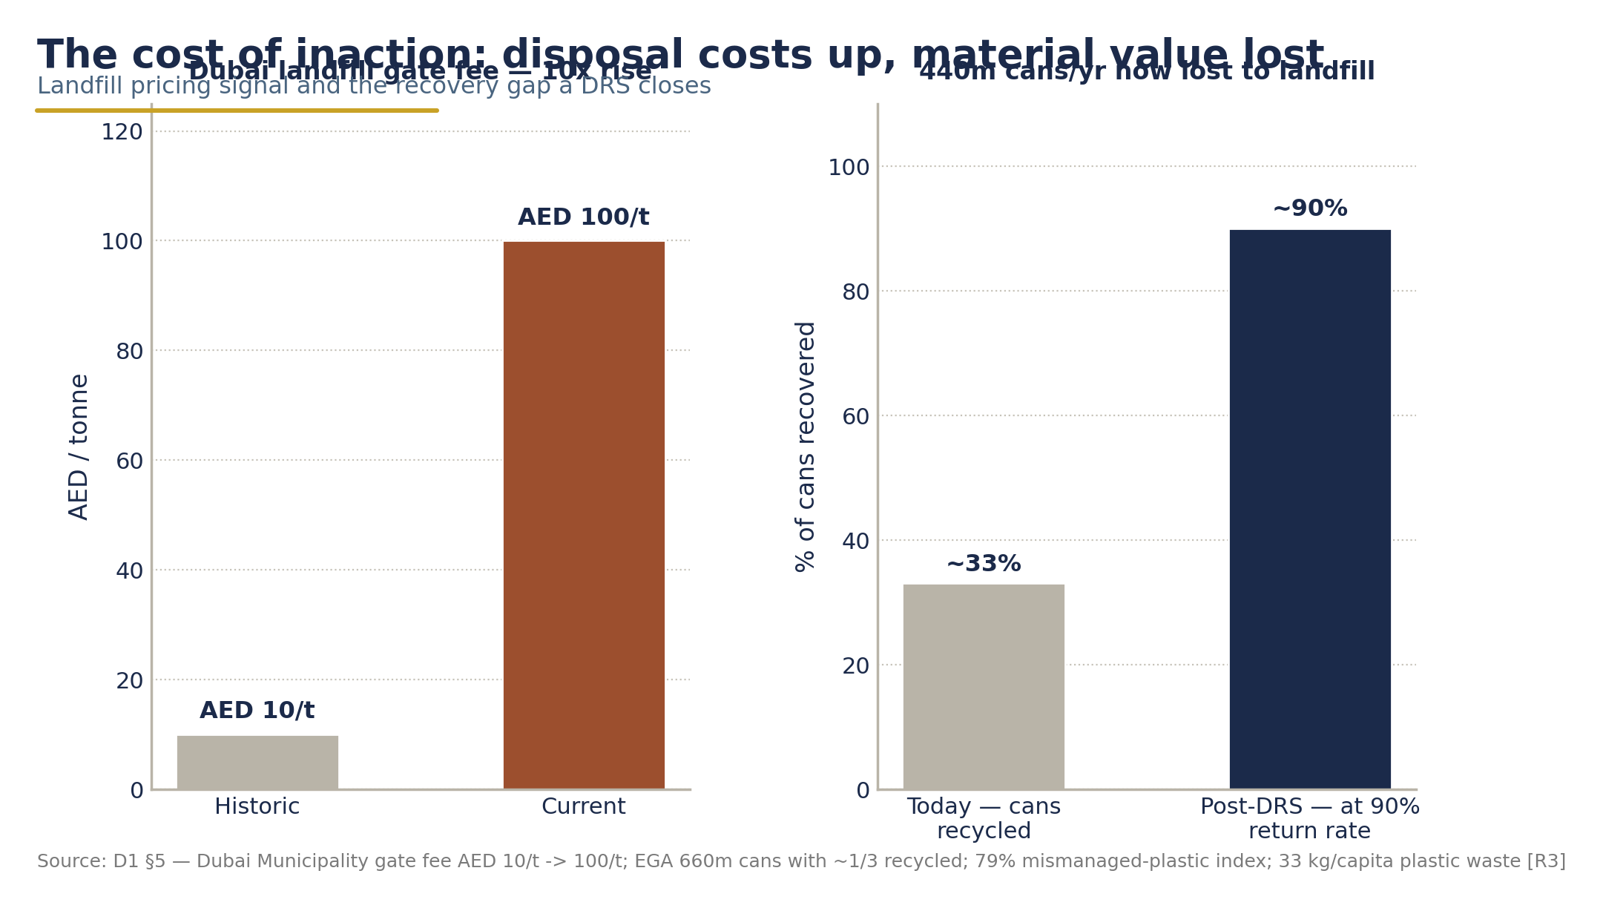
The cost of inaction - landfill gate-fee escalation, containers lost to landfill, and the post-DRS counterfactual at 90% return.

5.8 Implications for DRS Design
Six market facts carry direct design consequences:
1. Scale is certain, precision is not. The 2.8-4.5 billion-unit range (PET modelled; cans published) is sufficient for system sizing, but Phase 1 must secure SKU-level producer/importer reporting before final fee calibration.
2. Water dominates. ~55% of the eligible stream is water bottles - design RVM capacity, logistics and fraud controls around high-frequency, low-value 0.5 L units.
3. The retail anchor exists. Five modern-trade groups (~165-175 stores) plus fuel retail can carry the mandatory-return core; all five have live RVM or take-back experience and EPR Pledge or equivalent commitments.
4. Processing capacity must grow with capture. DRS feedstock at 90% return will exceed current food-grade rPET capacity within years of launch; offtake agreements (Repeet expansion, EGA Al Taweelah) are a launch prerequisite, not an afterthought.
5. Voluntary infrastructure is an asset, not a competitor. EAD/Sparklo, Tadweer and RECAPP networks (~150-200 machines, proven consumer base) should be absorbed into the national system as accredited return points from day one.
6. Glass requires an export-oriented logistics design until domestic furnace demand exists - include glass in scope (per the Tadweer-TOMRA MoU precedent) but plan aggregation economics accordingly.
The market, in short, is large, concentrated, policy-aligned and infrastructurally primed. What it lacks - and what only a mandated, producer-funded DRS supplies - is the universal collection front end that turns world-leading consumption into world-class circularity.

Annex 5.A - Data Provenance Register

Category | Published (usable as-is) | Estimated / modelled (flag in deck) | Data gaps (Phase-1 action)
Population | 11,294,243 (2024, FCSC) | Tourism 19.6M | -
Per-capita consumption | 265 L/yr (WAM, undated); ~450 bottles/yr (academic) | 250-300 L/yr range | WAM figure undated - re-verify
PET volumes | - | 2.1-3.8 bn units (survey); ~5 bn water bottles (MDPI 2023) | No official POM count - producer/importer reporting needed
Cans | 660M/yr, ~1/3 recycled (EGA; IAI) | 8,910 t tonnage (weight assumption) | -
Glass | - | ~0.18 bn units (analyst, ~5% of PET+cans) | No national glass figure - hospitality/importer study needed
Retail | Carrefour ~38, Lulu ~42, Spinneys ~30, Union Coop 24-27, Choithrams ~30 | Channel shares (IMARC/Mordor) | ADNOC/ENOC station counts
Infrastructure | Farz, BEEAH, Tadweer/Urbaser, DGrade, Al Taweelah capacities | - | Repeet rPET commissioning status
Voluntary collection | EAD 2,000 t / 23M units 2024 / 100+ RVMs; Bee'ah Rewards 250k/6mo | - | Sparklo national totals; EAD cumulative series beyond 2024
Waste economics | Dubai AED 100/t gate fee | Sharjah-Abu Dhabi fee spread (Mordor); 4% plastic recycling (secondary) | Per-emirate fee schedules; informal sector

PART III

System, Legal & Delivery Design

CHAPTER 6

System Design & Operating Model

6.0 Chapter overview
This chapter translates the strategic case for a UAE Deposit Return System into a concrete, buildable operating model. It specifies eight design layers: (1) scope and the deposit model; (2) governance and institutional structure; (3) the collection network; (4) logistics, counting and sorting; (5) recycling and material offtake; (6) the central IT platform; (7) the consumer experience; and (8) the treatment of unredeemed deposits.
Two principles govern every design choice that follows. First, the system is engineered for the steady state, not the ramp-up - producer fees are calibrated so that fees plus material revenue cover 105-110% of system costs at 90% redemption, with an annual cost-recovery review (the Ireland/Latvia methodology precedent). Second, deposit money is never operator revenue: deposit funds are pass-through liabilities held in transparent escrow, and Segen's commercial benefit arises exclusively from managing collection, sorting, processing and recycling operations and from the value of recovered materials - never from unclaimed deposits. This is a binding commitment from the Project Description, and the governance design in Section 6.2 is built to make it structurally enforceable.
"Deposit funds move between producers, importers, retailers, consumers, and the system administrator and are not treated as operating revenue for the project operator." - Project Description, Segen (verbatim commitment)

6.1 System scope and deposit model

6.1.1 Material and product scope
The UAE system launches nationally, from day one, across all three material streams: PET plastic, metal (aluminium and steel cans), and glass. This mirrors the proven scope of Lithuania, Romania, Hungary, Croatia, Malta and Estonia, all of which include glass in a single system (Reloop, 2024). Phased or partial scope is explicitly rejected: every recent fast-ramping system - Lithuania (2016), Slovakia (2022), Malta (2022), Romania (2023), Hungary (2024), Ireland (2024), Austria (2025), Türkiye (2026) - launched nationally in one step, and several reached 80-90% return rates within 12-24 months (Reloop, 2026; USAD, 2019).

Design parameter | Recommendation | Benchmark basis
Materials | PET, aluminium/steel cans, glass | LT, RO, HU, HR, MT, EE include glass (Reloop, 2024)
Size band | 0.1 L - 3.0 L | Standard band across LT/RO/HU/MT/EE/LV (Reloop, 2024)
Beverages | Water, CSD, juices, nectars, iced tea, sports/energy drinks, beer/cider; dairy excluded at launch | RO/HU/LT precedent; dairy exclusions common (Reloop, 2024)
Geography | All seven emirates, national day-one | Every 2016-2026 launch national from day one (Reloop, 2026)
Base-case placed-on-market (2028) | 3.74 bn units (PET 2.90 bn / cans 0.66 bn / glass 0.18 bn) | Financial assumptions memo, base case

Glass sizing is the one soft number in the scope table: 0.18 bn units is an analyst estimate (~5% of PET + can volume) because no glass-container market data exists in any internal source [DATA GAP: UAE glass beverage-container market sizing - pending producer/importer SKU validation]. Inclusion of glass is nonetheless strategically supported: the Tadweer Group-TOMRA MoU already contemplates a nationwide voluntary programme covering PET, cans and glass (WAM, 2023), and glass return rates in mixed systems run only 5-10 points below PET/metal (Reloop, 2024).

6.1.2 The deposit: flat AED 0.25 - a non-binding recommendation
We recommend a flat deposit of AED 0.25 (~€0.063) on every in-scope container, regardless of material or size. This recommendation is non-binding - a reference point for policymakers, to be set finally in the implementing regulation and reviewed at the year-2 statutory review.

Option assessed | Verdict
AED 0.10 | Rejected - too weak for a high-income, convenience-driven market; Lithuania's €0.10 works in a lower-income EU context; Türkiye's ₺1 (~AED 0.11) is unproven (launched 1 July 2026)
AED 0.25 | Recommended. ~25% of a typical AED 1 water-bottle price - a behaviour-changing incentive; flat = simple (LT/RO/HU precedent); low fraud incentive
AED 0.50 | Rejected for launch - approaches German €0.25 nominal in a market with no DRS history; raises cross-border fraud incentive and producer working-capital burden (gross float would reach ~AED 1.9-2.2 bn/yr)
Variable by size/material | Rejected for launch - adds consumer and IT complexity; every recent fast-ramping system launched flat. Revisit at the year-2 review

The fraud-balance logic is Lithuania's own: the deposit must be "motivating enough… but you don't want to set it too high because you want to minimize fraud" (USAD, 2019). Reloop identifies deposit level, programme scope and network convenience as the three strongest performance levers (Reloop, 2026) - AED 0.25 is calibrated to pull all three.

6.1.3 DRS marking and registration
Only registered containers are redeemable. Every in-scope SKU must be registered in the central database with its EAN barcode and carry a mandatory national DRS mark on the label - the standard fraud-control triad used by Romania (unique symbol + dedicated barcode), Slovakia ("Z - Zálohované" mark) and Ireland (registered barcode database) (Reloop, 2024; Global Payments Romania, 2023). Registration cost is negligible: the UK Defra impact assessment estimated standardised barcode/registration at £0.00019 per container (Scottish Government, 2025). For imports that cannot relabel at source, adhesive DRS stickers are permitted - the Latvian solution (Reloop, 2024). Eco-modulated producer fees (higher fees for coloured/opaque PET, full-body sleeves, mixed materials) are now standard practice in Finland, Norway, Slovakia, Romania and Estonia, and are scheduled for the UAE system's first fee review rather than at launch (Reloop, 2024).

6.2 Governance: a single, centralised, not-for-profit DSO under government supervision

6.2.1 The institutional model
The best-practice governance model - and the one recommended for the UAE - is a single, centralised, not-for-profit DSO, functioning as the national Producer Responsibility Organisation (PRO), operating under government sponsorship and supervision. This is the dominant structure among high performers: Lithuania (USAD), Norway (Infinitum), Sweden (Returpack), Finland (PALPA), Estonia, Slovakia, Ireland (Re-turn) and Malta (BCRS) all run single non-profit industry PROs (Reloop, 2024). Romania adds 20% state shareholding; Hungary runs a state concession; Türkiye a government agency. The UAE design sits closest to the Romanian variant: industry-led operations with a formal government seat and oversight.
The UAE DRS is framed as a national public-private initiative: the state provides sponsorship, regulatory approval, supervision and the legal framework; Segen builds and operates the operational and technology infrastructure in cooperation with producers, importers, retailers, waste-management companies and recycling facilities.

6.2.2 Board composition and control rights

Seat | Representation | Role
Producers & bottlers | Domestic beverage producers (water, CSD, juices) | Largest block; fund the system via producer fees
Importers | Beverage importers/distributors | Co-equal fee obligations on imported POM
Retailers | Major retail groups + small-format representation | Host the return network; receive handling fees
Government observer | Ministry of Climate Change & Environment / Ministry of Economy & Tourism | Non-executive oversight; statutory reporting line; veto over changes to deposit-level and escrow-use rules
Independent chair | Appointed jointly | Casting-vote neutrality; consumer-interest guardian

Founders should collectively represent >80% of containers placed on market - the threshold that made Lithuania's USAD and Slovakia's SZS effective from day one (Reloop, 2024; USAD, 2019).

6.2.3 Why this structure protects the unredeemed-deposits commitment
The Segen pledge - zero profit from unredeemed deposits - is credible only if the institution makes alternative behaviour structurally impossible. Three design features do this:
1. Non-profit principle. The DSO cannot distribute surpluses as profit; any surplus is retained in the system or returned to producers through downward fee resets at the annual review (the optimistic-scenario mechanic in the financial model). Lithuania's "surplus stays in the system" rule is the template (Earth Care Consulting, 2025).
2. Escrowed deposits. All deposit flows sit in a transparent escrow account, legally separated from DSO operating funds - the Slovak "transparent account" model, under which balances are by law usable only for development and improvement of the system (Barikáda, 2021).
3. Statutory reporting. Periodic public reporting of escrow balances and uses to the supervising ministries, with audit rights. Portugal's model - transferring unredeemed deposits above target to a state environment fund from year 3 - is available as a policy option (Reloop, 2024).
Consistency note for policymakers: Earth Care's generic DRS economics observe that unredeemed deposits typically make systems "largely self-financing" (Earth Care Consulting, 2025). In the UAE design, that self-financing role is deliberately replaced by producer fees calibrated for steady-state cost recovery - which is precisely why recommended UAE fees sit at the top of the European range. Segen's income is limited to operations management and recovered-material value.

6.3 Collection network design

6.3.1 Network architecture and density
The network is built on the return-to-retail principle: any retailer selling in-scope beverages accepts returns of all registered brands - the core of every European system (Earth Care Consulting, 2025). The design target is ~9,000 return points nationally (~1,250 people per point), inside the 1,000-1,500 people/point band where the best-performing systems cluster (Reloop, 2024). For context: Norway runs ~370 people/point, Germany ~642, Romania ~545, Lithuania ~1,110, Ireland ~1,893 (Reloop, 2024).

Layer | Scale | Function
RVM network | 3,500 reverse vending machines | Automated, compacting, multi-material; the system's backbone (~39% of points)
Manual return points | ~5,500 | Small-format retail, HoReCa, community points (Latvia manual-point model: ~15-30 min staff time/day)
Bulk/hybrid add-ons | Phased | Bulk stations, event/beach units, HoReCa pick-up, e-commerce collection

The 3,500-machine figure is anchored in the MDPI 2023 UAE study ("3,500+ RVMs"), cross-checked against Hungary's ~3,200 people/RVM at launch, at an installed unit cost of AED 110,000 - within the international range of US$10-25k for standard multi-material compacting units and Ireland's €15-30k retailer-reported actuals (Market Growth Reports, 2026; Oireachtas, 2026). Gulf-specific installation (shading, outdoor rating, power, connectivity) is priced in.

6.3.2 Placement strategy
Placement follows footfall and convenience, in line with the Project Description's infrastructure commitments: shopping centres and malls, supermarkets and hypermarkets, petrol stations (ADNOC forecourts), and public locations - metro and airport transit hubs, universities, event venues. UAE retail groundwork already exists: Carrefour/Majid Al Futtaim operates RVM partnerships with Coca-Cola Middle East and Sparklo; LuLu has piloted 14 Sparklo RVMs in Dubai and Abu Dhabi; Choithrams runs a bottle-return loyalty campaign; and Abu Dhabi's EAD scheme has 100+ Sparklomat RVMs in service (Majid Al Futtaim, 2025; Sparklo, 2023; Abu Dhabi Media Office, 2025). The mandatory DRS converts these voluntary beachheads into a universal obligation.
Retailer obligations follow the European threshold model: take-back duty tied to shop-floor area, with exemptions for the smallest formats (Lithuania exempts ≤300 m² urban / ≤60 m² rural; Hungary mandates RVM hosting above 400 m²; Malta above 150 m²) (Reloop, 2024). Retailers are compensated through a retailer handling fee (RHF) on a cost-only basis - recommended at AED 0.10 per container, bracketed by Ireland's €0.022-0.026 (= AED 0.088-0.104) and Lithuania's range up to €0.049 (Container Recycling Institute, 2024; Reloop, 2024). The fee formula should follow Finland's bottom-up methodology: space, labour, RVM investment and service, and consumables (Reloop/Eunomia, 2024). Hungary's friction with retail partners over under-compensation (Budapest Business Journal, 2025) is the cautionary lesson: set the RHF transparently, on a published cost methodology, from day one.
Over €300M in additional consumer revenue passes through retail for every 3 billion packages returned at a €0.10 deposit - returned deposits are re-spent where they are refunded (Earth Care Consulting, 2025). At AED 0.25 on ~3.4 bn returned units at maturity, the equivalent UAE retail footfall effect is roughly AED 850M per year flowing back through return-point locations.

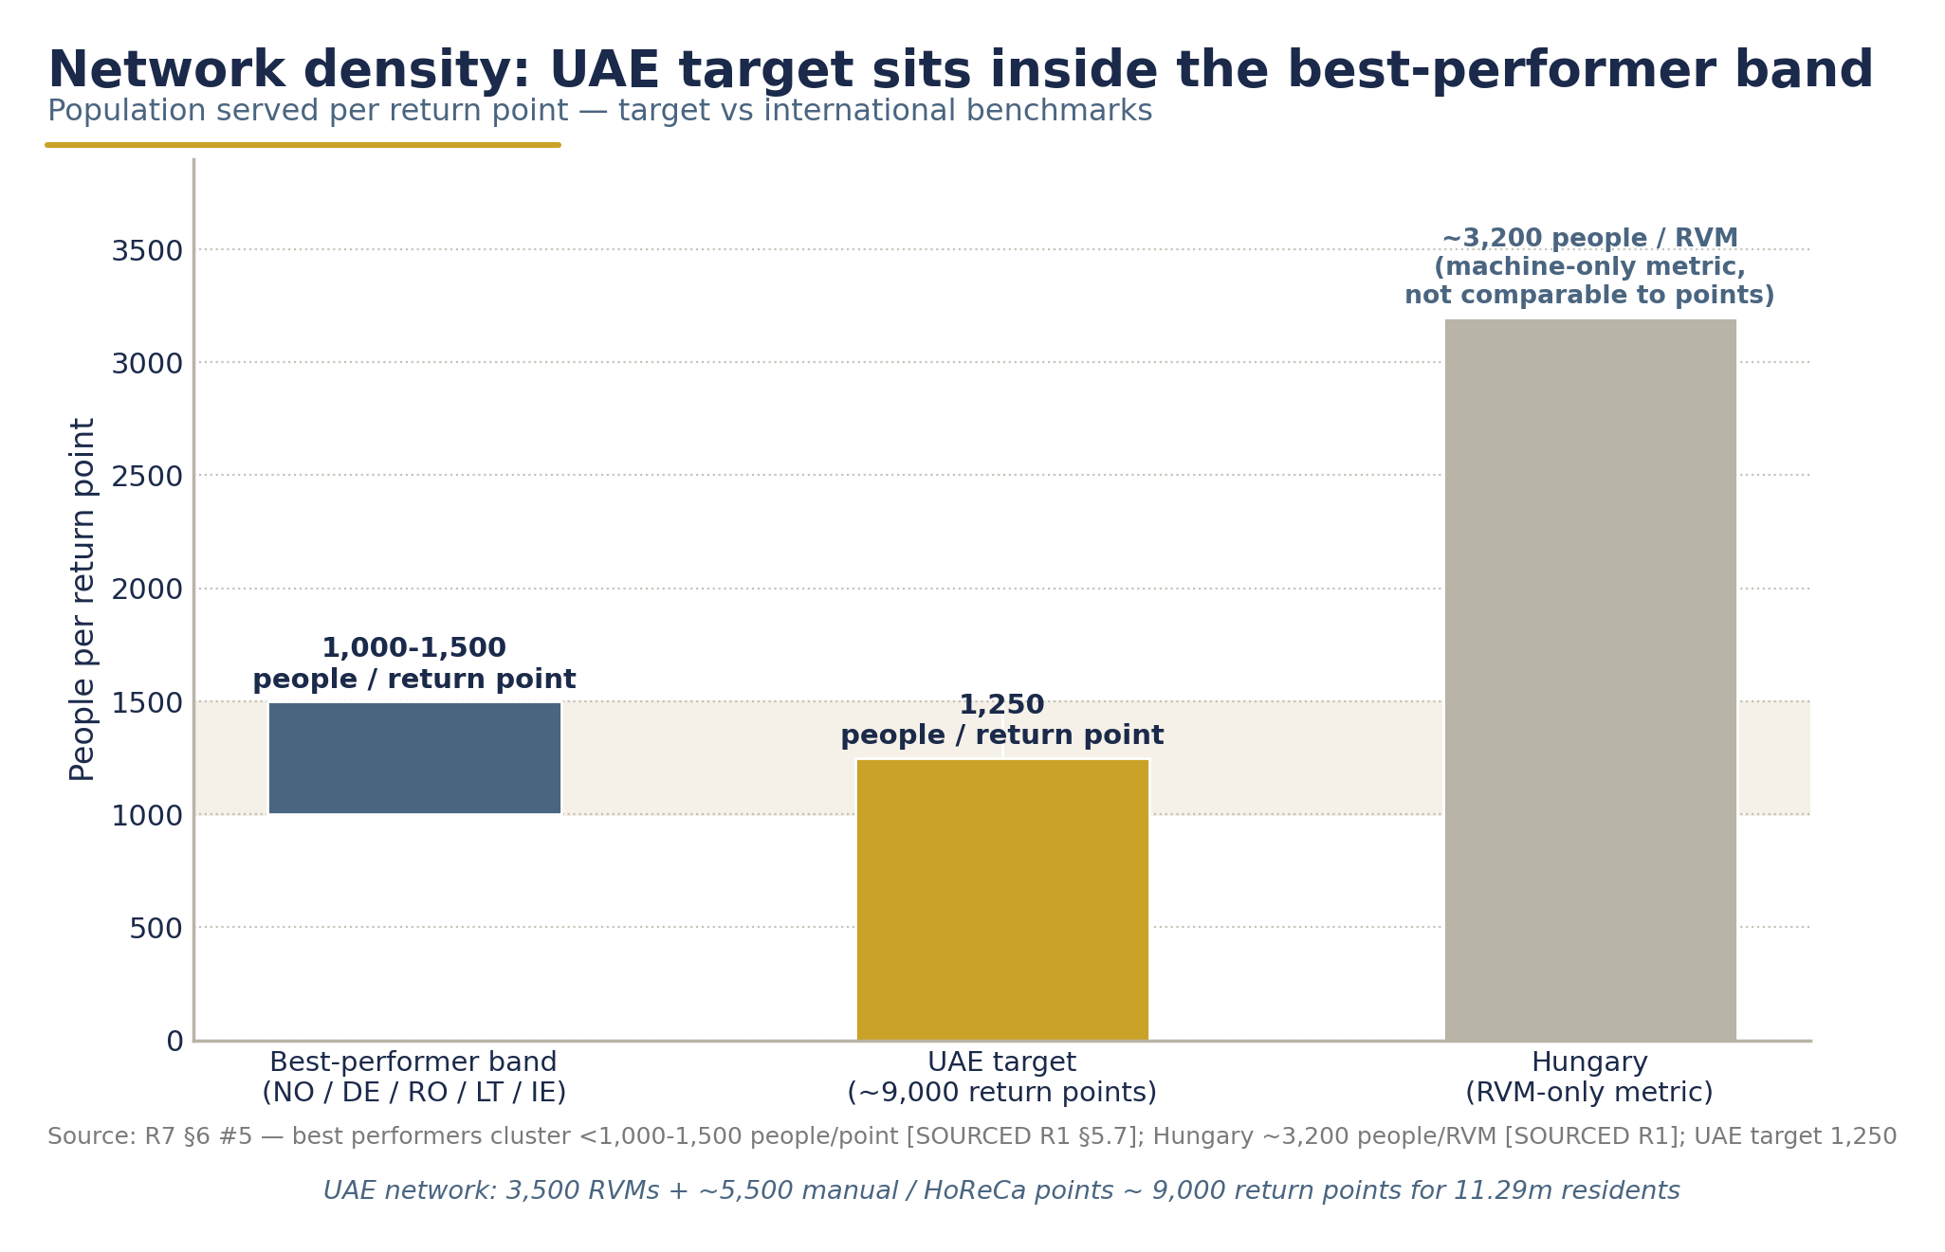
Network density - people per return point across benchmark systems vs the UAE target of ~1,250.

6.4 Logistics, counting and sorting

6.4.1 Three regional counting & sorting centres
Material flows from return points to three regional counting and sorting centres - Dubai, Abu Dhabi, and Sharjah/Northern Emirates - at a combined capital cost of AED 108M (AED 36M each). The per-centre benchmark is Romania's RetuRO: ~€8-9M average capex per regional centre of 6,000-8,000 m², with individual centres counting 280-650M packages/yr and sorting >1.2 bn/yr (Green-Forum, 2024). Three centres for a ~3.5-4 bn-unit UAE system scales directly from RetuRO's seven centres for ~7 bn units.

6.4.2 Backhaul-first logistics
Logistics design follows the Lithuanian backhaul model: delivery trucks returning from stores carry compacted empties, with counting centres co-located where possible with major retail central warehouses - the design that let USAD credit its system with near-zero additional transport and 152,400 t of avoided CO₂ (USAD, 2019). A backhaul-first architecture is what keeps the dedicated fleet modest (AED 40M vehicles & logistics capex) for a national system. Romania's scale - >1,000 collection runs per day - indicates the orchestration intensity the central platform must handle (Green News/Agerpres, 2024).

6.4.3 EAN-level traceability
Every container is reconciled twice: at the RVM (barcode read, deposit refunded, container compacted - compaction at the point of return destroys re-redemption value, the core anti-fraud control) and again at the counting centre (EAN-level verification before producer-fee and material-revenue settlement). This dual reconciliation, run against the central registration database, is the standard fraud architecture across Romania, Slovakia, Ireland and Estonia (Reloop, 2024). Only registered SKUs are redeemable; deposit payments by producers are matched monthly against placed-on-market volumes (the Hungary MOHU model; Grant Thornton, 2025).

6.5 Recycling and material offtake
A DRS's economic engine is the quality of its output: DRS-collected PET bales command a 15-25% premium over curbside MRF bales because of purity (Polyestertime, 2026) - the same "very pure, not contaminated" stream that Lithuanian operators report attracts competing bids from top European recyclers (USAD, 2019). The UAE offtake architecture maps each stream to a named domestic or export route:
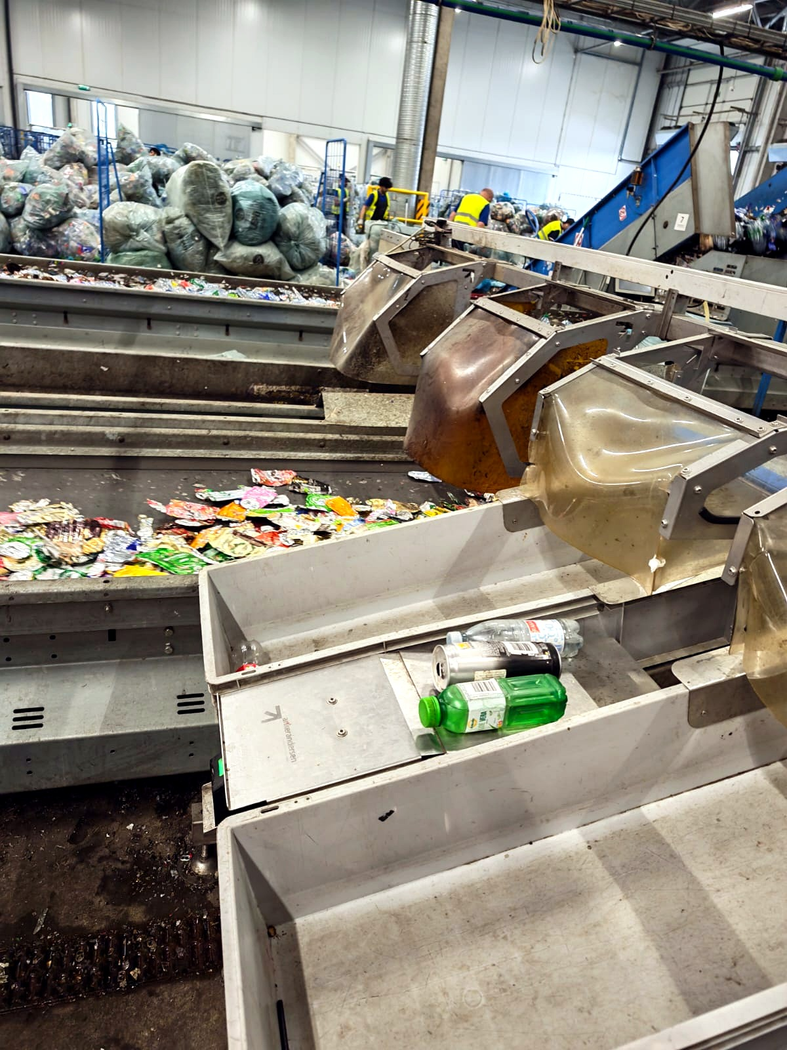
Sorting at industrial scale - optical separation line, European benchmark DRS operator facility, 2026.

Stream | Volume at 90% redemption (base case) | Offtake route | Value basis
PET | ~2.6 bn units/yr (~52 kt) | Repeet food-grade rPET plant, Abu Dhabi (12,000 t/yr; BEEAH feedstock, Agthia offtake) + DGrade KIZAD bottle-to-fibre plant (up to ~1 bn bottles/yr) | rPET base US$1,200/t (range $1,100-2,100, 2024-26)
Aluminium cans | ~594 m units/yr (~8 kt) | EGA Al Taweelah recycling plant - the UAE's largest, 185,000 t/yr capacity with scrap sorting up to 150,000 t/yr, in production from 2026 | UBC base US$1,800/t (range $1,200-2,050)
Glass | ~162 m units/yr (~32 kt) | Aggregation and export/downcycling - no UAE container-glass furnace takes high cullet intake | Cullet AED 440/t (EU €100-150/t equivalent)

Two honest caveats. First, domestic PET capacity is the binding constraint: existing bottle-to-fibre (DGrade, ~1 bn bottles/yr maximum) plus announced food-grade capacity (Repeet, 12 kt/yr - commissioning status unverified [DATA GAP: Repeet plant commissioning/operational status as of mid-2026]) fall well short of the ~52 kt/yr DRS stream; the system's success case requires additional food-grade rPET investment, which the DRS's guaranteed clean feedstock is designed to induce. Second, glass is a net-cost stream: cullet revenue rarely covers glass collection and logistics costs - the reason many systems exclude glass and the reason the UAE glass producer fee (AED 0.24) is the highest of the three (financial assumptions memo; Reloop, 2024). Aluminium is the margin engine that cross-subsidises the system; Norway, Sweden and Slovakia run zero or near-zero can fees for exactly this reason (Reloop, 2024). MENA-specific commodity price series are not publicly available; European/US/Asian benchmarks are used as proxies [DATA GAP: MENA rPET/UBC/cullet price indices].
Producers receive a right of first refusal on their own recovered material - the Dutch/Infinitum practice that closes the bottle-to-bottle loop and converts producer fees into supply security for recycled-content commitments (Reloop, 2024).

6.6 The central IT platform: the system's single source of truth
The central platform is the DRS's nervous system, budgeted at AED 30M capex / ~AED 8M per year opex. National DRS IT contract values are not publicly disclosed anywhere [DATA GAP: central-IT contract benchmarks - none published; Sensoneo company revenue >€8M in 2024 used as scale signal], but build-time is well evidenced: Slovakia's national platform was built in 6-10 months, and the dominant integrator (Sensoneo) runs the platforms of Romania, Slovakia, Malta, Ireland, Hungary, Austria, Portugal and Poland - Romania's integrating up to 90,000 stakeholders and ~80,000 collection points (Waste Management World, 2022; Sensoneo, 2024).
Five functional layers:
1. Registration database - every producer, importer, retailer, SKU and EAN barcode registered before sale; only registered containers redeemable.
2. Real-time clearing - online RVMs reconcile every transaction against the database before reimbursement; deposit flows between producers, retailers, consumers and the system administrator cleared centrally (the single-clearing-entity standard; Reloop, 2024).
3. Fraud control - compaction at point of return; mandatory DRS marking; real-time voucher validation (Malta's central voucher redemption server; Sensoneo, 2026); monthly deposit-payment/POM matching (Hungary model); international-barcode fee surcharges to price cross-border fraud risk (Estonia, Slovakia, Malta, Ireland precedent - directly relevant to a Gulf state with non-DRS neighbours). No reliable published fraud-rate figures exist for any system [DATA GAP: quantified DRS fraud rates - no published measurements; mitigation is by design, not ex-post reporting].
4. Government reporting - statutory dashboards to the Ministry of Climate Change & Environment and the Ministry of Economy & Tourism: quantities placed on market, collected and recycled, by material, emirate and channel; escrow balances; fee-review inputs.
5. Consumer-facing services - the refund channels of Section 6.7, including app-based digital-wallet refunds (Türkiye's DOA app is the closest structural analogue: hot climate, tourism-heavy, app-first; monitor its first-year results).
System money flows - producer fees and material sales fund operations; deposits pass through a ring-fenced escrow, never operator revenue.

6.7 Consumer experience and refund channels
The consumer proposition must be frictionless: buy, drink, return, instant refund. The deposit is framed as a returnable incentive, not a tax (Earth Care Consulting, 2025). Four refund channels, matching the best-performing systems:
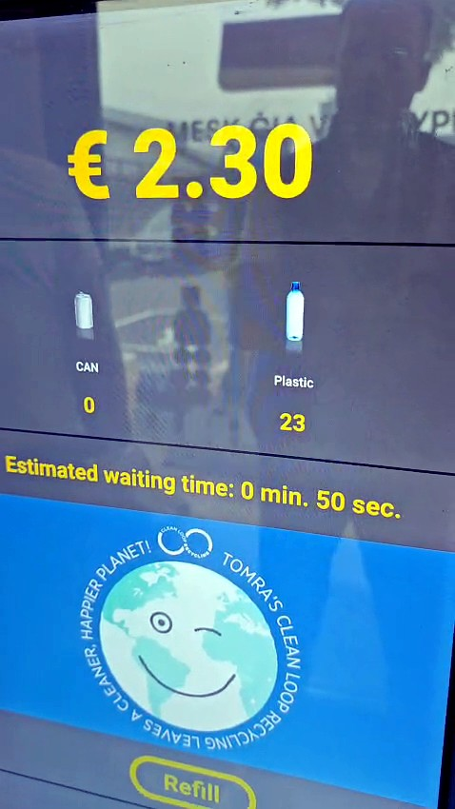
Deposit return in practice - European benchmark system (Lithuania): the refund counts up live at the RVM, €0.10 per container.

Channel | Mechanism | Precedent
Retail voucher | RVM prints redeemable voucher; spendable at the issuing retailer | Hungary: >80% of refunds taken as store vouchers; Malta voucher redemption >98% (MaltaToday, 2026)
Cash | Mandatory cash option at obligatory return points | Slovakia requires cash refund at obligatory points (Reloop, 2024); Lithuania offers cash
Digital wallet / app | Scan-to-wallet refund via national DRS app | Türkiye DOA app/e-wallet (2026); Norway's barcoded-bag online take-back
Charity donation | One-tap donation of the deposit to accredited charities | Lithuania and Norway (charity lottery) precedent - high-uptake goodwill feature (Reloop, 2024)

Lithuania's acceptance metrics are the benchmark for what a well-designed consumer experience delivers: 97% public support, 97% satisfaction with convenience, 90% reporting visibly less litter (USAD, 2018 survey). Manual return points and HoReCa integration ensure the ~61% of points that are non-automated do not become second-class channels; small-format retail serves returns with 15-30 minutes of staff time per day (DIO Latvia, 2024).

6.8 Unredeemed deposits policy: transparent escrow, zero operator benefit
This is the policy area where ministerial scrutiny will be most intense, and where the UAE design is deliberately more conservative than European practice.
The facts. At AED 0.25 on 3.74 bn units, gross annual deposits are ~AED 935M in year 1 (within the survey's AED 0.75-1.08 bn sensitivity range). Unredeemed balances are modelled at AED 421M in year 1, declining to ~AED 110M/yr at 90% redemption, with cumulative escrow of ~AED 1.8 bn by 2037 (financial assumptions memo - memo item only, never revenue).
The policy. Four binding rules:
1. Pass-through, not revenue. Deposit funds are liabilities of the system to consumers. They sit in a transparent escrow account, legally separated from DSO operating funds - the Slovak statutory model (Barikáda, 2021).
2. Segen takes zero. Segen's income is limited to the operations management fee (OMF) and the value of recovered materials. No unredeemed deposit, float income, or escrow yield accrues to Segen or any operator entity - the Project Description's verbatim pledge, enforced by the governance structure of Section 6.2.
3. Restricted uses. Unredeemed balances may be used only for (a) a system rebate/reserve stabilising producer fees across redemption cycles, and (b) consumer awareness and system-improvement programmes. Ireland's experience - where unredeemed deposits paid off setup costs but triggered a €23.7M VAT settlement and political controversy over €66.7M unclaimed (CSNA, 2025) - shows why uses must be legislated in advance.
4. Periodic public reporting. Escrow balances, flows and uses are published at defined intervals and reported to the supervising ministries, with independent audit. Portugal's state Environment Fund transfer option remains available to policymakers from year 3 (Reloop, 2024).
Design consequence: because unredeemed deposits are not operator revenue, every additional returned container adds ~AED 0.22 of variable cost against ~AED 0.09 of material value. Higher redemption is margin-dilutive at fixed fees - which is why producer fees are set on an annual cost-recovery formula, keeping system economics stable across redemption levels. Ireland's lesson, verbatim: producer fees must be set for the steady state, not the ramp-up (Re-turn 2024 Annual Report via CSNA, 2025).

6.9 Chapter summary: the operating model at a glance

Layer | Design | Key figures
Scope | PET + metal + glass, 0.1-3 L, national day-one | 3.74 bn units POM (2028 base)
Deposit | Flat AED 0.25 (non-binding recommendation) | Gross float ~AED 935M yr-1
Governance | Single centralised not-for-profit DSO/PRO; producers, importers, retailers, government observer | >80% POM founder coverage target
Collection | Return-to-retail; 3,500 RVMs + ~5,500 manual points | ~1,250 people/point; RHF AED 0.10/container
Logistics | Backhaul-first; 3 counting/sorting centres | AED 108M centres + AED 40M fleet
Offtake | Repeet & DGrade (PET); EGA Al Taweelah (cans); glass export | Material revenue AED ~331M/yr steady state
IT | Central registration, real-time clearing, fraud control, ministry reporting | AED 30M capex; 6-12-month build
Consumer | Voucher / cash / digital wallet / charity donation | AED 0.25 instant refund
Unredeemed deposits | Transparent escrow; restricted uses; public reporting; Segen takes zero | AED 421M yr-1 → ~AED 110M/yr at 90%

The system is financeable on these terms - total CAPEX of AED 664M, payback in 2031, and an unlevered project IRR of 27.7% - with the complete financial case, revenue architecture and scenario analysis set out in Chapter 10. Chapters 7 and 8 set out the legal pathway and the implementation roadmap to reach national go-live.
CHAPTER 7

Regulatory & Legal Framework

7.1 The legal starting point: an empty shelf, a prepared runway
As of July 2026, the UAE has no federal Deposit Return System legislation and no binding beverage-container collection target (ESG Mena, 2023; research brief R2). Yet the legislative runway is unusually well prepared. Four federal instruments together supply nearly every element a DRS law needs:

Existing instrument | What it already provides for a DRS
Federal Law No. 12 of 2018 on Integrated Waste Management | Anchor federal statute standardising waste management across all seven emirates; the legal basis cited for the incoming EPR framework (ESG WISE, 2025; LuLu Retail Offering Memorandum)
Ministerial Decision No. 380 of 2022 (single-use products) | Precedent for phased federal product regulation - Phase 1 bag ban (1 Jan 2024) to final-phase ban on cups, cutlery, plates, straws and foam containers (1 Jan 2026) (USDA FAS, 2023; Plastics News, 2026)
UAE Circular Economy Policy 2021-2031 | Cabinet-approved national framework (26 Jan 2021) co-authored by MOCCAE and the Ministry of Economy; names sustainable consumption a priority area (MOCCAE, 2021)
Federal Decree-Law No. 11 of 2024 (Climate Change Law) | GHG measurement, reporting and verification architecture - the statutory home for DRS carbon claims (ESG WISE, 2025)

In parallel, the National Agenda for Integrated Waste Management 2023-2026 - 19 strategic projects targeting treatment of 80% of municipal solid waste - has established delivery machinery and ministerial attention around exactly this policy space (WAM, 2024).
The policy logic is now sequential. With the 1 January 2026 single-use plastics ban in force, PET, metal and glass beverage containers are the dominant remaining single-use packaging stream. A DRS is the natural policy sequel - and the region's only proven instrument for lifting container collection above 90%, versus kerbside systems that rarely exceed 50% (Reloop, 2026).
"The shift to a circular economy will require concerted effort from national and local government, the private sector, and general public… a call to action for all stakeholders."
- H.E. Mariam Almheiri's successor-era framing of the Circular Economy Policy launch, MOCCAE (2021)

7.2 Two viable instrument pathways - and a recommended hybrid

Option A - Cabinet Resolution under Federal Law No. 12 of 2018
A Cabinet Resolution, issued on the joint proposal of MOCCAE and the Ministry of Economy & Tourism, could establish the DRS as implementing regulation under the existing waste statute. This mirrors how Ministerial Decision No. 380 of 2022 delivered the phased single-use plastics regime.
• Advantages: speed (no federal legislative cycle); precedent-tested; can be amended annually as fee and deposit levels are reviewed; nests naturally inside the expected 2026 national EPR framework built on the same statute (ESG WISE, 2025).
• Limitations: subordinate legislation is a weaker foundation for (i) licensing a national system operator with long-duration exclusivity, (ii) mandating escrow and ring-fencing of deposit funds, and (iii) imposing penalties at the AED 100,000-1,000,000 scale reported for EPR reporting violations (ESG WISE, 2025 - single secondary source; verify against the final regulation).

Option B - New federal decree-law ("Beverage Container Deposit Return Law")
A dedicated decree-law would give the scheme maximal legal durability: statutory creation of the DSO licence, statutory escrow, statutory collection targets, and full enforcement powers.
• Advantages: strongest investor certainty for an AED 664 million capital programme (R7); clean authority for escrow ring-fencing and audit; alignment with the Lithuania model, where a dedicated packaging law (May 2014) preceded launch (USAD, 2019).
• Limitations: longer passage; risk of re-opening scope debates (glass inclusion, deposit level) late in the process - the dynamic that stalled Spain's legally-mandated SDDR even after Royal Decree 1055/2022 (RTVE, 2024; PPWR Atlas, 2026).

Recommended hybrid: resolve fast, entrench later
Phase the instruments. Issue a Cabinet Resolution under Federal Law No. 12 of 2018 in 2027 to launch the scheme, DSO licensing, escrow and reporting; simultaneously begin drafting a federal decree-law to entrench the regime by 2029-2030, once operational data exists and the EPR framework's final form is known. This is the pragmatic middle path between Scotland's over-built legal structure that collapsed on a trade-law conflict (Insider, 2023) and Spain's under-specified mandate that stalled on operator authorisation (PPWR Atlas, 2026).
[DATA GAP: No UAE federal DRS bill, draft regulation, or official public consultation has been published as of 26 July 2026 (R2 §3.1). This chapter's pathway analysis is therefore a proposal, not a description of a live process.]

7.3 Institutional roles: a two-ministry sponsorship
The study is addressed jointly to the two ministries whose mandates the DRS straddles:

Institution | Proposed DRS role | Basis
MOCCAE (Minister: Dr. Amna bint Abdullah Al Dahak) | Lead regulator: federal waste policy, single-use plastics regime, EPR programme, environmental targets, MRV of outcomes | Owns Federal Law 12/2018 implementation and signed the 2025 EPR pilot with Tadweer as PRO (Gulf News, 2025)
Ministry of Economy & Tourism (Minister: H.E. Abdulla bin Touq Al Marri) | Co-sponsor: producer/importer registration interface, trade and market-conduct oversight, chair of the UAE Circular Economy Council | Chaired the Council's first restructured meeting on 9 Dec 2024, covering the Aluminium Recycling Coalition and Circular Economy Innovation Platform (UAE Ministry of Economy, 2024)
UAE Circular Economy Council | Standing governance forum for DRS policy review (deposit level, fee reviews, scope extensions) | Existing cross-government body (UAE Ministry of Economy, 2024)
Emirate environment & waste authorities (EAD, Dubai Municipality, Sharjah/BEEAH, others) | Implementation partners: siting, licensing of collection points, municipal logistics interfaces, local enforcement | See §7.4
DSO (licensed operator) | Not-for-profit system operator: registration, clearing, escrow administration, logistics, reporting | Single centralised not-for-profit PRO is the dominant best-practice model (Reloop GDB, 2024)

7.4 Emirate-level implementation agreements
A federal DRS operates physically at emirate level. The legislative package should be accompanied by implementation agreements with each emirate's waste authority, modelled on the structures already in place:
• Abu Dhabi - Tadweer Group. The natural lead partner: Tadweer already acts as PRO for the federal EPR pilot covering packaging (Gulf News, 2025), holds the TOMRA MoU for a bottle-returns programme covering PET, glass and cans (Tadweer Group, 2024), operates 25 RVMs linked to its rewards platform (Gulf News, 2024), and is building a 1.3 Mt/yr MRF within a "circular cluster" (Plant Machinery Vehicles, 2025). The DRS's Abu Dhabi counting centre (one of three in the CAPEX plan, R7) should be co-located with Tadweer infrastructure.
• Dubai - Dubai Municipality. Law No. (18) of 2024 Regulating Waste Management already mandates source segregation and licenses haulers - the local statutory hook for DRS collection-point licensing (Dubai Legislation Portal, 2024). Dubai's Integrated Waste Management Strategy 2021-2041 targets zero waste to landfill by 2041; a DRS is the highest-yield single instrument toward that target for the beverage stream (P&S Intelligence, 2025). Dubai Municipality has run its own RVM pilot (Kiosk Marketplace, 2023).
• Sharjah - BEEAH Group. ~90% landfill diversion already claimed (BEEAH, 2023 - company-reported); the northern-emirates counting centre should interface with BEEAH's material-processing footprint.
• Northern emirates. Served via the third counting centre and retail-network obligations; no emirate should be exempted - day-one national coverage is the proven launch pattern (Lithuania 2016, Slovakia 2022, Romania 2023, Hungary 2024, Ireland 2024, Austria 2025) (Reloop, 2026).
Each agreement should cover: siting approvals for RVMs and counting centres; integration with municipal collection logistics; data-sharing obligations; and local enforcement delegation. Legal alignment across emirates must be secured before operator contracts are signed - Scotland's failure, where the operator collapsed with £86.2m in liabilities after a cross-border legal conflict surfaced, is the standing warning (Insider, 2023).

7.5 Alignment with the expected 2026 national EPR framework
The single most consequential design decision is to nest the DRS inside the EPR architecture, not alongside it. The 3 July 2025 MOCCAE-Tadweer EPR pilot - covering packaging, with Tadweer as PRO and 26 companies participating - creates exactly the institutional machinery (producer registration, reporting, a PRO) into which a deposit system slots (Gulf News, 2025; Packaging MEA, 2025). UAE advisors themselves describe DRS as "the foundation for EPR" (Waste & Recycling MEA, 2026).
Concretely, the DRS legislation should provide that:
1. Producer registration under the DRS counts as registration under the EPR packaging regime - one registry, one reporting portal.
2. DRS producer fees discharge the producer's EPR financial obligation for in-scope beverage containers - no double-charging. Recommended reference fees: AED 0.20 / 0.08 / 0.24 per PET / aluminium / glass container, calibrated for steady-state cost recovery (R7; non-binding reference for policymakers).
3. The DSO's audited return-rate data feeds the EPR target-compliance MRV - one data spine for both regimes.
This integration is also the financial keystone: because unredeemed deposits in the UAE design sit in a transparent escrowed reserve and never accrue to the operator, the system's self-financing role is carried by producer fees - which is why the recommended UAE fees sit at the top of the EU benchmark range (R7 §5, §7).

7.6 Timeline: 18-24 months from legislation to launch
Global benchmarks are consistent on duration:

System | Law/decision → national launch | Duration
Lithuania (USAD) | Law May 2014 → launch 1 Feb 2016 | ~18 months (USAD, 2019)
Slovakia | Decision → 1 Jan 2022 national launch | ~2 years (Reloop GDB, 2024)
Ireland (Re-turn) | Operator formation → 1 Feb 2024 | ~18 months (Re-turn, 2025)
Romania (RetuRO) | Decision → 30 Nov 2023 | ~2 years (Reloop GDB, 2024)
Türkiye | Announced 2021 → launched 1 Jul 2026 | ~5 years - the cautionary case (AdsaleCPRJ, 2026)

The planning basis for the UAE is 18-24 months from Cabinet Resolution to full national launch in 2028. Türkiye's five-year slide shows the risk is real even with legislation in place; Scotland shows the cost of signing infrastructure contracts before the legal framework is final (Insider, 2023). Both lessons are priced into the roadmap in Chapter 8.

7.7 Draft Legislative Outline (structured annex)
The following article-by-article outline translates the design into a drafting skeleton for legislative counsel. It is a working annex for policymaker discussion - non-binding.
ANNEX 7-A - DRAFT LEGISLATIVE OUTLINE: Cabinet Resolution on the National Beverage Container Deposit Return System
Chapter I - Definitions and Scope
- Art. 1 Definitions: beverage container, deposit, producer, importer, retailer, DSO, return point, escrow account.
- Art. 2 Scope: single-use beverage containers of PET, metal (aluminium/steel) and glass, 0.1-3 L, covering water, soft drinks, juices, beer and other beverage categories as scheduled. (Lithuania/Romania scope precedent: USAD, 2019; Reloop GDB, 2024.)
- Art. 3 Exemptions: containers for export; refillable containers under separate regime; dairy-based beverages at launch, reviewable at year-2 statutory review.
Chapter II - The Deposit
- Art. 4 A refundable deposit applies to every in-scope container placed on the market. Reference value (non-binding, set by Cabinet schedule): AED 0.25 flat across materials and sizes - flat deposits dominate all recent fast-ramping systems (Reloop, 2026; R7 §4).
- Art. 5 Deposit displayed separately at point of sale; refundable in cash, voucher or digital credit.
- Art. 6 Deposit review: statutory review at year 2 against achieved return rate and regional benchmarks (incl. Türkiye's first-year results) (R7 §4).
Chapter III - Registration and Market Obligations
- Art. 7 All producers and importers of in-scope beverages must register with the DSO before placing containers on the market; unregistered products may not be sold (centralised barcode registration - standard fraud control, Reloop GDB, 2024).
- Art. 8 Mandatory deposit mark/logo and barcode registration per SKU; international-barcode surcharge mechanism permitted (Estonia/Slovakia/Malta/Ireland precedent).
- Art. 9 Retailers above a defined floor-area threshold must accept returns of all in-scope materials; small-format exemptions per schedule (Lithuania: ≤300 m² urban / ≤60 m² rural exemption precedent).
- Art. 10 Producer fees payable on all units placed on market, per material schedule; annual cost-recovery review mechanism (Hungary MOHU monthly model; Ireland/Latvia methodology - R7 §5).
Chapter IV - The Deposit System Operator
- Art. 11 MOCCAE (with MOET concurrence) licenses a single national DSO for an initial term; licensing criteria: not-for-profit operation, industry and government governance participation, financial adequacy.
- Art. 12 DSO duties: central clearing, barcode registry, logistics and counting, material marketing, consumer awareness, data reporting.
- Art. 13 DSO capitalisation and delay-resilience requirements - operator must be capitalised for delay scenarios (Scotland lesson: Circularity Scotland folded with £86.2m liabilities, Insider, 2023).
Chapter V - Deposit Funds and Escrow
- Art. 14 All deposit monies are pass-through liabilities held in a transparent, ring-fenced escrow account; they are not revenue of the DSO, the operator consortium, or any private party. Unredeemed balances accrue to a transparent system reserve administered under Cabinet-approved rules (Slovakia "transparent account" / Portugal state-fund models; R7 §7).
- Art. 15 Independent annual audit of the escrow and clearing system; audit reports published.
- Art. 16 The operator's remuneration derives exclusively from contracted operations-management fees and recovered-material value, as per its licence. The operator earns nothing from unredeemed deposits.
Chapter VI - Targets, Reporting and Enforcement
- Art. 17 Statutory collection targets on a published ramp (reference: 55% year 1 rising to 90% by year 7 - R7; Romania statutory ramp precedent: Interreg Europe, 2025).
- Art. 18 Quarterly DSO reporting to MOCCAE/MOET; annual public report; data feeds the Climate Change Law MRV (Federal Decree-Law 11/2024).
- Art. 19 Penalties for non-registration, misreporting and fraud; alignment with EPR penalty scales (reported AED 100,000-1,000,000 - ESG WISE, 2025; verify against final EPR regulation).
- Art. 20 Enforcement delegation to emirate authorities under implementation agreements.
Chapter VII - EPR Integration and Transitional Provisions
- Art. 21 DRS registration and fees discharge EPR packaging obligations for in-scope containers.
- Art. 22 Transitional sell-through period for pre-marked stock; voluntary schemes (EAD bottle-return, Tadweer-TOMRA, retail RVM networks) may apply for recognition as authorised return points.

CHAPTER 8

Implementation Roadmap 2026-2030

8.1 Design principles for the national rollout
Three benchmark lessons govern the roadmap:
1. Launch nationally, day one. Lithuania, Slovakia, Malta, Romania, Hungary, Ireland and Austria all launched nationally in a single step; none phased by region (Reloop, 2026).
2. Legislate before you build. Scotland signed infrastructure contracts before its legal framework was final and paid £86.2m for the mistake (Insider, 2023). The UAE sequence below puts the Cabinet Resolution ahead of all irrevocable capital commitments.
3. New systems reach 80-90% within 12-24 months when deposit and network density are right: Romania 84% at month 11, Hungary 88.8% in year 2, Austria 81.5% in year 1, Ireland 91% in-scope recycling by year 2 (Reloop, 2026; Oireachtas, 2025). The UAE plan adopts a deliberately more moderate ramp - 55% in year 1 to 90% by year 7 (R7) - reflecting first-in-region status and network build-out.

8.2 Phase plan
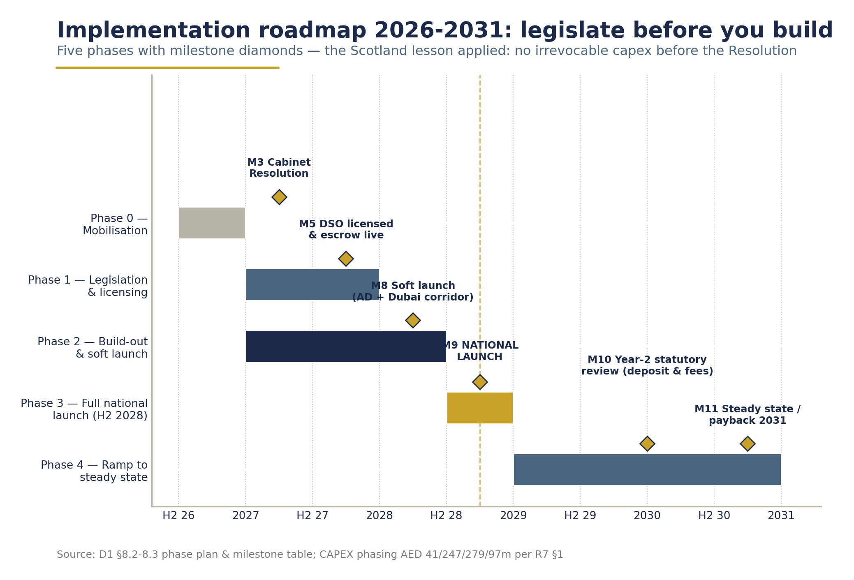
Implementation roadmap 2026-2030 - phases, milestones, the 55% → 90% return-rate ramp and CAPEX phasing.

Phase 0 - Mobilisation (H2 2026)
Owner: MOCCAE + MOET joint programme office; Segen / Earth Care as advisors
• Establish the joint ministerial programme office and DRS steering committee under the UAE Circular Economy Council.
• Confirm the legal pathway (§7.2) and instruct legislative counsel on the Cabinet Resolution (Annex 7-A as drafting basis).
• Begin producer/importer volume validation - the PET placed-on-market figure (2.90bn base case) is survey-modelled and must be validated against producer/importer SKU data before fee levels are fixed (R7; R5 caveat).
• Open structured consultation with producers, retailers, waste operators (see Chapter 9).
• Deliverable: DRS policy paper approved by both ministries; drafting instructions issued.

Phase 1 - Legislation & operator licensing (2027)
Owner: MOCCAE (lead), MOET (co-sponsor), Cabinet Affairs
• Cabinet Resolution issued under Federal Law No. 12 of 2018 (target: H1 2027).
• DSO licence competition and award (target: H2 2027); SPV formation with not-for-profit charter, governance including industry and government representation (Romania 20% state / 80% industry precedent).
• Escrow and clearing-bank arrangements executed; independent auditor appointed.
• Emirate implementation agreements signed with Tadweer (Abu Dhabi), Dubai Municipality, BEEAH (Sharjah) and northern-emirate authorities.
• EPR integration instrument agreed so DRS registration discharges EPR packaging obligations (§7.5).
• CAPEX 2027: AED 247m committed (R7) - central IT platform build starts (6-12 month build, Slovakia-type precedent), counting-centre sites secured.
• Gate: No irrevocable RVM fleet orders before the Resolution is in force and emirate agreements signed.

Phase 2 - Build-out (2027-H1 2028)
Owner: DSO; oversight: programme office
• RVM procurement and installation toward the 3,500-machine national fleet (AED 385m installed, R7); network plan toward ~9,000 return points (~1,250 people/point - within the <1,000-1,500 band where best performers cluster, Reloop GDB, 2024).
• Three counting/sorting centres under construction: Dubai, Abu Dhabi (co-located with Tadweer), Sharjah/Northern Emirates (AED 108m total, R7).
• Central IT: barcode registry, clearing, escrow interface, retailer settlement, consumer app/refund rails; cybersecurity and fraud-control penetration testing.
• Producer/importer registration wave; SKU barcode registration; deposit-mark artwork transition (12-month sell-through for legacy stock).
• Retailer onboarding: hosting agreements for RVMs at large-format stores; manual return-point contracts for small format and HoReCa.
• Soft launch (H1 2028): pilot geography (recommended: Abu Dhabi city + one Dubai corridor, building on EAD's 100+ Sparklomat RVM estate and Tadweer's 25 RVMs) to stress-test clearing, settlement and consumer UX at limited scale.
• CAPEX 2028: AED 279m (R7) - the peak build year.

Phase 3 - Full national launch (H2 2028)
Owner: DSO; regulator: MOCCAE
• Deposit goes live nationally on a single date across all seven emirates; ~3.74bn containers/year placed on market enter the deposit regime (R7 base case).
• National consumer campaign (Arabic/English creative; tourism-channel messaging) - Lithuania's experience shows public acceptance follows visible convenience: 97% support within two years of launch (USAD, 2019).
• Year-1 target: 55% return rate (R7) - deliberately below the fastest EU launches.
• Deposit float at year 1: gross annual deposits ~AED 935m, held in transparent escrow (memo item - never operator revenue, R7).

Phase 4 - Ramp to steady state (2029-2030)
Owner: DSO; oversight: programme office
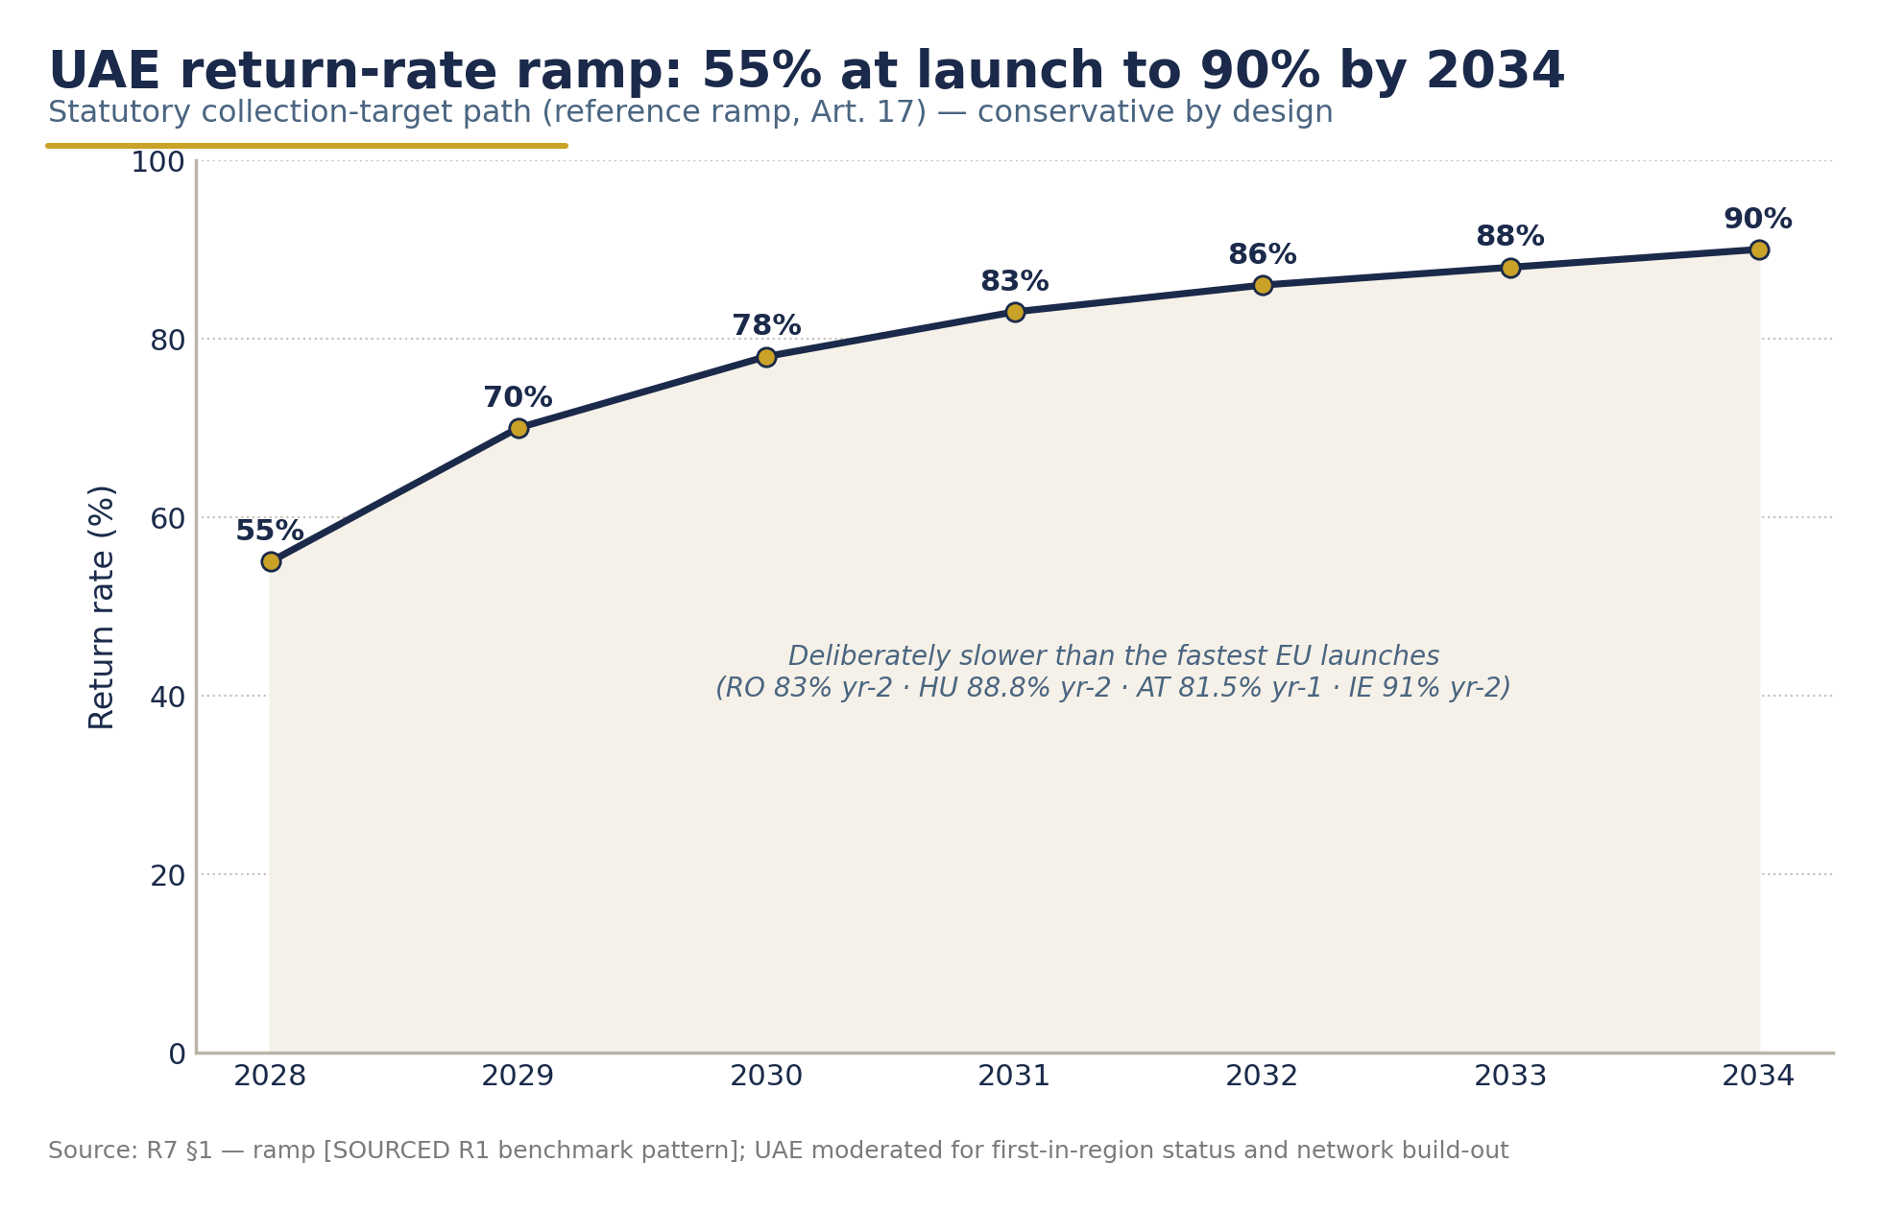
Statutory return-rate trajectory - 55% at launch rising to 90% by 2034.
• Return-rate ramp: 70% (2029) → 78% (2030) on the path to 90% by 2034 (R7).
• First statutory reviews: deposit level and producer fees at year 2 (2030) against achieved rates, cost-recovery formula, and Türkiye's first-year results (R7 §4).
• Remaining CAPEX: AED 97m in 2029 completes the programme (total AED 664m, R7).
• Eco-modulation of producer fees (coloured PET, sleeves) introduced at first review - now standard practice in Finland, Norway, Slovakia, Romania, Estonia (Reloop, 2026).
• Federal decree-law drafting to entrench the regime (§7.2 Option B) informed by two years of operational data.
• Financial trajectory: system payback 2031 (year 4 of operations); steady-state EBITDA margin ~9-10% of revenue (R7).

8.3 Milestones, owners and dependencies

# | Milestone | Target | Owner | Critical dependencies
M1 | Joint programme office stood up | Q4 2026 | MOCCAE + MOET | Ministerial sponsorship confirmed
M2 | POM volume validation complete | Q1 2027 | Programme office / DSO-designate | Producer & importer SKU data access
M3 | Cabinet Resolution issued | H1 2027 | Cabinet / MOCCAE | Legal pathway decision (§7.2)
M4 | Emirate implementation agreements signed | H2 2027 | MOCCAE + Tadweer / Dubai Municipality / BEEAH / N. emirates | M3
M5 | DSO licensed & capitalised; escrow live | H2 2027 | MOCCAE/MOET; DSO shareholders | M3; Scotland-capitalisation lesson applied
M6 | Central IT platform accepted | H1 2028 | DSO | M5; fraud-control penetration test passed
M7 | Counting centres (3) commissioned | H1-H2 2028 | DSO + emirate partners | M4; site approvals
M8 | Soft launch (Abu Dhabi + Dubai corridor) | H1 2028 | DSO | M5, M6; ≥300 RVMs installed
M9 | National launch - deposit live | H2 2028 | DSO / MOCCAE | M6-M8; ≥80% of planned return network live
M10 | Year-2 statutory review (deposit & fees) | 2030 | Circular Economy Council | 2 years of audited operating data
M11 | Steady state: ≥83% return rate; system payback | 2030-2031 | DSO | M9, M10

CHAPTER 9

Risk Register, KPI Framework & Stakeholder Engagement Plan

9.1 Risk register & mitigation
Fourteen principal risks, scored for likelihood (L) and impact (I) on a 1-5 scale, with mitigations and owners. Benchmark-derived risks are cited to the system that experienced them.

# | Risk | L | I | Mitigation | Owner
R1 | Legislative delay - Cabinet Resolution slips, compressing build-out (Türkiye slipped ~5 years; Poland delayed Jan→Oct 2025) | 3 | 5 | 18-24-month planning buffer already embedded; hybrid instrument path (§7.2); early drafting instructions in Phase 0; political sponsorship by two ministries | MOCCAE / MOET
R2 | Cross-emirate legal misalignment - emirate rules conflict with federal scheme post-contract (Scotland: operator folded, £86.2m liabilities; Biffa suing for £166m) | 2 | 5 | Emirate implementation agreements signed before DSO licence and any irrevocable capex (Gate, Phase 1); federal primacy clause in the Resolution | MOCCAE
R3 | DSO under-capitalisation / delay insolvency (Circularity Scotland precedent) | 2 | 5 | Statutory capitalisation requirement (Art. 13); peak funding AED 294m pre-arranged; 60/40 debt/equity with green-loan structuring (Romania €85-90m precedent, R7) | DSO shareholders
R4 | POM volumes mis-estimated - PET base 2.90bn is survey-modelled (range 2.1-3.8bn) | 3 | 4 | Mandatory Phase 0 producer/importer SKU validation (M2); fees set on annual cost-recovery formula so economics hold across volume scenarios (R7 §3) | Programme office
R5 | Producer-fee resistance - fees at top of EU range (AED 0.20/0.08/0.24) trigger industry pushback | 3 | 4 | Transparent fee methodology published with the Resolution; fees discharge EPR obligations (no double charge); fee-review clause with downside protection (±20% reset mechanic, R7) | MOET
R6 | Return-rate underperformance - consumer adoption slower than ramp (each ±5 pts moves project IRR by ~16 pts, R7 §3) | 3 | 4 | AED 0.25 deposit sized for UAE income levels; dense network (~1,250 people/point); national campaign; soft-launch correction loop; note: higher redemption is margin-dilutive at fixed fees, so fee formula is the true stabiliser (R7) | DSO
R7 | Retailer friction on hosting economics (Hungary: large retail partners publicly frustrated by handling-fee economics, 2025) | 3 | 3 | RHF benchmarked to Ireland (AED ~0.10/container, R7); small-retailer RVM support grants (Ireland €1,000-3,000 precedent); early retail working group (§9.3) | DSO
R8 | Fraud & cross-border leakage - GCC neighbours have no DRS; UAE tourism/transit flows are large | 3 | 3 | Moderate flat deposit (fraud/incentive balance principle, USAD); centralised barcode clearing; mandatory deposit mark; international-barcode surcharge; export exemption documentation (Art. 3) | DSO / customs authorities
R9 | Incumbent-operator resistance - existing voluntary RVM networks (Sparklo, RECAPP) or waste incumbents contest the scheme (Spain stalled on incumbent PRO resistance) | 3 | 3 | Recognition pathway for existing RVM estates as authorised return points (Art. 22); procurement neutrality; early engagement (§9.3) | Programme office
R10 | rPET/UBC price collapse - material revenue ~30% of steady-state income; ±30% rPET price swings IRR ~29 pts (R7 §3) | 3 | 3 | Fee formula absorbs commodity cycles; floor-price offtake agreements with regional recyclers (EGA aluminium ecosystem); eco-modulation revenue | DSO
R11 | Glass economics drag - glass is a net-cost stream (cullet ~AED 440/t rarely covers logistics; no UAE furnace offtake) | 4 | 2 | Glass fee AED 0.24 already priced as net-cost stream (R7); glass return-rate target set 5 pts below PET/metal (Lithuania pattern); review scope at year-2 review | DSO
R12 | Escrow/float governance criticism - public or producer suspicion over AED 935m/yr deposit flows | 2 | 4 | Statutory ring-fenced transparent escrow (Art. 14-16); published independent audits; explicit rule that the operator earns zero from unredeemed deposits | MOCCAE / DSO auditor
R13 | IT/clearing failure at launch - settlement or barcode-clearing outage in launch weeks | 2 | 4 | Soft launch as live stress test; Slovakia-type 6-12-month build with acceptance testing; manual-fallback refund procedures | DSO
R14 | Tourism-channel underperformance - containers consumed in hotels/events/airports bypass return points | 3 | 3 | HoReCa return-point obligations (Lithuania: 700 HoReCA points); airport/hotel RVM partnerships (Tabreed-Sparklo precedent at Ferrari World/Yas, 2025); event-deposit schemes | DSO / Dubai Municipality / DMT

Residual-risk statement: with mitigations applied, no risk remains above the "manageable" threshold except R1 (legislative delay), which is inherently a ministerial-domain risk - reinforcing the case for early, visible two-ministry sponsorship.
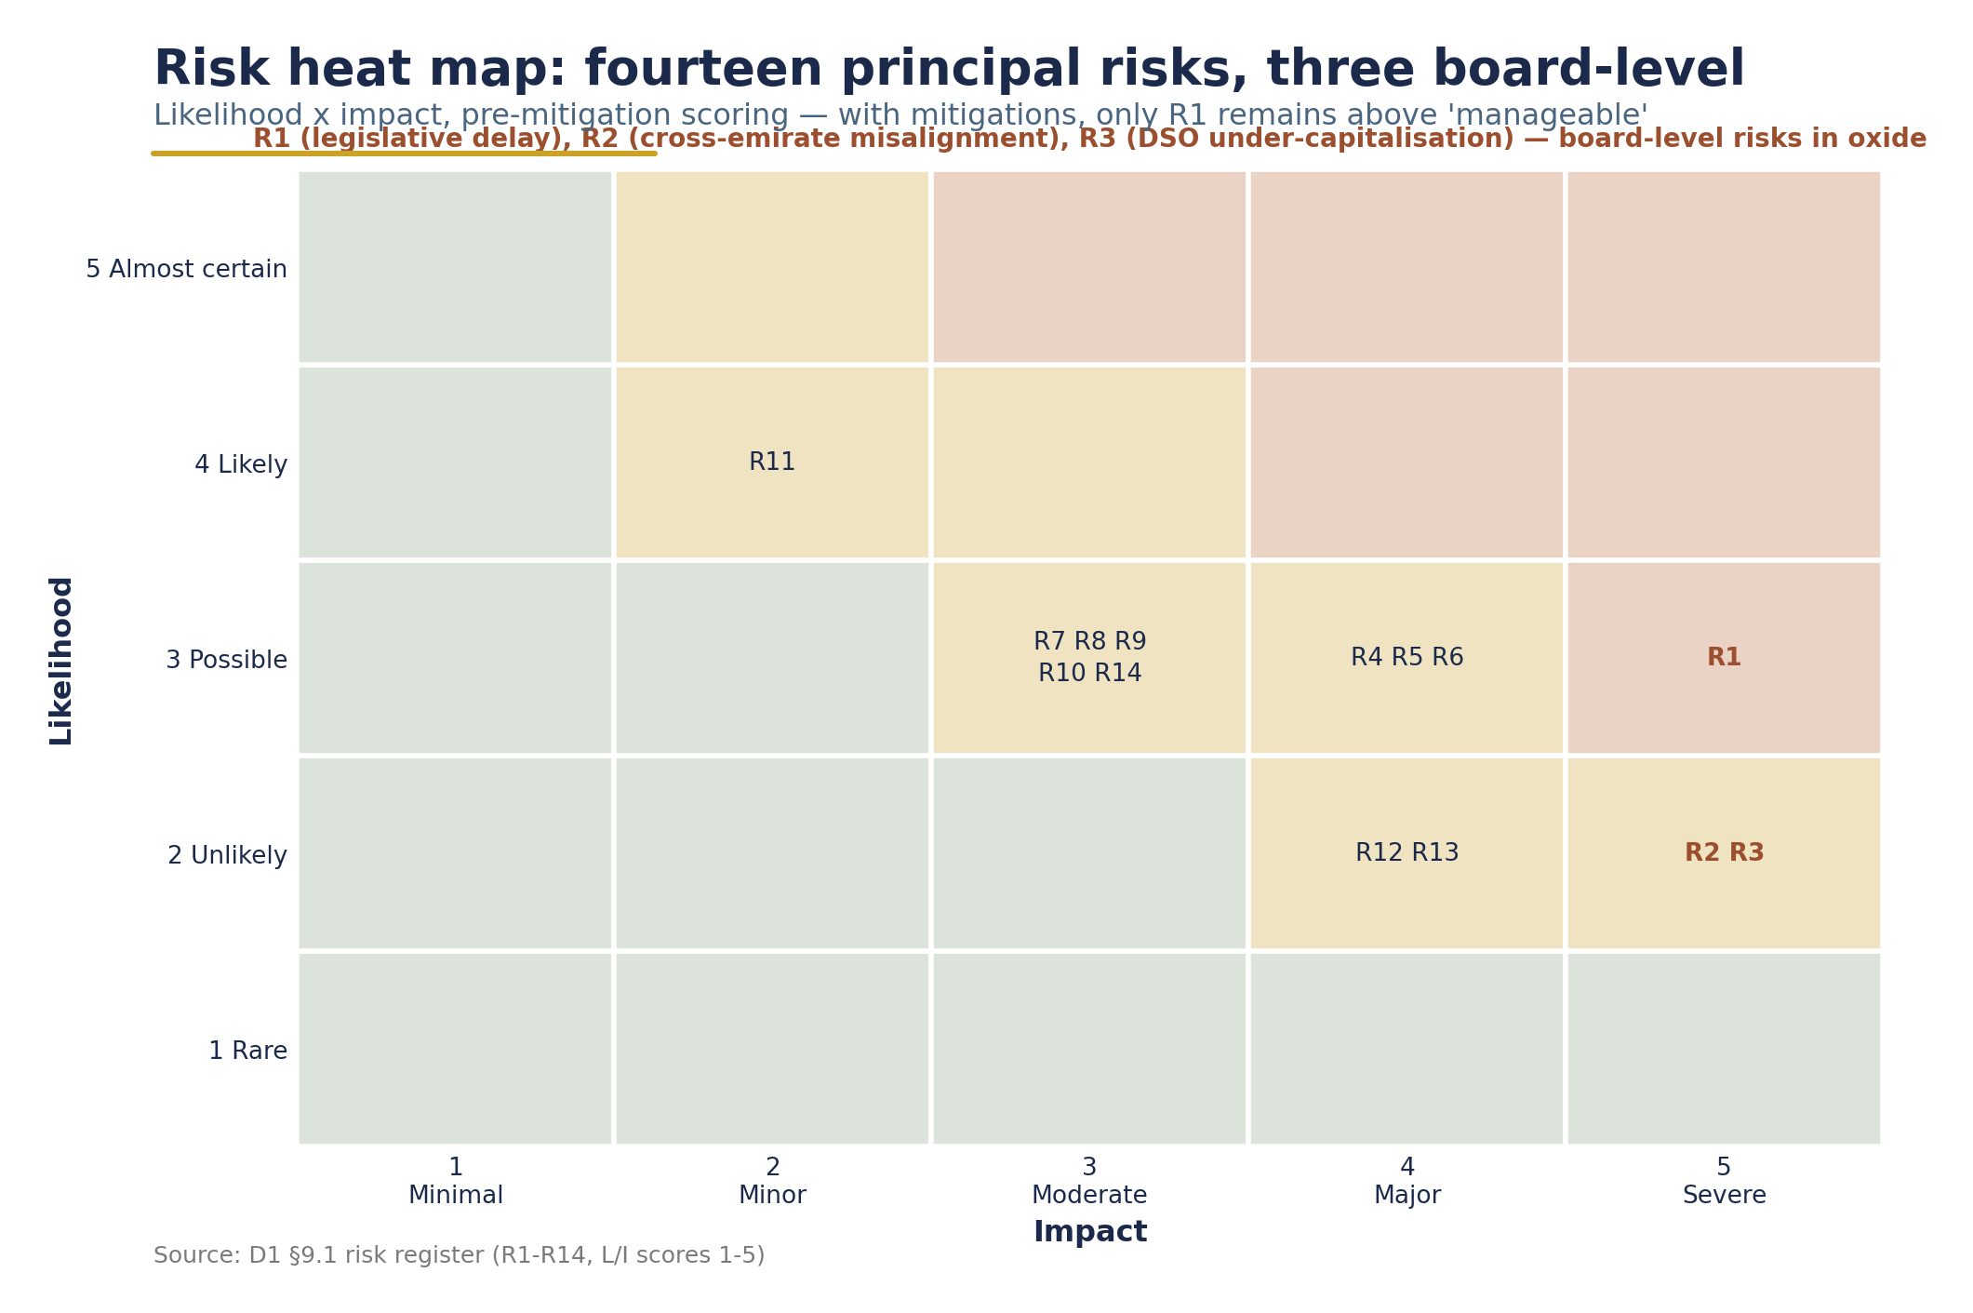
Risk heat-map - R1-R14 plotted by likelihood and impact; R1, R2 and R3 flagged as the three board-level risks.

9.2 KPI framework & MRV protocol

KPI framework

KPI | Definition | Year-1 target (2028/29) | Steady-state target (2034) | Benchmark anchor
Return rate (total & by material) | Returned ÷ placed on market | 55% | 90% | EU DRS median 91% (Reloop, 2026); ramp per R7
Cost per returned container | Total system OPEX ÷ returned units | ≤ AED 0.27 | ≤ AED 0.29 | Ireland €0.053 direct / €0.071 all-in year 1 (R7, citing R4)
Material purity | Contamination rate of DRS bales by material | ≤ 3% | ≤ 2% | DRS streams "very pure"; premium pricing vs Green Dot stream (USAD, 2019)
Litter reduction | Beverage-container share of litter (annual litter survey) | −30% vs 2027 baseline | −70% | 90% of Lithuanians report visibly less litter (USAD, 2019)
Jobs created | Direct SPV + logistics/indirect FTEs | ~800 | ~1,200-1,500 | Romania 800+ direct for ~7bn-unit system (R7, citing R4)
Network density | People per return point | ≤ 1,500 | ≤ 1,250 | Best performers cluster <1,000-1,500 (Reloop GDB, 2024)
Refund convenience | % refunds completed <60 seconds; % digital refunds | ≥ 95% / ≥ 40% | ≥ 98% / ≥ 60% | Hungary: >80% of refunds taken as vouchers (Reloop GDB, 2024)
CO₂ avoided | Tonnes CO₂e vs landfill/incineration baseline | Reported | Reported | Lithuania 152,400 t since launch (USAD, 2019); feeds NDC 3.0 (−47% by 2035) (UNFCCC, 2024)
Escrow integrity | Unqualified independent audit of deposit escrow | Annual, unqualified | Annual, unqualified | Slovakia "transparent account" model (R7, citing R4)
Producer compliance | % of POM units from registered producers | ≥ 95% | ≥ 99% | Centralised registration standard (Reloop GDB, 2024)

MRV protocol for ministry reporting
The DRS's monitoring, reporting and verification stack should be designed once, to serve three masters - the DRS regulator, the EPR framework, and the Climate Change Law (Federal Decree-Law No. 11 of 2024):
1. Measurement. Every returned container is counted at machine or counting-centre level by barcode/material; POM is declared by registered producers monthly (Hungary MOHU model, R7). No estimates in the primary data spine.
2. Reporting. DSO publishes quarterly dashboards (return rate by material and emirate, cost per container, network uptime) and an audited annual report; data feeds MOCCAE's EPR compliance registry and the National Agenda for Integrated Waste Management successor framework.
3. Verification. Three independent layers: (i) annual financial & escrow audit; (ii) annual environmental audit (material mass-balance: POM → returns → recycler offtake); (iii) carbon quantification under the Climate Change Law's MRV rules so DRS carbon benefits are monetisable and count toward NDC 3.0 (ESG WISE, 2025; UNFCCC, 2024).
[DATA GAP: Current UAE/emirate beverage-container recycling rates (PET, aluminium, glass) are not publicly reported (R2 §3.2). The litter-reduction and CO₂ KPIs therefore require a funded 2027 baseline study - both a compositional litter survey and a container-flow mass-balance - before launch-year targets can be finalised.]

9.3 Stakeholder engagement plan
Engagement runs in three waves mapped to the roadmap: Wave 1 (Phase 0-1): policy co-design; Wave 2 (Phase 2): operational onboarding; Wave 3 (Phase 3+): performance partnership.

Stakeholder group | Interest / likely position | Engagement approach | Timing
Producers & bottlers (incl. Coca-Cola Middle East - already sponsoring RVMs with Carrefour/Sparklo, Majid Al Futtaim, 2025) | Fee levels; EPR double-charging fear; barcode/artwork transition cost | Producers' roundtable under MOET; publish fee methodology early; single-registry EPR integration commitment; 12-month sell-through | Wave 1
Importers & distributors | Registration burden; international-barcode surcharges | Dedicated importer working group; surcharge rationale (fraud-risk pricing) explained with Estonia/Slovakia precedent | Wave 1
Retailers (Carrefour, LuLu, Spinneys, Waitrose, Choithrams, Coops - all with Abu Dhabi single-use-policy track record, EAD, 2023) | Floor space, handling fees, RVM economics (Hungary friction lesson) | Retail council co-chaired with a major retailer; handling-fee benchmarking transparency; small-store grant scheme (Ireland precedent) | Waves 1-2
Waste-management companies (Tadweer, BEEAH, Dubai Municipality operators, private haulers) | Role in DRS logistics; MRF interfaces; turf concerns | Implementation agreements (§7.4); backhaul-first logistics design (Lithuania model); counting-centre co-location offers | Waves 1-2
Recyclers & material offtakers (EGA aluminium ecosystem; regional rPET buyers) | Securing high-purity DRS feedstock - DRS bales command premiums (USAD, 2019) | Offtake MOUs with floor pricing; Aluminium Recycling Coalition channel (UAE Ministry of Economy, 2024) | Wave 2
Consumers | Deposit cost at till; return convenience | National bilingual campaign at launch; digital refund rails; charity-donation option (Lithuania/Norway precedent); soft-launch feedback loop | Waves 2-3
NGOs & civil society | Ambition of targets; transparency of escrow | NGO advisory seat on DSO governance; published audits; litter-survey partnership | Waves 1-3
Tourism & HoReCa sector | Operational burden in hotels/events | HoReCa-specific return solutions; venue RVM partnerships (Tabreed precedent, 2025) | Wave 2

The governing principle: every fast-launching system - Lithuania (18 months), Ireland, Romania - co-designed with industry through a single industry-led operator; every stalled or failed one - Spain, Scotland - let stakeholder conflict outlive the legal process. The UAE plan front-loads engagement into Phase 0 for exactly this reason.

[DATA GAP: The status of the Tadweer-TOMRA "nation-wide voluntary bottle return initiative" (announced April 2024 for early 2025) has no published update beyond the 25-RVM Abu Dhabi deployment (R2 §3.1). Whether that initiative is absorbed into, or runs parallel to, the national DRS is an open engagement item for Wave 1.]
PART IV

Financial Case

CHAPTER 10

Financial Model & Economic Impact

10.1 Chapter Summary
A national Deposit Return System for PET, metal and glass beverage containers is financially self-sustaining under conservative, benchmarked assumptions - without public subsidy and without any reliance on unredeemed consumer deposits.
The model presented in this chapter - built bottom-up from audited European benchmarks and UAE-specific market research - shows:

Headline metric | Base case
Containers placed on market (2028 launch) | 3.74 billion units/yr
Total CAPEX (2026-2029) | AED 664 million (~USD 181m / EUR 166m)
OPEX at steady state (2034) | AED ~1.08 billion/yr
Revenue at steady state (2034) | AED ~1.10 billion/yr
System project IRR (unlevered, 2026-2037) | 27.7%
NPV @ 8% discount rate | +AED 349 million
Payback / peak funding requirement | 2031 / AED 294 million
Direct + indirect employment | ~1,200-1,500 jobs

The deposit is not the business model. Deposit funds are pass-through consumer liabilities held in transparent escrow. The system is financed by producer fees calibrated for steady-state cost recovery, plus the market value of recovered materials. Segen earns nothing from unredeemed deposits - its income derives exclusively from operations management and recovered-material value.

Three design features underpin the financial case: (1) a phased CAPEX programme that peaks before launch; (2) a producer-fee architecture deliberately set for steady-state economics, not ramp-up optics - the central lesson of Ireland's audited first year (Re-turn Annual Report, 2024); and (3) a statutory annual fee-review mechanism that keeps the system solvent across the full range of modelled scenarios.

10.2 Market Sizing: Units and Value

10.2.1 Placed-on-market volumes
The addressable market at launch (2028) is modelled at 3.74 billion containers per year, growing at a deliberately conservative 2% per annum (below the UAE's 5.7% 2024 population growth, to allow headroom for tourism and demographic upside):

Material | POM 2028 (bn units) | Basis
PET bottles | 2.90 | Mid-range of UAE consumer-survey modelled range 2.1-3.8bn; caveat: requires validation against producer/importer SKU data before policy finalisation
Aluminium cans | 0.66 | Emirates Global Aluminium published figure (EGA, 2024)
Glass bottles | 0.18 | Estimate (~5% of PET + cans); explicit gap in UAE packaging-flow data
Total | 3.74

10.2.2 Deposit value recommendation (non-binding)
Following the analysis of deposit levels in Chapter 6, the model's reference assumption is a flat deposit of AED 0.25 across all materials and sizes (0.1-3 L) - approximately 25% of the price of a typical AED 1 bottled water, a behaviour-changing incentive consistent with the flat-deposit structures of Lithuania, Romania and Hungary, and within the EUR 0.10-0.25 international band on a purchasing-power-adjusted basis (Reloop, 2024).
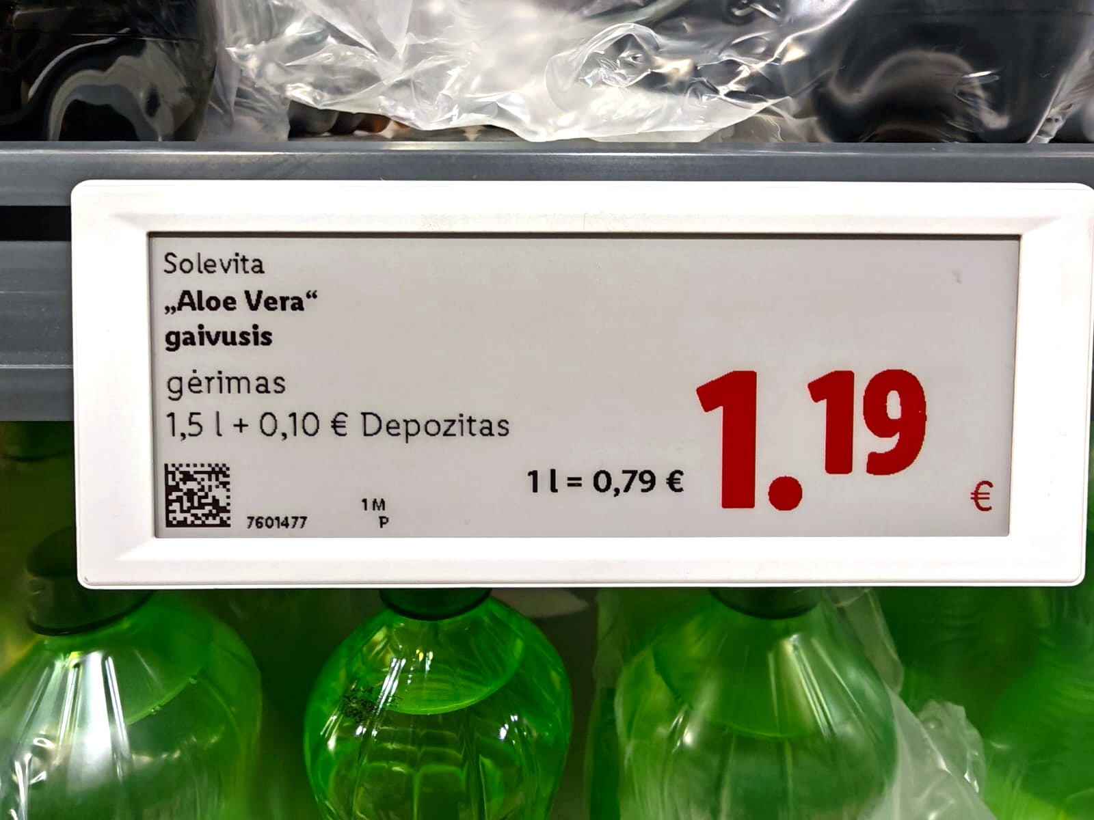
The deposit visible at the shelf - €0.10 added at point of sale and refunded on return (European benchmark system, Lithuania).
• AED 0.10 was rejected as too weak for a high-income, convenience-driven market; AED 0.50 was rejected for launch on fraud-incentive and working-capital grounds (gross deposit flows would reach ~AED 1.9-2.2bn/yr).
• This recommendation is non-binding - a reference value for policymakers, to be reassessed at the year-2 statutory review against achieved return rates and Türkiye's first-year results as the closest structural analogue (hot climate, tourism-heavy, app-based refunds).

10.2.3 Return-rate trajectory
The model assumes a launch return rate of 55%, ramping to 90% by year 7 (2034) - deliberately slower than the fastest European launches (Romania 83-84% by year 2; Hungary 88.8% year 2; Ireland 91% recycling by year 2) to reflect first-in-region status and network build-out (Reloop, 2024; letsrecycle, 2025).

10.3 Capital Expenditure: AED 664 Million, Phased 2026-2029
Total programme CAPEX is AED 664 million (~USD 181m / EUR 166m, at the USD peg of 3.6725 and an indicative EUR rate of 4.00) - approximately AED 59 per resident. Unlike several European systems where retailers own the reverse vending machines, the UAE design has the system SPV own the full infrastructure, which raises headline CAPEX relative to comparators such as Romania (whose €85-90m operator loan excluded retailer-borne RVMs) but gives the system direct control over service quality, data and fraud prevention.

CAPEX line | AED m | Basis
RVM fleet - 3,500 machines @ AED 110k installed | 385 | MDPI UAE study count benchmark (MDPI, 2023); unit cost within international range of USD 10-25k standard / >USD 30k AI-equipped; Ireland outdoor actuals €30k ≈ AED 120k (Market Growth Reports, 2026; Oireachtas, 2026)
Counting & sorting centres - 3 facilities (Dubai, Abu Dhabi, Sharjah/N. Emirates) | 108 | Romania ~€8-9m per regional centre; 7 centres for ~7bn packages/yr → 3 for ~3.5-4bn (RetuRO press, 2024)
Central IT platform | 30 | Estimate; Slovakia-type build 6-12 months (Sensoneo, 2024) - no national DRS IT contract values are publicly disclosed [DATA GAP: national DRS central-IT contract values - vendor figures not disclosed; estimate based on scale signals only]
Vehicles & logistics | 40 | Backhaul-first design (European benchmark operations model) limits dedicated fleet
Setup & pre-launch | 45 | Context: Romania setup financed by €85-90m green loan; Ireland repaid setup from year-1 surplus (CSNA, 2025)
Contingency (10% on hard capex) | 56 | Estimate
Total | 664

Phasing:

Year | 2026 | 2027 | 2028 | 2029 | Total
CAPEX (AED m) | 41 | 247 | 279 | 97 | 664

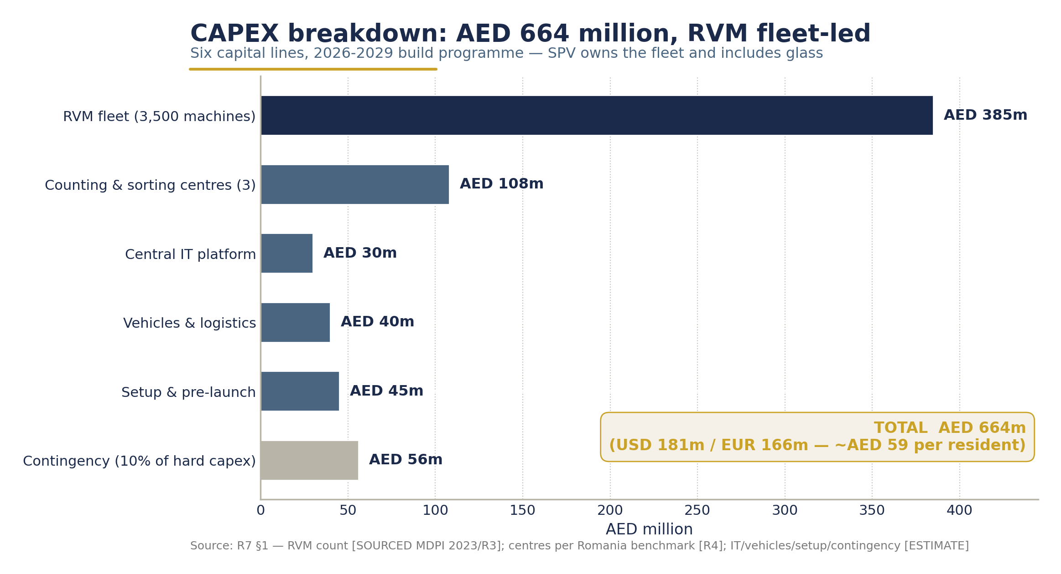
CAPEX breakdown - AED 664m across six investment lines.
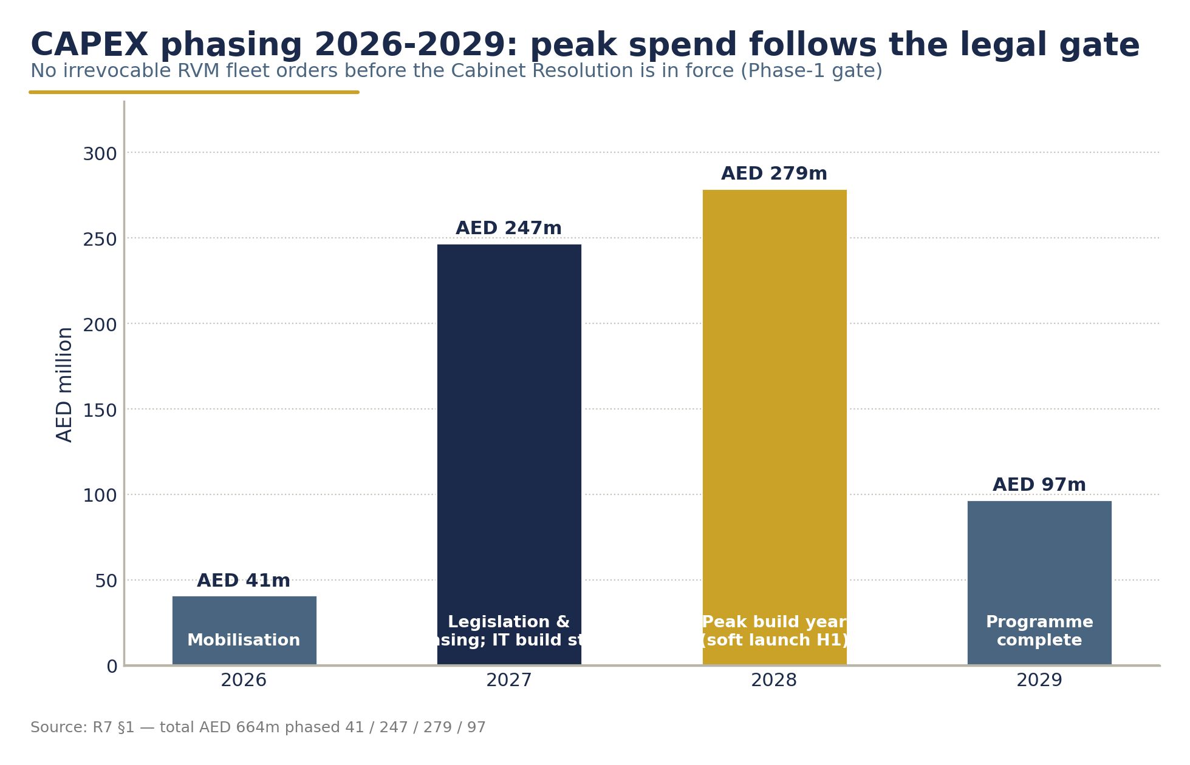
CAPEX phasing 2026-2029 - AED 41m / 247m / 279m / 97m.
Financing is modelled at 60% debt / 40% equity, debt at 5.5% repaid over 10 years from 2029 - following the RetuRO green-loan precedent (ING, 2023). Peak funding requirement is AED 294 million.

10.4 Operating Expenditure: Trajectory to ~AED 1.08bn/yr
Steady-state OPEX reaches AED ~1.08 billion per year (2034), equivalent to AED 0.29 per returned container (AED 0.27 in year 1) - approximately €0.07, in line with Ireland's audited year-1 all-in cost of €0.071 per container (direct cost €0.053) (Re-turn Annual Report, 2024, via CSNA, 2025).
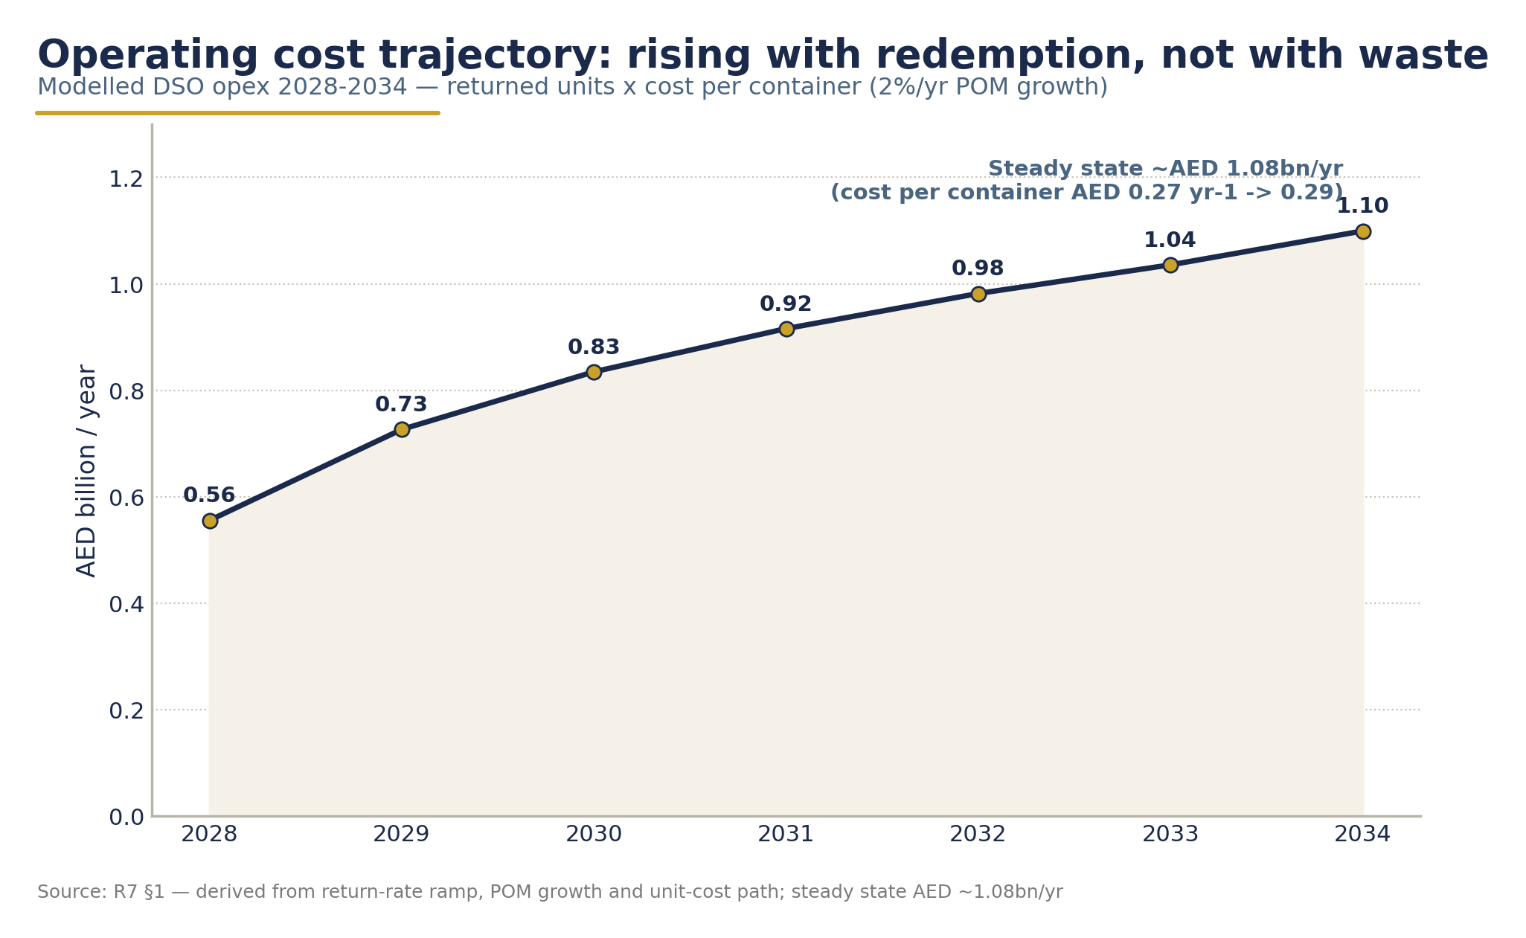
Operating expenditure trajectory - rising with the return ramp to ~AED 1.08bn per year at steady state (2034).
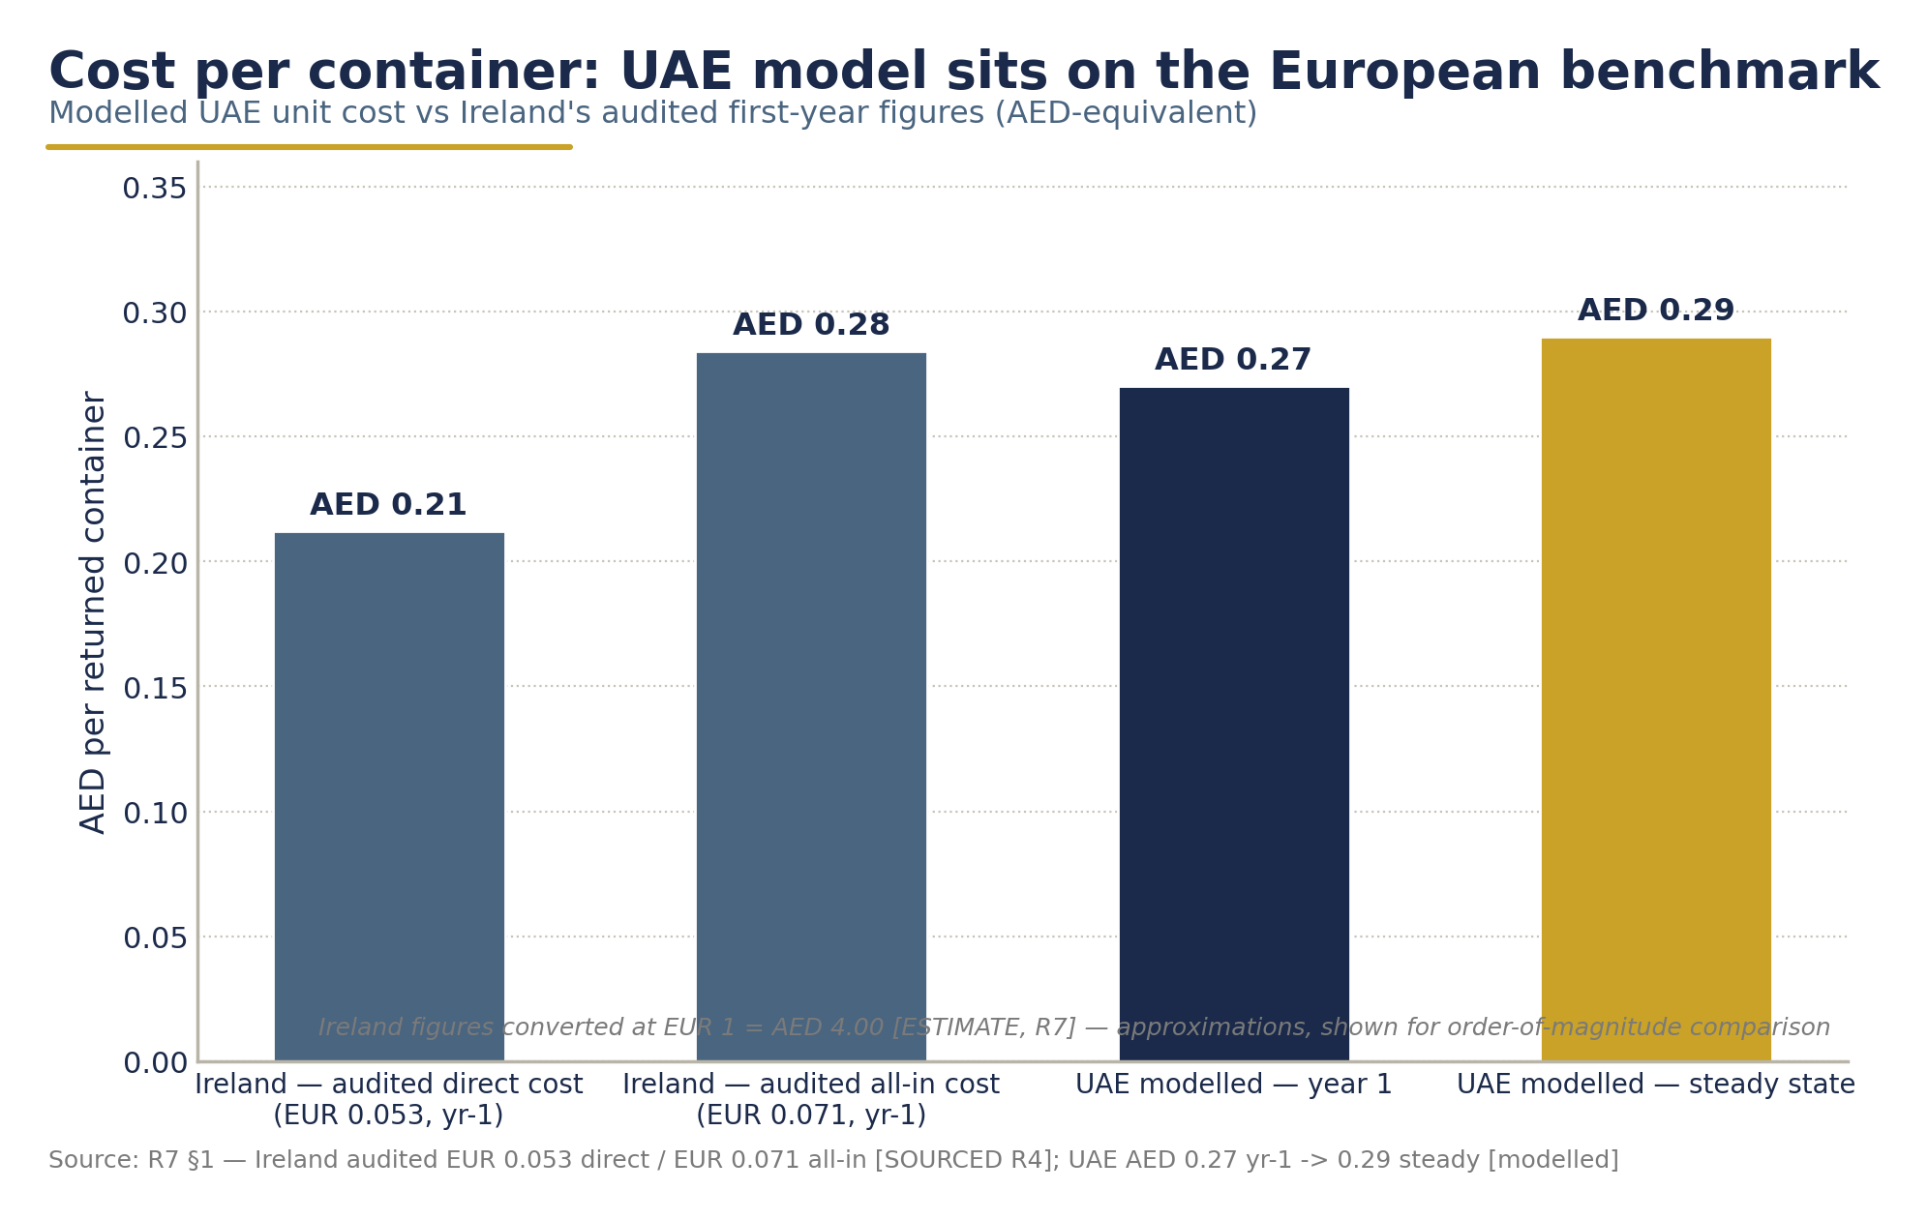
Unit economics - cost per container handled, UAE trajectory vs the audited Ireland benchmark (FX estimate noted on-chart).

OPEX mix (steady state) | Share | Comment
Retailer handling fee (RHF) | ~35% | AED 0.10/container - calibrated to Ireland's €0.022-0.026 (AED 0.088-0.104) and Lithuanian ranges up to €0.049 (CRI, 2024; Reloop, 2024)
Logistics | ~21% | Logistics + centre ops modelled at AED 0.11/container combined - residual of Ireland's €0.053/container direct cost after handling fees
Counting/sorting centre operations | ~17% | 3 centres, Romania scale analogue
Consumables | ~3%
Maintenance, IT, administration, awareness | ~14% | RVM maintenance AED 4,400/machine/yr (~USD 1,200 benchmark; Market Growth Reports, 2026)
Operations management fee (OMF - Segen) | ~9% | Fixed AED 25m/yr - Segen's operations-management income

The cost architecture mirrors audited European structures: in the European benchmark operations system (Lithuania), retailer compensation, logistics and administration account for 74%/12%/14% of expenses respectively (Reloop, 2024).

10.5 Revenue Architecture: Designed for the Steady State
Steady-state revenue (2034) is AED ~1.10 billion per year, structured on two legs only:
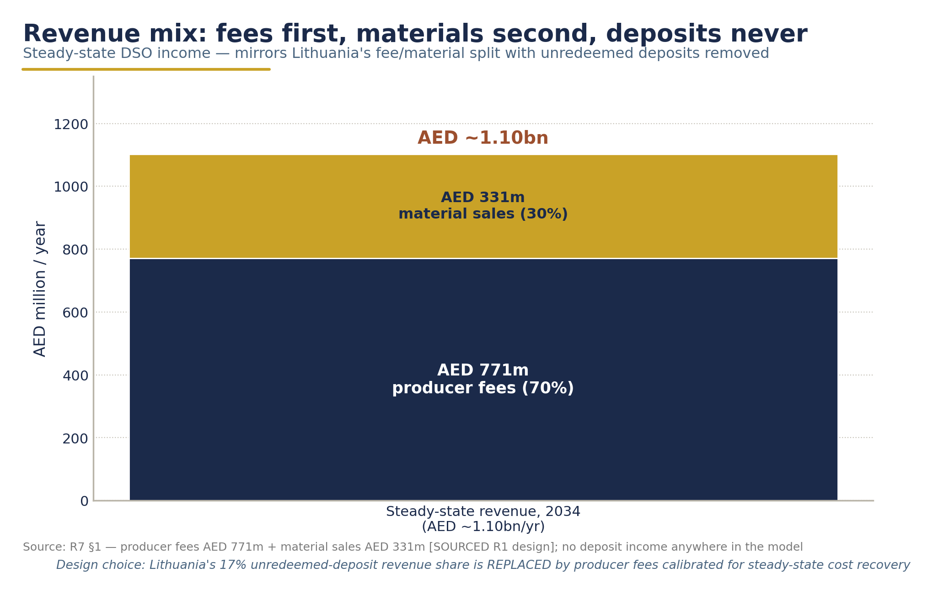
Steady-state revenue architecture - producer fees ~70%, material sales ~30%; unredeemed deposits excluded by design.

Revenue line | AED m/yr | Share
Producer fees (on all placed-on-market units) | 771 | 70%
Recovered-material sales | 331 | 30%
Unredeemed deposits | 0 | 0% - escrowed, never revenue (see §10.6)

10.5.1 Producer fees (recommended, non-binding)

Material | Fee (AED/container) | ≈ EUR | Benchmark anchor
PET | 0.20 | €0.050 | Lithuania €0.044 (AED 0.176) plus replacement of the ~17% unredeemed-deposit revenue share the operator forgoes; EU planning range €0.01-0.05 (Eunomia, 2025). Ireland's €0.02 is not cost-covering - its year-1 surplus was unredeemed-deposit-driven (CSNA, 2025)
Aluminium | 0.08 | €0.020 | Ireland €0.0125, Lithuania €0.019 (CRI, 2024; Reloop, 2024); high UBC value (~AED 6,600/t base) cross-subsidises - Norway, Sweden and Slovakia run zero or negative can fees
Glass | 0.24 | €0.060 | Lithuania €0.055 (AED 0.22), Malta €0.037; glass is a net-cost stream - cullet at AED 440/t rarely covers collection logistics (IndexBox, 2024)

Rationale. Fees are calibrated so that producer fees + material sales ≈ 1.05-1.10 × system costs at 90% redemption, charged on all placed-on-market units (Hungary MOHU monthly model; Grant Thornton, 2025), with an annual cost-recovery review (Ireland/Latvia-Deloitte methodology precedent; DIO, 2024). Eco-modulation (coloured PET, sleeves) is deferred to the first review.
This is the decisive structural choice of the UAE design. In the European benchmark literature, unredeemed deposits typically fund a large share of system revenue; under the Segen model that role is replaced by producer fees - which is why the recommended UAE fees sit at the top of, but within, the EU range.
"Producer fees must be set for the steady state, not the ramp-up." - the central lesson of Ireland's audited year 1 (Re-turn Annual Report, 2024).

10.5.2 Material revenues
Material sales of AED 331m/yr at steady state rest on conservative decks: rPET at USD 1,200/t (2024-26 range USD 1,100-2,100/t; base set low given weak 2026 markets despite the 15-25% DRS bale premium; IMARC, 2026; Polyestertime, 2026), UBC at USD 1,800/t (range USD 1,200-2,050/t, supported by the Q4-2025→Jan-2026 LME rally; Fastmarkets, 2025; SMM/AlCircle, 2026), and cullet at AED 440/t (export/downcycle only - no UAE furnace offtake). Aluminium is the margin engine that cross-subsidises PET and glass - the universal pattern in European systems.

10.5.3 Outflows embedded in the model
The retailer handling fee (RHF) (~35% of OPEX, AED 0.10/container) is the single largest outflow, followed by logistics and centre operations. All fee and cost lines escalate at 2% per annum.

10.6 The Deposit Float: What It Is - and What It Is Not
This subsection exists to prevent a misreading that has distorted DRS debates in several countries.

10.6.1 Scale of the float
At the recommended AED 0.25 deposit, gross annual deposit flows are ~AED 935 million in year 1 (consistent with the UAE consumer-survey range of AED 0.75-1.08bn). Unredeemed deposits - the residue of containers never returned - are modelled at AED 421 million in year 1, falling to ~AED 110 million per year once the system reaches 90% redemption. The cumulative escrowed reserve reaches ~AED 1.8 billion by 2037.

10.6.2 The float is a liability, not income
Deposit money belongs to consumers until containers are returned. Accordingly:
• Every dirham of deposit flow is held in transparent escrow as a pass-through liability.
• Unredeemed balances accrue to a ring-fenced system reserve - governance options include Slovakia's statutory "transparent account," usable by law only for development and improvement of the system, or a state-fund model as in Portugal (Barikáda, 2021; PwC, 2021).
• Segen earns AED 0 from unredeemed deposits. Its income derives exclusively from (a) the fixed operations-management fee (AED 25m/yr) and (b) its share of recovered-material value and delivery-cost recovery. There is no deposit income anywhere in the Segen commercial structure.

10.6.3 Why this matters for system integrity
Where operators keep unredeemed deposits, an implicit incentive exists to suppress return rates - Michigan's 25% retailer share of unredeemed deposits is the documented cautionary case (Reloop, 2024). Ireland's experience shows the fiscal complexity of operator-retained floats (a €23.7m VAT settlement on €66.7m recognised unredeemed deposits; CSNA, 2025). The UAE escrow design removes these incentives and ambiguities by construction. It also explains the model's most counter-intuitive sensitivity result (§10.8): higher redemption is margin-dilutive at fixed fees, because the system never monetises non-redemption.

10.7 System Returns: IRR 27.7%, NPV +AED 349m, Payback 2031

Metric | Base case
Project IRR (unlevered, 2026-2037) | 27.7%
NPV @ 8% / @ 10% | +AED 349m / +AED 287m
Payback | 2031 (year 4 of operations)
Peak funding requirement | AED 294m
Steady-state EBITDA margin | ~9-10% of revenue

The IRR is front-loaded by ramp-up surpluses: producer fees are charged on 100% of placed-on-market volume from day one, while return-linked costs scale only with returned units - the documented Ireland pattern, where Re-turn recorded a €51.3m pre-tax surplus in year 1 (CSNA, 2025). The steady-state margin of ~9-10% is the more meaningful long-run indicator. Internationally, DRS payback periods of 2-10 years are the norm (Lakhan meta-analysis, cited in Eunomia, 2025); the modelled 2031 payback sits comfortably within that range.
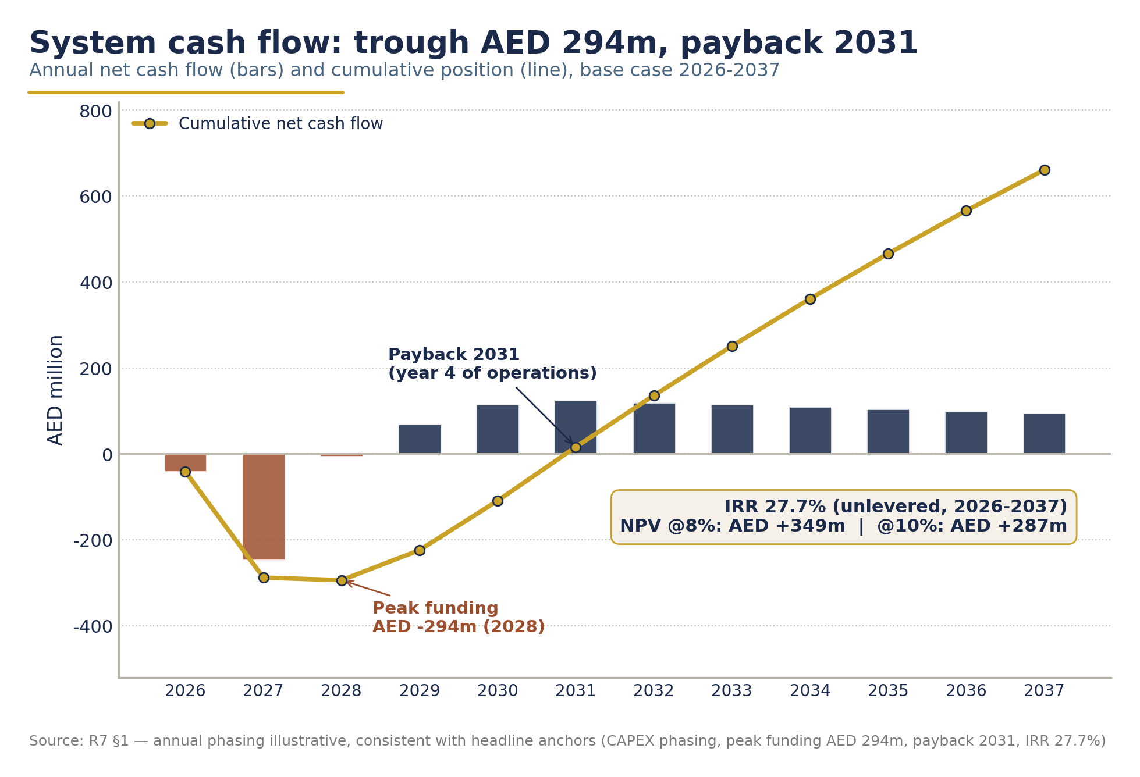
System cash flow 2026-2037 - peak funding AED 294m, payback 2031, IRR 27.7%, NPV +AED 349m at an 8% discount rate.

10.8 Scenario Analysis: Honest Bounds on the Base Case

 | Conservative | Base | Optimistic
POM PET 2028 (bn) | 2.60 | 2.90 | 3.30
Plateau return rate | 80% | 90% | 91%
RVM count / unit cost | 3,000 @ AED 130k | 3,500 @ AED 110k | 4,000 @ AED 95k
rPET / UBC price (USD/t) | 900 / 1,400 | 1,200 / 1,800 | 1,300 / 1,900
Total CAPEX (AED m) | 745 | 664 | 603
Fee-review factor (from year 4) | +20% | - | −15%
Project IRR | 2.5% | 27.7% | 67%
NPV @ 8% (AED m) | −121 | +349 | +976
Payback | 2036 | 2031 | 2029
Peak funding (AED m) | 494 | 294 | 253

How to read the conservative case. The 2.5% IRR is not a model failure - it is the demonstration that the fee-review mechanic works as designed: under combined adverse conditions (lower volumes, higher RVM costs, weak commodity prices, lower plateau), a +20% producer-fee reset from year 4 restores cost recovery. Symmetrically, the optimistic case returns surplus to producers via a −15% fee reset, honouring the non-profit cost-recovery principle. The fee-review mechanism is the system's financial governor in both directions.
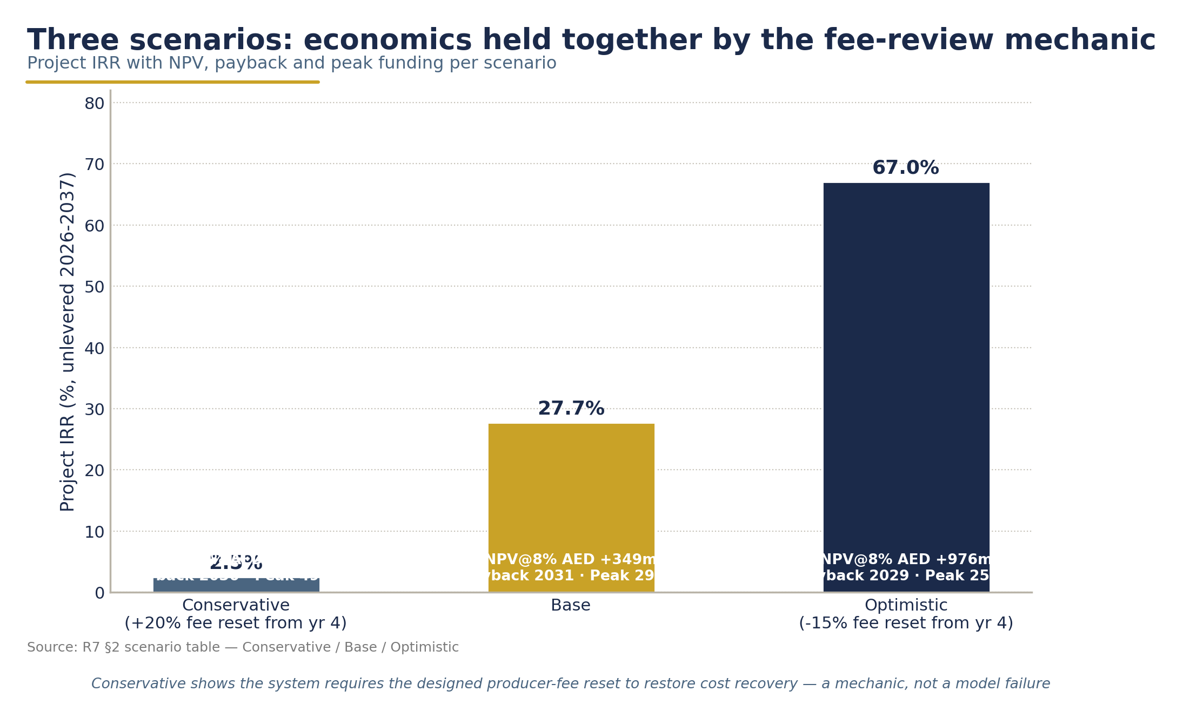
Scenario analysis - honest bounds on the base case: Conservative / Base / Optimistic IRR, NPV, payback and peak funding.

10.9 Sensitivity: Fees Dominate - and the Return Rate Bites Inverted
One-way sensitivity of project IRR against the base case:
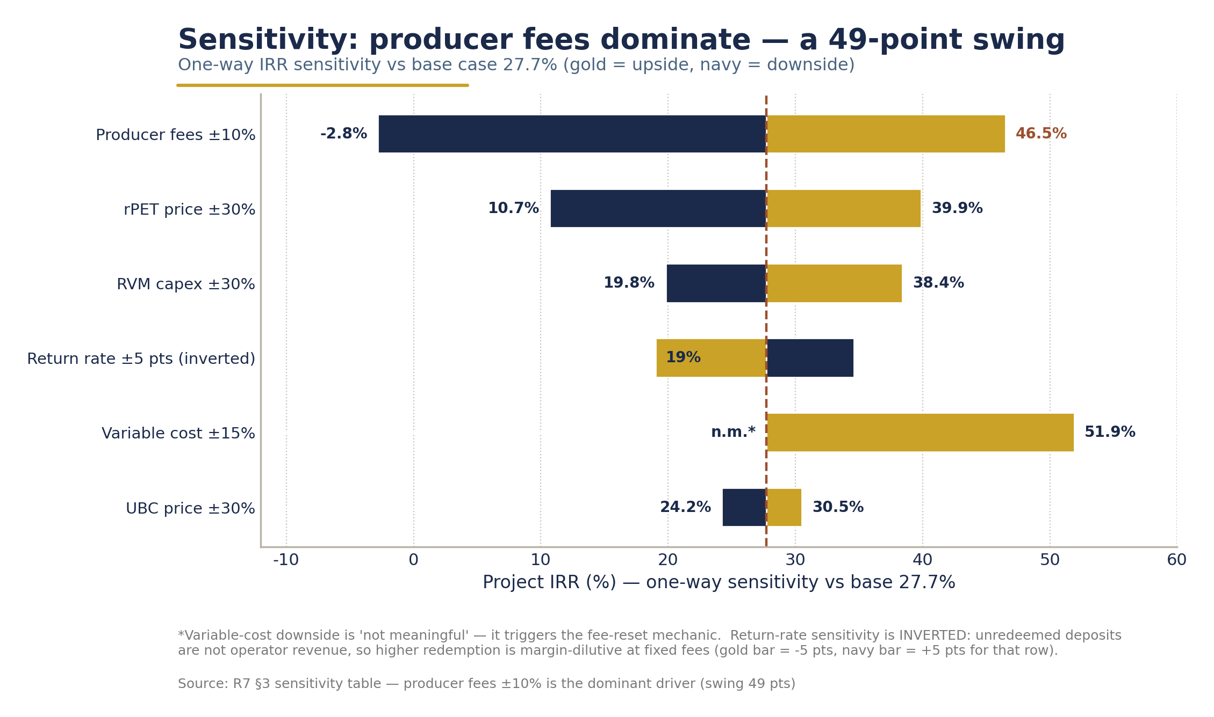
Sensitivity - producer fees dominate system economics; the return rate bites inverted (margin-dilutive at fixed fees).

Driver | Downside | Upside | Swing
Producer fees ±10% | −2.8% | 46.5% | 49 pts - dominant
rPET price ±30% | 10.7% | 39.9% | 29 pts
RVM capex ±30% | 19.8% | 38.4% | 19 pts
Return rate ±5 pts | 34.6% (−5 pts) | 19.0% (+5 pts) | 16 pts - inverted
Variable cost ±15% | n.m. (requires fee reset) | 51.9% | large
UBC price ±30% | 24.2% | 30.5% | 6 pts

Two findings deserve ministerial attention:
1. Producer fees are the single dominant value driver. A ±10% fee movement swings IRR by 49 points. This makes the fee-setting and review process - not commodity markets or technology costs - the critical governance function.
2. The return-rate sensitivity is inverted - and the design already contains the remedy. Because unredeemed deposits are not operator revenue in this design, each additional returned container adds ~AED 0.22 of variable cost against only ~AED 0.09 of material value: higher redemption is margin-dilutive at fixed fees. The same dynamic exists in Ireland and Norway, where unredeemed-deposit income shrinks as redemption rises. We present this honestly rather than obscuring it: the system's economics must be, and are, stabilised by setting producer fees on an annual cost-recovery formula so that performance success never threatens solvency. This is precisely Ireland's lesson - "producer fees must be set for the steady state, not the ramp-up" (Re-turn Annual Report, 2024).

10.10 Macro-Economic Impact
Beyond the system P&L, the DRS generates measurable national economic value:
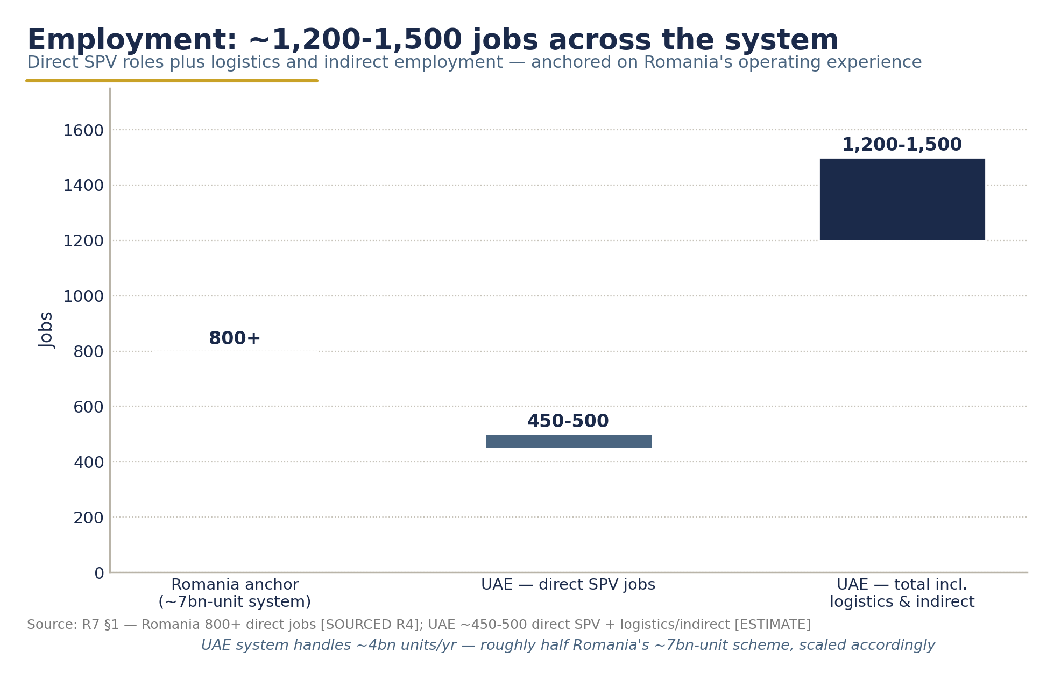
Employment impact - ~450-500 direct SPV jobs and ~1,200-1,500 total (estimate), anchored on Romania's 800+ operator jobs.
Employment: ~1,200-1,500 jobs. Approximately 450-500 direct SPV positions plus logistics and indirect employment. The anchor is Romania, where RetuRO created 800+ direct green jobs within 14 months for a ~7-billion-unit system (RECYCLING magazine, 2025); the UAE system is roughly half that volume.
Material value retention and import substitution. At steady state the system returns ~AED 331m/yr of high-purity rPET, UBC and cullet to the economy. DRS-collected PET commands a 15-25% bale premium over curbside material due to purity (Polyestertime, 2026), and food-grade rPET carries a structural premium driven by recycled-content mandates (ICIS via Recycling Today, 2025). For the UAE - which imports the bulk of its packaging resin - domestic supply of certified food-grade recyclate substitutes imports and supports the national circular-economy agenda. [DATA GAP: AED quantification of packaging-resin import substitution - no UAE-specific resin import value series was available in the research base]
Landfill cost avoidance. Every container returned is a container diverted from landfill and municipal collection, avoiding gate fees and extending landfill life. [DATA GAP: UAE-specific landfill gate-fee / avoided-disposal-cost series - not available in the research base; quantify at implementation-plan stage using emirate-level tariff data]
Litter and cleanup savings. International experience associates deposit systems with sharp reductions in beverage-container litter, reducing municipal cleanup burden and protecting marine environments. [DATA GAP: quantified UAE litter-cleanup cost savings - no UAE baseline litter-cost study was available in the research base; recommend commissioning one as a pre-launch baseline]
These unquantified benefits are deliberately excluded from the IRR and NPV above - the financial case stands on system cash flows alone, with macro-economic upside as additional margin for the nation.

10.11 Conclusion
The base case is robust: AED 664m of phased capital builds a system that pays back by 2031, generates a 27.7% unlevered IRR, and operates at cost recovery with a transparent, non-profit fee governor. The design's financial credibility rests on three pillars - benchmarked costs (Ireland's audited actuals), conservative revenue decks, and an explicit fee-review mechanism that keeps the system solvent in the conservative scenario and returns surplus in the optimistic one. Most importantly, the model requires no public subsidy and no dependence on consumer non-redemption: deposits remain consumer money in escrow, producers fund the system they place on the market, and recovered materials pay their share.
PART V

Sources & Annexes

CHAPTER 11

Sources & Methodology

11.1 Research basis
This study is built on seven research briefs prepared for this engagement (all dated 26 July 2026), each an internally citable source. Full source URLs are recorded in the briefs themselves.

Brief | Title | Role in this study
R1 | Global DRS Benchmarks | All international benchmark facts: return rates, deposits, governance and financing structures, launch ramp-ups, cautionary cases (Chapters 3, 4, 6, 7, 8)
R2 | UAE Policy & Regulatory Landscape | Federal and emirate instruments, the MOCCAE-Tadweer EPR pilot, the legal pathway (Chapters 3, 7)
R3 | UAE Market Assessment | Consumption and container volumes, producer and retail landscape, recycling infrastructure, waste-flow economics (Chapter 5)
R4 | DRS Economics & Technology | Cost and fee benchmarks, technology and IT evidence, financing precedents (Chapters 6, 10)
R5 | Internal Documents | Segen Project Description commitments; UAE DRS Market Survey volumes, float analysis and standing caveats (Chapters 1, 2, 5)
R6 | Media Asset Inventory | Field media of European benchmark operations (the Lithuanian system); captioning and usage rules - no asset depicts UAE infrastructure
R7 | Financial Assumptions Memo | Single citable source for every headline financial figure (Chapters 1, 4, 6, 8, 9, 10); companion artefact `final\Segen_DRS_Financial_Model.xlsx`

11.2 Citation style
In-text citations follow a (Publisher, Year) convention - e.g. (Reloop, 2024), (USAD, 2019), (EGA, 2024), (Abu Dhabi Media Office, 2025). Internal commitments are cited to their source document (Project Description, 2026). Every financial headline figure traces to the R7 memo and the linked financial model.

11.3 Data-status labels
Figures are labelled [PUBLISHED] (government, corporate-primary or academic sources), [ESTIMATE] (market-research models and analyst estimates) or [DATA GAP] (no credible figure exists; a validation action is named rather than a number invented). Modelled container volumes carry the market survey's standing caveat: estimates require validation with producer/importer SKU-level data before policy design.

11.4 Standing data gaps and Phase-1 validation actions

# | Gap | Validation action
1 | No official UAE count of DRS-eligible PET containers placed on market | Mandatory SKU-level producer/importer reporting (material, size, one-way vs reusable, barcode, annual units, channel split)
2 | No national glass beverage-container figure (~0.18bn units is an analyst estimate) | Hospitality-channel and importer study in Phase 1
3 | Final scope, fees and treatment of beverage containers in the expected 2026 national EPR framework not yet public | Track publication; align DRS instrument per Chapter 7
4 | Veolia Repeet rPET plant commissioning status unverified | Confirm with MoIAT/Veolia before offtake commitments
5 | ADNOC/ENOC station and convenience-store counts not verified | Verify in Phase 1 for fuel-retail return-channel design
6 | Per-emirate landfill fee schedules beyond Dubai not retrieved | Collect via emirate implementation agreements
7 | Informal collection sector size and economics unstudied | Social-integration design study in Phase 2
8 | Sparklo national machine count and cumulative collections not published; EAD cumulative series beyond 2024 unreconciled | Reconcile with EAD/Sparklo in Phase 1
9 | Türkiye first-year return-rate performance (system live 1 July 2026) | Monitor quarterly; input to the year-2 deposit review
10 | National DRS central-IT contract values; quantified DRS fraud rates; MENA rPET/UBC/cullet price series | Procure vendor benchmarks; proxy with EU/US/Asian series
11 | No UAE baseline for beverage-container recycling rates, litter composition or cleanup costs | Funded 2027 baseline study (compositional litter survey + container-flow mass-balance)

11.5 Financial conventions
Currency: AED. FX: 1 USD = 3.6725 AED (peg, sourced); 1 EUR = 4.00 AED (indicative estimate). Model horizon 2026-2037; base case with live Conservative/Base/Optimistic scenario toggle in the companion financial model. Deposit level (AED 0.25) and producer fees (AED 0.20 / 0.08 / 0.24) are non-binding recommendations for policymaker consideration.
ANNEX A

Register of [INFOGRAPHIC] Markers
Every infographic marker in this study, with its location. Markers are production instructions for the design stage; none is a data source in itself.

# | Location | Marker
1 | 1.3 Headline economics | "The UAE DRS at a glance" - single-page dashboard panel: 3.74bn containers, 3,500 RVMs, 3 sorting centres, AED 664m CAPEX, 90% return rate by 2034,…
2 | 2.4 Guiding principles | "Money and material flow" - closed-loop diagram: producer → retailer → consumer → RVM/collection point → counting & sorting centre → recycler; depo…
3 | 3.1 Alignment map | "Alignment wheel" - central circle "UAE National DRS" with seven spokes to the instruments above, each tagged with its headline target (Net Zero 20…
4 | 4.1 The Global Landscape in 2026 | World map of DRS jurisdictions 2026 - operating systems (60, dark), legislated/in-launch by end-2027 (light), with callout stats "396M people cover…
5 | 4.2 Deep Dive: Lithuania (USAD) - the Closest Design Template | Lithuania timeline + results panel - 2014 law → 2016 launch → return-rate curve <33% (2015) → 74% (2016) → 92.3% (2023); side panel with 53/30/17 f…
6 | 4.3 The Newest Wave: Proof That 80-90% Is Achievable Within 24 Months | "Race to 90%" line chart - return-rate trajectories by months since launch for Romania, Hungary, Ireland, Austria, Malta, Slovakia, with the UAE mo…
7 | 4.7 Ten Design Patterns for the UAE | "10 design patterns" wheel or staircase diagram - each pattern as one segment with its benchmark flag icon (LT, RO, HU, IE, NO, FI, DE, TR, Scotlan…
8 | 5.0 Chapter Summary | "UAE at a glance" dashboard strip - population 11.29M, bottled water 250-300L per capita, ~450 PET bottles/person/yr, 660M cans/yr with only ~1/3 r…
9 | 5.1.3 Policy tailwinds already in force | Policy timeline 2022-2031 - SUP ban phases, EPR pilot, sugar excise, rPET decree, 2031 diversion targets - horizontal timeline with milestones
10 | 5.2.3 Glass: a quantified gap, not an omission | Stacked bar - containers placed on market by material (PET range bar with low/high markers, cans point estimate, glass estimate hatched as "estimat…
11 | 5.4 Retail Landscape & Return-Channel Readiness | Map of UAE with return-network layers - modern trade anchor stores, fuel stations, malls/transit, traditional trade - plus a density gauge showing …
12 | 5.5 Existing Recycling Infrastructure | "Infrastructure vs feedstock" two-column diagram - left: processing capacity bars (Farz, BEEAH, Tadweer, DGrade, Repeet, Al Taweelah); right: avail…
13 | 5.7 Waste-Flow Economics | "Cost of inaction" panel - landfill fee trend AED 10/t → AED 100/t, 440M cans/yr to landfill, 79% mismanaged plastic index, 33 kg/capita plastic wa…
14 | 6.2.3 Why this structure protects the unredeemed-deposits commitment | Organisational chart - supervising ministries (top, oversight dashed line) → single not-for-profit DSO board (producers / importers / retailers / g…
15 | 6.3.2 Placement strategy | Network density map of the UAE - emirate-level return-point allocation against population (Dubai, Abu Dhabi, Sharjah/Northern Emirates), with icons…
16 | 6.4.3 EAN-level traceability | Material-flow diagram - Consumer purchase (deposit paid at till) → return at RVM/manual point (barcode scan, compaction, instant refund) → backhaul…
17 | 6.6 The central IT platform: the system's single source of truth | Money-flow diagram - Producers/importers pay producer fees (AED 0.20 PET / 0.08 aluminium / 0.24 glass per unit POM) + deposit funding (AED 0.25/un…
18 | 8.2 Phase plan | Horizontal timeline/Gantt for 2026-2030 showing the six phases below as bars, with milestone diamonds (Cabinet Resolution, DSO licence, first RVM l…
19 | 9.1 Risk register & mitigation | 5×5 risk heat-map plotting R1-R14 by likelihood and impact, colour-coded green/amber/red, with R1, R2, R3 flagged as the three board-level risks.
20 | 10.3 Capital Expenditure: AED 664 Million, Phased 2026-2029 | CAPEX breakdown - stacked bar or waterfall showing the six CAPEX lines (RVM fleet 385 / centres 108 / IT 30 / logistics 40 / setup 45 / contingency…
21 | 10.7 System Returns: IRR 27.7%, NPV +AED 349m, Payback 2031 | Cash-flow curve 2026-2037 - annual net cash flow bars (negative 2026-2028 build years, trough at peak funding AED 294m, crossing zero at 2031 payba…
22 | 10.8 Scenario Analysis: Honest Bounds on the Base Case | Scenario chart - three-line cumulative cash-flow or IRR tornado panel for Conservative (2.5% IRR, +20% fee reset) / Base (27.7%) / Optimistic (67%,…

